Name

Mathematics Stage 4
Operations with
Fractions and Decimals

Book 4 | Solve problems that involve the addition and subtraction of fractions  Solve problems that involve the multiplication and division of fractions and decimals | Version: 260706  Feedback:  https://MrDingMaths.com
Contents
Syllabus Content 2
Learning Intention Error! Bookmark not defined.

Syllabus Content
MA4-FRC-C-01 represents and operates with fractions, decimals and percentages to solve problems
Solve problems that involve the addition and subtraction of fractions
- Represent addition and subtraction of fractions with the same or unrelated denominators
- Solve problems involving adding and subtracting fractions and mixed numbers, including finding a common denominator
- Solve problems that involve subtracting a fraction from a whole number, with and without the use of digital tools
Solve problems that involve the multiplication and division of fractions and decimals
- Compare and generalise the effect of multiplying or dividing by a number with magnitude between zero and one
- Represent multiplication and division of decimals
- Represent multiplication and division of fractions, including mixed numbers
- Multiply and divide decimals, using digital tools to solve problems
- Multiply and divide fractions and mixed numbers, with and without using digital tools to solve problems
- Compare initial estimates with the results of calculations
- Apply knowledge of fractions and decimals of quantities to solve problems
- Apply knowledge of multiplication and division of fractions and decimals to solve problems

Fraction Addition: Same Denominator

- Adding and Subtracting Fractions with the Same Denominator
When working with fractions that have the same denominator:
- Add or subtract the numerators.
- The denominators stay the same.

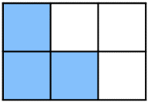
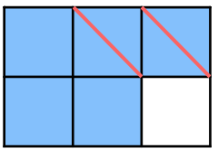
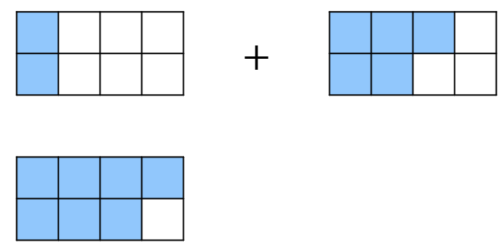
- Example Add and subtract fractions with the same denominator
$$\frac{2}{8}+\frac{5}{8}$$  $$=\frac{7}{8}$$ | $$\frac{5}{6}-\frac{2}{6}$$  $$=\frac{3}{6}$$

- Guided Practice
Add and subtract these fractions.
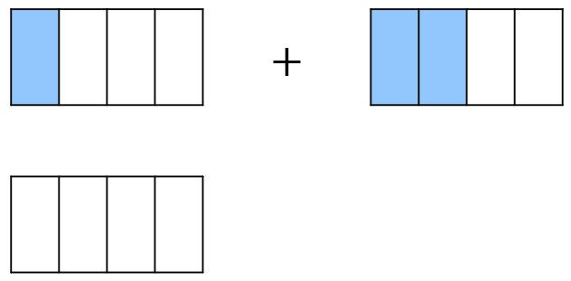  $$\frac{1}{4}+\frac{2}{4}$$  $$=\frac{ }{4}$$ | 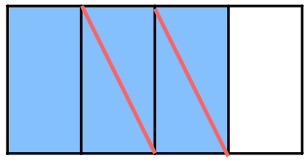  $$\frac{3}{4}-\frac{2}{4}$$  $$=\frac{ }{ }$$
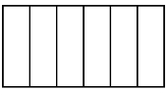  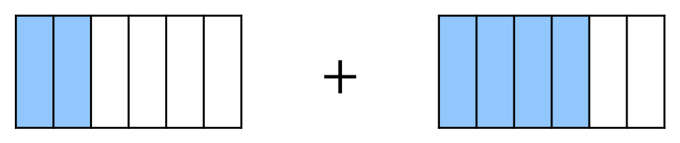  $$\frac{2}{6}+\frac{4}{6}$$ | 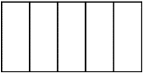  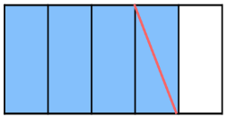  $$\frac{4}{5}-\frac{1}{5}$$
$$\frac{2}{6}+\frac{3}{6}$$ | 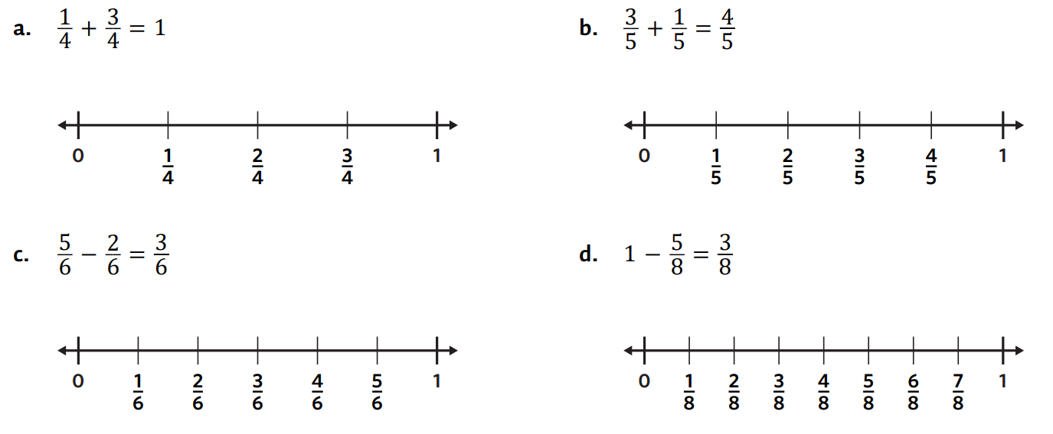  $$\frac{4}{5}-\frac{3}{5}$$
- Adding and Subtracting Fractions with the Same Denominator
$$\frac{a}{n}+\frac{b}{n}=\frac{a+b}{n}$$ | $$\frac{a}{n}-\frac{b}{n}=\frac{a-b}{n}$$
- Always simplify the result, if possible.

- Example Add and subtract fractions with the same denominator
$$\frac{2}{5}+\frac{6}{5}$$  $$=\frac{8}{5}$$ | $$\frac{9}{12}-\frac{5}{12}$$  $$=\frac{4}{12}$$  $$= \frac{1}{3}$$

- Guided Practice
Add and subtract these fractions.
$$\frac{12}{19}+\frac{5}{19}$$  $$=\frac{ }{19}$$ | $$\frac{9}{11}-\frac{8}{11}$$  $$=\frac{ }{ }$$
$$\frac{9}{28}+\frac{17}{28}$$ | $$\frac{12}{22}-\frac{16}{22}$$

- Key Ideas
- When adding or subtracting fractions with the same denominator, we add or subtract the …………………… and keep the …………………… the same.
- The denominator stays the same because the ………… of the parts stays the same.

Foundation
- Add and subtract these fractions using the diagrams.
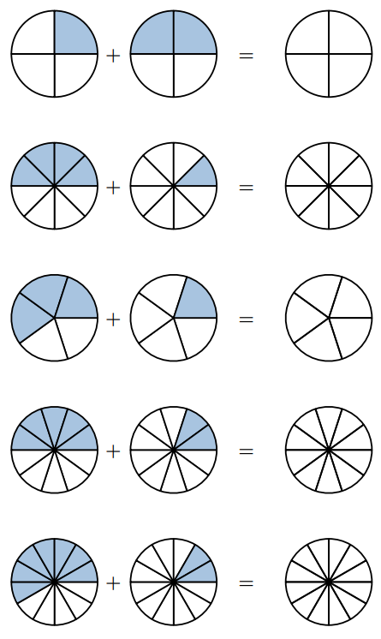  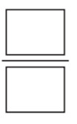  $$\frac{1}{4} + \frac{2}{4} =$$  $$\frac{3}{4}$$ | $$\frac{4}{8} + \frac{1}{8} =$$  $$\frac{5}{8}$$ | $$\frac{3}{5} + \frac{1}{5} =$$  $$\frac{4}{5}$$
$$\frac{7}{12} + \frac{2}{12} =$$  $$\frac{9}{12}=\frac{3}{4}$$ | 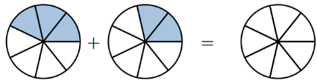  $$\frac{3}{7} + \frac{2}{7} =$$  $$\frac{5}{7}$$ | 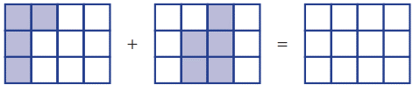  $$\frac{4}{12} + \frac{5}{12} =$$  $$\frac{9}{12}=\frac{3}{4}$$

- Add or subtract these fractions.
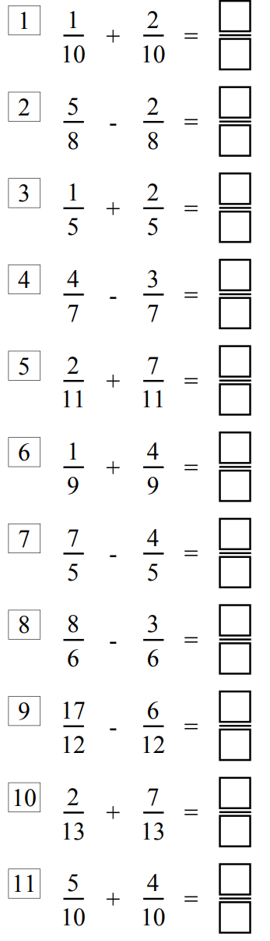  $$\frac{3}{10}$$ | $$\frac{3}{8}$$ | $$\frac{3}{5}$$
$$\frac{1}{7}$$ | $$\frac{9}{7}$$ | $$\frac{5}{9}$$
$$\frac{3}{5}$$ | $$\frac{5}{6}$$ | $$\frac{11}{12}$$

- Add or subtract these fractions. You will need to simplify.
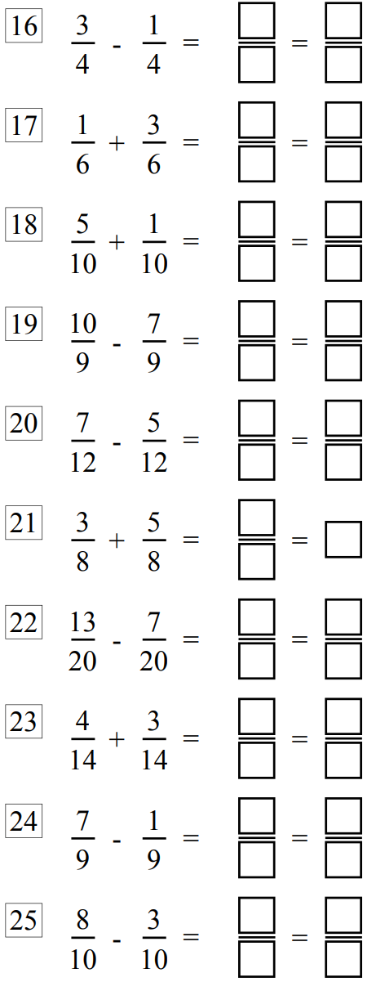  $$\frac{2}{4}=\frac{1}{2}$$ | $$\frac{4}{6}=\frac{2}{3}$$ | $$\frac{6}{10}=\frac{3}{5}$$
$$\frac{3}{9}=\frac{1}{3}$$ | $$\frac{2}{12}=\frac{1}{6}$$ | $$\frac{8}{8}=1$$
$$\frac{6}{20}=\frac{3}{10}$$ | $$\frac{7}{14}=\frac{1}{2}$$ | $$\frac{6}{9}=\frac{2}{3}$$

Development
- Add or subtract these fractions. You will need to simplify, then write as a mixed number.
$$\frac{14}{6}=\frac{7}{3}=2\frac{1}{3}$$ | 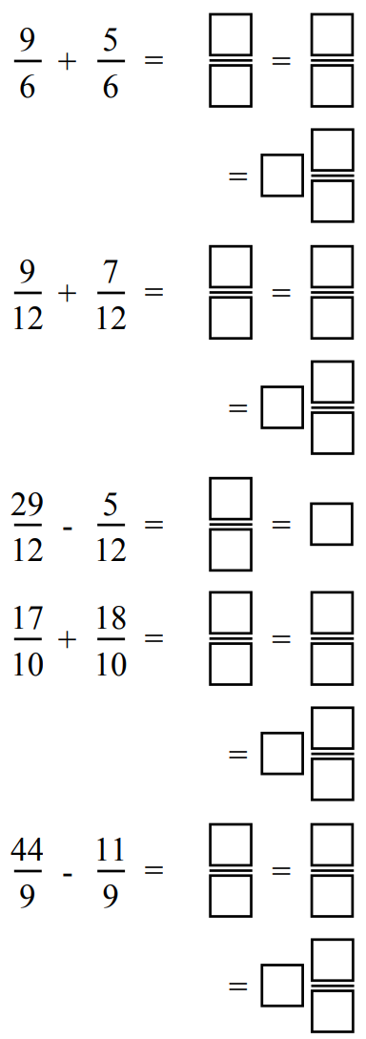  $$\frac{16}{12}=\frac{4}{3}=1\frac{1}{3}$$ | $$\frac{24}{12}=2$$
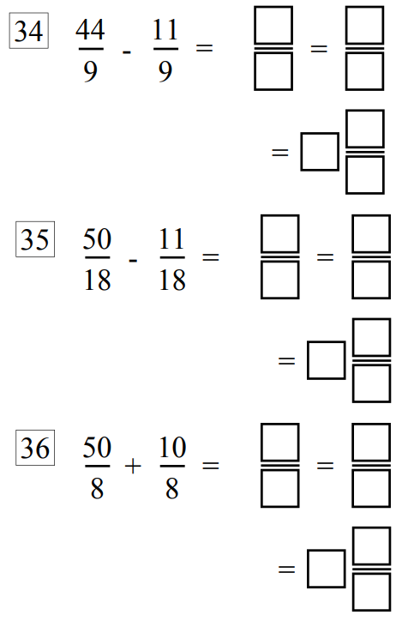  $$\frac{33}{9}=\frac{11}{3}=3\frac{2}{3}$$ | $$\frac{39}{18}=\frac{13}{6}=2\frac{1}{6}$$ | $$\frac{60}{8}=\frac{15}{2}=7\frac{1}{2}$$

- Work out the perimeter of each shape.
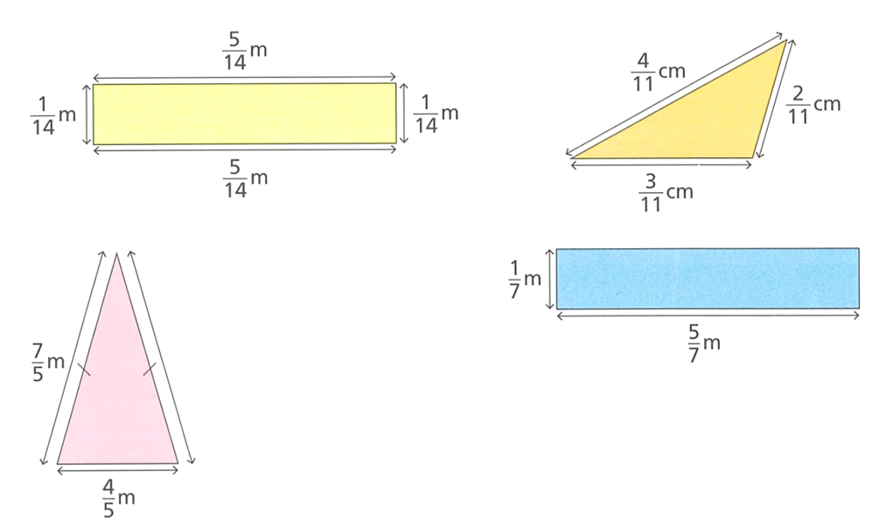  $$\frac{6}{7} m$$ | $$\frac{9}{11} cm$$
$$\frac{18}{5} m$$ | $$\frac{12}{7} m$$

- Work out the following, leave your answer as an improper fraction.
- $\frac{5}{7}+\frac{1}{7}$  $$\frac{6}{7}$$ | - $\frac{2}{15}+\frac{8}{15}+\frac{1}{15}$  $$\frac{11}{15}$$ | - $\frac{5}{9}-\frac{4}{9}$  $$\frac{1}{9}$$
- $\frac{5}{6}+\frac{5}{6}$  $$\frac{5}{3}$$ | - $\frac{5}{6}-\frac{5}{6}$  $$0$$ | - $\frac{4}{11}-\frac{3}{11}+\frac{5}{11}$  $$\frac{6}{11}$$
- $1-$ $\frac{1}{3}$  $$\frac{2}{3}$$ | - $\frac{3}{8}+\frac{5}{8}$  $$1$$ | - $\frac{6}{7}-\frac{2}{7}-\frac{4}{7}$  $$0$$
- $1-$ $\frac{1}{5}$  $$\frac{4}{5}$$ | - $1-$ $\frac{1}{4}$  $$\frac{3}{4}$$ | - $1-$ $\frac{8}{9}$  $$\frac{1}{9}$$
- $1-$ $\frac{4}{9}$  $$\frac{5}{9}$$ | - $1-$ $\frac{3}{5}$  $$\frac{2}{5}$$ | - $2-$ $\frac{1}{5}$  $$\frac{9}{5}$$
- $2-$ $\frac{6}{7}$  $$\frac{8}{7}$$ | - $2-$ $\frac{12}{17}$  $$\frac{22}{17}$$ | - $2-$ $\frac{15}{19}$  $$\frac{23}{19}$$
- $3-$ $\frac{1}{4}$  $$\frac{11}{4}$$ | - $6-$ $\frac{3}{5}$  $$\frac{21}{4}$$ | - $10-$ $\frac{7}{8}$  $$\frac{73}{8}$$

Mastery
- Calculate the perimeter of these shapes.
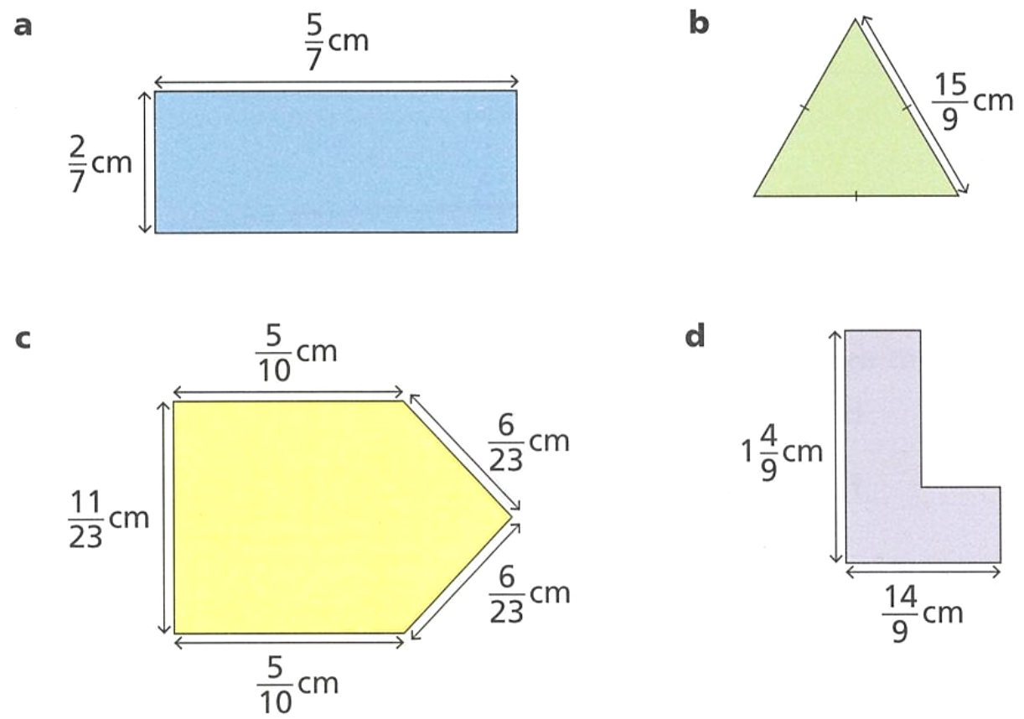  $$2 cm$$ | $$5 cm$$ | $$4 cm$$
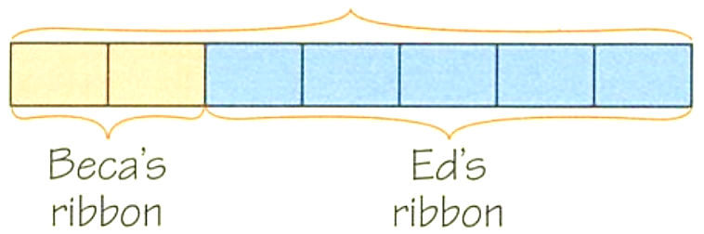
?
- Beca and Ed each have a piece of ribbon.
Beca’s ribbon is $\frac{2}{7}$ of a metre.
Ed’s ribbon is $\frac{5}{7}$ of a metre.
What is the total length of their ribbon?

1 m
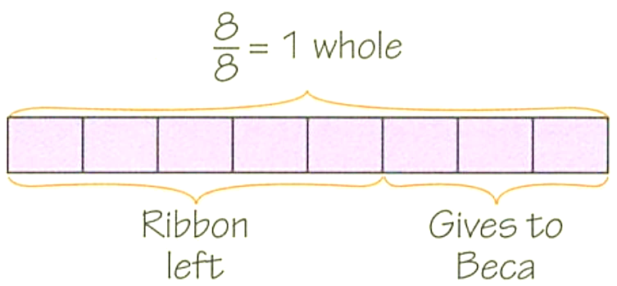
- Ed has a piece of ribbon that is a metre long.
He cuts off $\frac{3}{8}$ of a metre and gives it to Beca.
How much ribbon does he have left?

$$\frac{5}{8} m$$
- Emily and Marta each have a piece of ribbon.
Emily’s piece is $\frac{3}{11}$ of a metre and Marta’s piece is $\frac{2}{11}$ of a metre.
What fraction of a metre of ribbon do Emily and Marta have in total?

$$\frac{5}{11} m$$
- Ali is $\frac{4}{26}$ of his way through a journey. What fraction of the journey does he have left?

$$\frac{11}{13}$$
- Ed, Marta and Jakub are sharing a large pizza.
Ed eats $\frac{2}{9}$ of the pizza.
Marta eats $\frac{2}{9}$ of the pizza.
Jakub eats $\frac{4}{9}$ of the pizza.
What fraction of the whole pizza did they eat?
$$\frac{8}{9}$$
What fraction of the whole pizza is left?
$$\frac{1}{9}$$
- Ed eats $\frac{1}{9}$ of a cake. Flo eats $\frac{4}{9}$ of the same cake. What fraction of the cake is left?

$$\frac{4}{9}$$
- Consider this equation:
$$\frac{2}{w}+\frac{a}{w}=\frac{9}{w}$$
  - Work out the value of $a$
$$7$$
  - Explain why the value of $w$doesn’t matter.

All the denominators are the same, so we only add the numerators.
  - $w$ is a positive integer. For what values of $w$ is $\frac{9}{w}$ an improper fraction?

3, 6, 9
- Find the missing numbers.
- $\frac{1}{4}$ $+$ …… $=1$  $$\frac{3}{4}$$ | - $1=$ …… $+$ $\frac{3}{5}$  $$\frac{2}{5}$$ | - $\frac{8}{5}$ $-$ …… $=1$  $$\frac{3}{5}$$
- $1=$ …… $+$ $\frac{3}{5}$  $$\frac{2}{5}$$ | - $\frac{12}{19}$ $+$ …… $=1$  $$\frac{7}{19}$$ | - $1=$ …… $-$ $\frac{5}{7}$  $$\frac{12}{7}$$
- $\frac{2}{7}$ $+$ …… $=2$  $$\frac{12}{7}$$ | - $3=$ …… $+$ $\frac{5}{9}$  $$\frac{22}{9}$$ | - $\frac{14}{3}$ $-$ …… $=4$  $$\frac{2}{3}$$

- Find the missing integers.
2 | 1 | 3

Fraction Addition: Related Denominator

- Adding and Subtracting Fractions with Related Denominators
When working with fractions that have related denominators:
- Rewrite the fractions with the lowest common multiple of the denominators.
- Add or subtract the numerators.

- Example Add and subtract fractions with related denominators
$$\frac{1}{4}+\frac{3}{8}$$  $$=\frac{2}{8}+\frac{3}{8}$$  $$=\frac{5}{8}$$  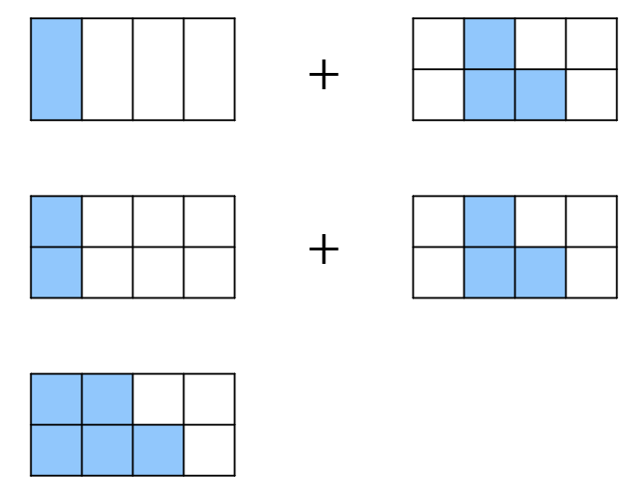 | $$\frac{5}{12} - \frac{1}{4}$$  $$=\frac{5}{12}-\frac{3}{12}$$  $$=\frac{2}{12}$$  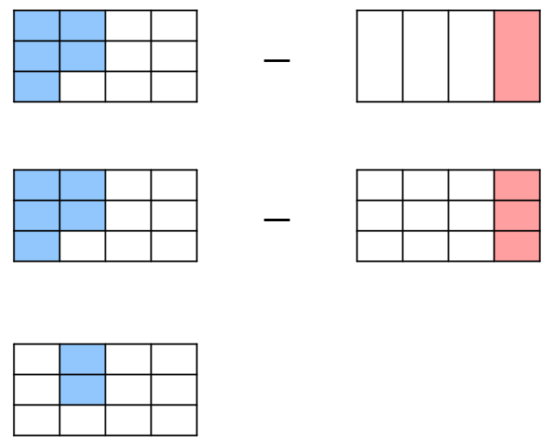

- Guided Practice
Add and subtract these fractions.
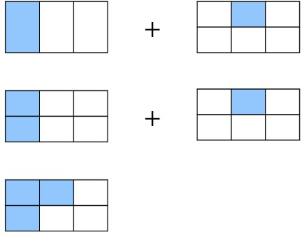  $$\frac{1}{3} +\frac{1}{6}$$  $$=\frac{ }{6}+\frac{1}{6}$$  $$=$$ | 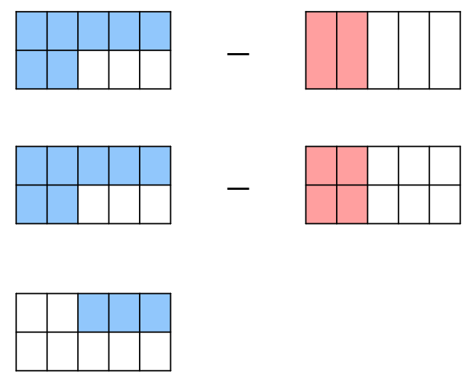  $$\frac{7}{10}- \frac{2}{5}$$  $$=\frac{7}{10}-\frac{ }{10}$$  $$=$$
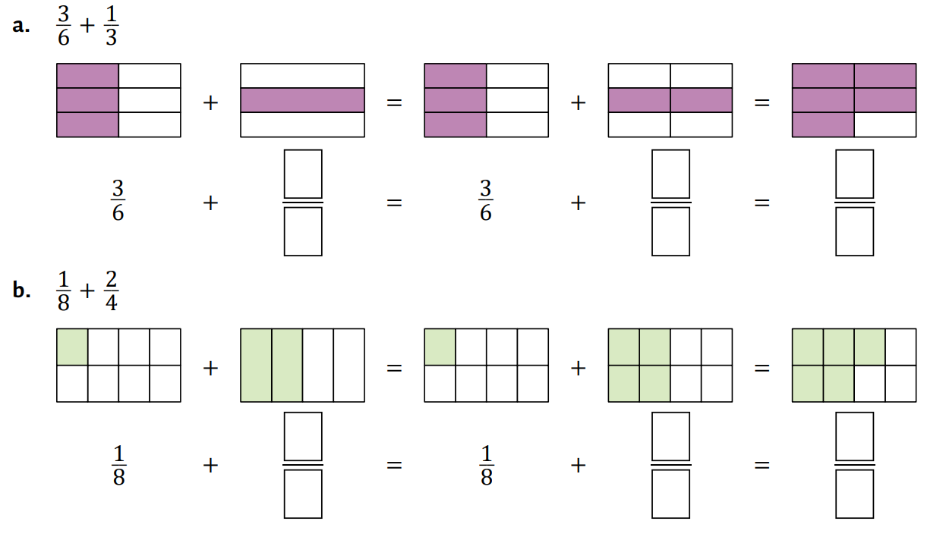  $$\frac{3}{6} +\frac{1}{3}$$  $$=\frac{ }{ }+\frac{ }{ }$$  $$=$$ | 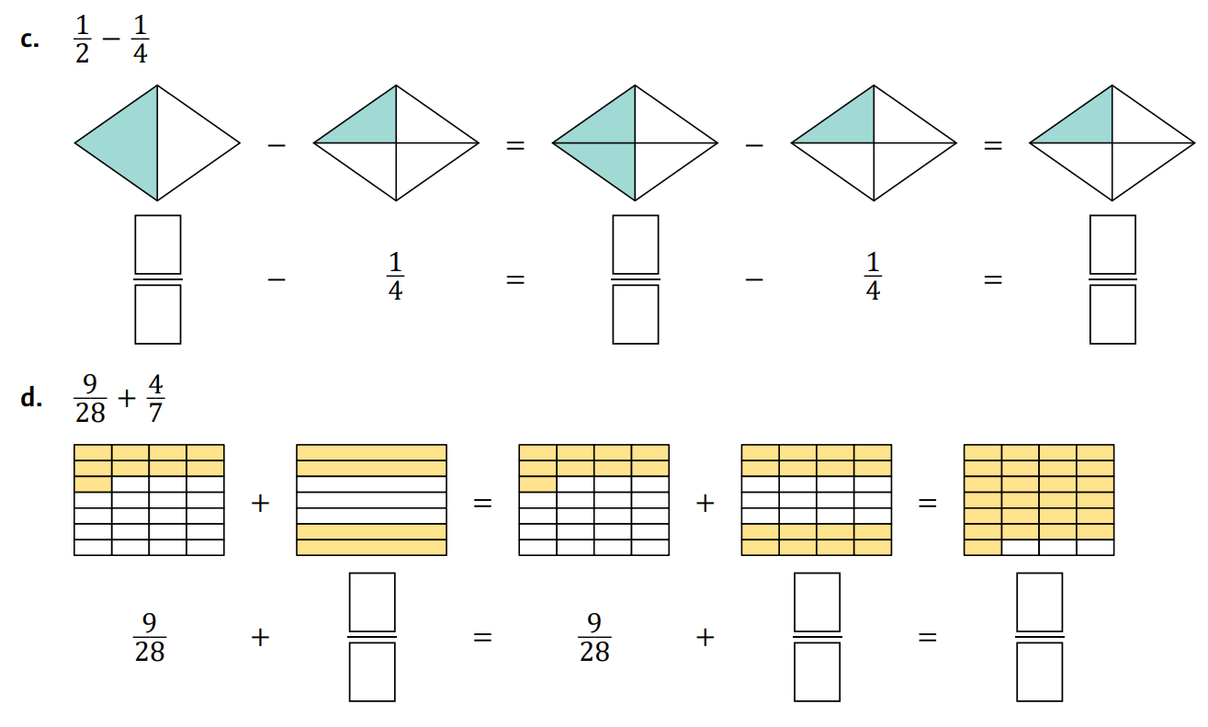  $$\frac{1}{2}- \frac{1}{4}$$  $$=\frac{ }{ }-\frac{ }{ }$$  $$=$$

- Example Add and subtract fractions with related denominators
$$\frac{1}{5} + \frac{3}{10}$$  1. Same denominators $\frac{2}{10}$ $+$ $\frac{3}{10}$  2. Add numerators $\frac{5}{10}$ | To add and subtract fractions, the …………………… must be the same.  We make the denominators the l…………… c………………… m………………… by multiplying the numerator and denominator by the …………………… number.
$$\frac{9}{12} - \frac{5}{6}$$
1. Same denominators $\frac{9}{12}$ $-$ $\frac{10}{12}$
2. Subtract numerators $-$ $\frac{1}{12}$

- Guided Practice
Add and subtract these fractions.
$$\frac{2}{3}+\frac{1}{9}$$  $$=\frac{ }{9}+\frac{1}{9}$$  $$=\frac{ }{9}$$ | $$\frac{17}{20}-\frac{3}{5}$$  $$=\frac{ }{20}-\frac{ }{20}$$  $$=$$
$$\frac{3}{4}+\frac{5}{12}$$  $$=\frac{ }{ }+\frac{ }{ }$$  $$=$$ | $$\frac{8}{6}-\frac{5}{36}$$  $$=$$  $$=$$

- Key Ideas
- To add and subtract fractions, their ……………………… must be the same.
- If two fractions don’t have the same denominator, we should change their denominators to a common …………………
- To change denominators of fractions, we …………………… the numerator and denominator by the same number.

Foundation
- Complete the table.
Question | Diagram | Rewritten Denominators | Answer
$$\frac{2}{5}+\frac{1}{2}$$ | 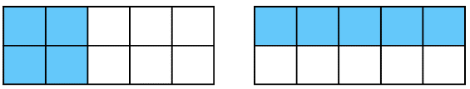 | $$\frac{4}{10}+\frac{5}{10}$$ | $$\frac{9}{10}$$
$$\frac{1}{2}+\frac{1}{3}$$ | 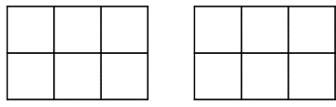 | $$\frac{3}{6}+\frac{2}{6}$$ | $$\frac{5}{6}$$
$$\frac{2}{3}+\frac{1}{6}$$ |  | $$\frac{4}{6}+\frac{1}{6}$$ | $$\frac{5}{6}$$
$$\frac{1}{3}+\frac{5}{12}$$ | 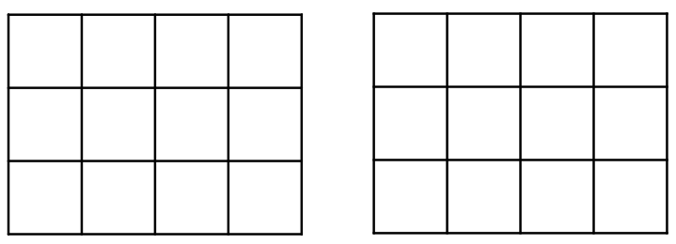 | $$\frac{4}{12}+\frac{5}{12}$$ | $$\frac{9}{12}=\frac{3}{4}$$
$$\frac{1}{4}+\frac{7}{12}$$ |  | $$\frac{3}{12}+\frac{7}{12}$$ | $$\frac{10}{12}=\frac{5}{6}$$
$$\frac{2}{3}+\frac{1}{4}$$ | 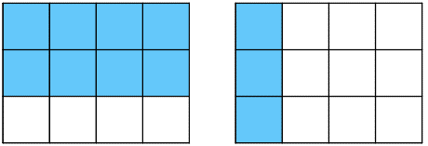 | $$\frac{8}{12}+\frac{3}{12}$$ | $$\frac{11}{12}$$
$$\frac{1}{3}+\frac{2}{15}$$ | 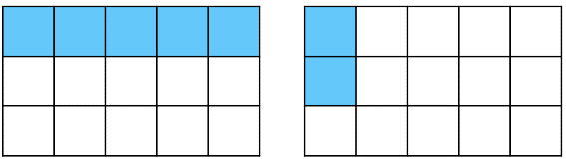 | $$\frac{5}{15}+\frac{2}{15}$$ | $$\frac{7}{15}$$
$$\frac{2}{3}+\frac{2}{5}$$ | 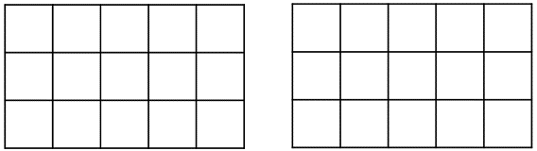 | $$\frac{10}{15}+\frac{6}{15}$$ | $$\frac{16}{15}$$

- Work out $\frac{7}{9}-\frac{1}{3}$  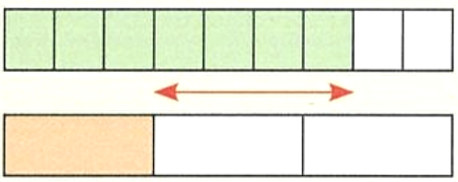  $$\frac{4}{9}$$ | 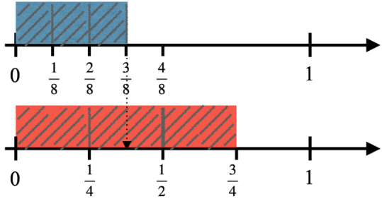  - How much more is $\frac{3}{4}$ than $\frac{3}{8}$?  $$\frac{3}{8}$$

- Add and subtract these fractions but rewriting them with the lowest common denominator.
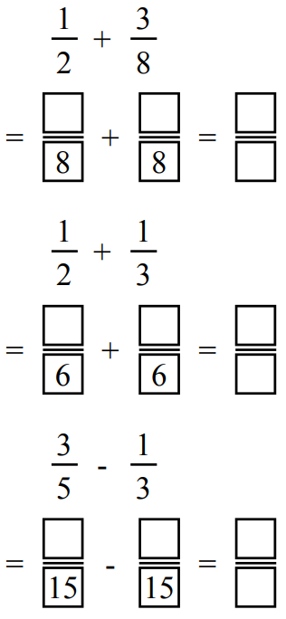  $$\frac{7}{8}$$ | $$\frac{5}{6}$$ | $$\frac{4}{15}$$
$$\frac{3}{14} + \frac{5}{7}$$  $$\frac{13}{14}$$ | $$\frac{2}{3} - \frac{4}{9}$$  $$\frac{2}{9}$$ | $$\frac{3}{16} + \frac{1}{8}$$  $$\frac{5}{16}$$

- Read the example carefully and answer the questions.
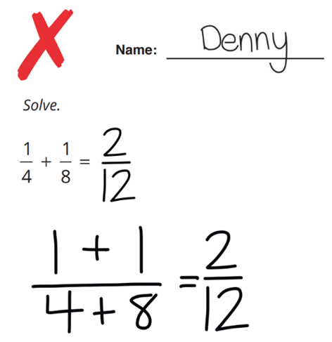 | 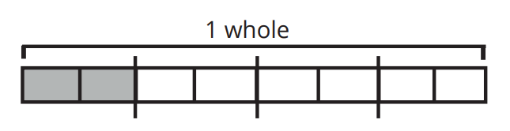  Add $\frac{1}{8}$ to $\frac{1}{4}$ represented on the diagram below by shading  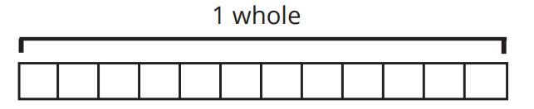  Shade $\frac{2}{12}$ on the diagram below  Compare the two diagrams to explain why  $\frac{1}{4}+\frac{1}{8}$ is not equal to $\frac{2}{12}$  Hence solve $\frac{6}{12}+\frac{2}{6}$  $$\frac{5}{6}$$
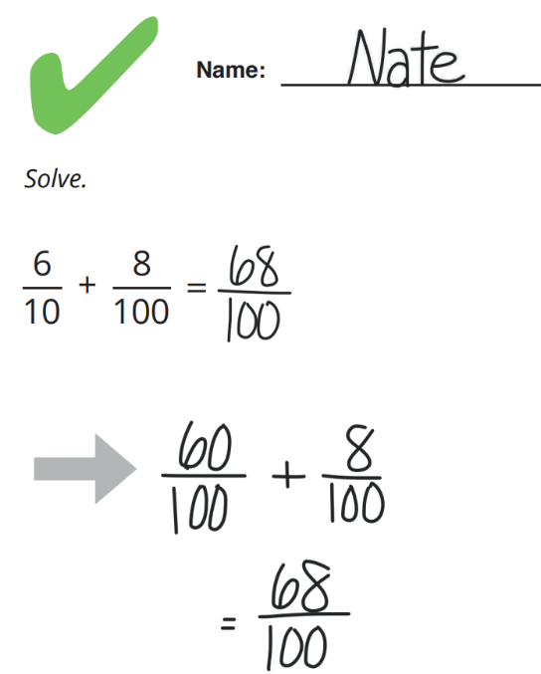 | Look at the step marked with an arrow. Why did Nate rewrite the first fraction as $\frac{60}{100}$?  The common …………… of 10 and 100 is ………  Denominator, 100  How do you know $\frac{6}{10}$ is equivalent to $\frac{60}{100}$?  We multiply the numerator and denominator by ………  10  Hence solve:  $$\frac{5}{10}+\frac{7}{100}$$  $$\frac{57}{10}$$
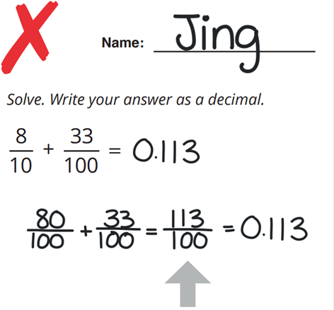 | Explain why Jing’s final answer, 0.113, is not equivalent to $\frac{113}{100}$  0.113 is less than one whole $\frac{113}{100}$ is more than one whole  In the step marked with an arrow, look at the values of the numerator and the denominator. How could Jing have known the answer should be greater than 1?  The numerator is greater than the denominator, so the decimal must be greater than one.  Solve. Write your answer as a decimal.  $$\frac{4}{10}+\frac{95}{100}$$  1.35

Development
- Add these fractions.
- $\frac{3}{5}+\frac{2}{5}$  $$1$$ | - $\frac{3}{5}-\frac{2}{5}$  $$\frac{1}{5}$$ | - $\frac{3}{5}+\frac{3}{5}+\frac{2}{15}$  $$\frac{4}{3}$$
- $\frac{7}{20}+\frac{5}{10}$  $$\frac{17}{20}$$ | - $\frac{7}{8}-\frac{3}{4}$  $$\frac{1}{8}$$ | - $\frac{5}{6}-\frac{1}{3}$  $$\frac{1}{2}$$
- $\frac{1}{4}+\frac{3}{8}$  $$\frac{5}{8}$$ | - $\frac{2}{5}+\frac{4}{15}$  $$\frac{2}{3}$$ | - $\frac{7}{10}-\frac{2}{5}$  $$\frac{3}{10}$$
- $\frac{11}{12}-\frac{1}{3}-\frac{1}{4}$  $$\frac{1}{3}$$ | - $\frac{1}{5}+\frac{3}{10}+\frac{2}{15}$  $$\frac{19}{30}$$ | - $\frac{1}{3}+\frac{5}{12}-\frac{1}{6}$  $$\frac{7}{12}$$

- Chloe eats $\frac{1}{10}$ of her birthday cake. She gives her friends $\frac{3}{5}$ of the cake.
She gives her family $\frac{3}{10}$ of the cake. Does Chloe have any cake left?

No cake left :(
- Beca has some football cards.
She gives $\frac{1}{8}$ of them to her friend Benji and $\frac{1}{2}$ of them to her friend Becky.
What fraction of the cards does Beca have left?

$$\frac{3}{8}$$

Mastery
- Marta has a chocolate bar. She eats $\frac{2}{3}$ of the chocolate bar and gives her friend $\frac{1}{6}$ of it.
  - What fraction of the chocolate bar is eaten?

$$\frac{5}{6}$$
  - What fraction of the chocolate bar is left?

$$\frac{1}{6}$$
- Jakub cycles $1$ $\frac{3}{4}$ km on Monday, and $2$ $\frac{1}{8}$ km on Tuesday. How far does he cycle in total?

$$\frac{31}{8}$$
- A barrel holds $12$ $\frac{1}{4}$ litres of water. A bucket holds $3$ $\frac{11}{12}$ litres of water.
Max fills up the bucket with water from the barrel. How much water is left in the barrel?

$$8\frac{1}{3}$$

Fraction Addition: Unrelated Denominators

- Adding and Subtracting Fractions with Unrelated Denominators
When working with fractions that have different denominators:
- Rewrite the fractions with the lowest common multiple of the denominators.
- Add or subtract the numerators.

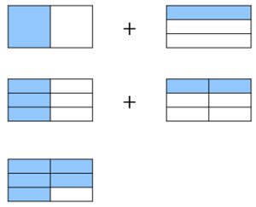
- Example Add and subtract fractions with unrelated denominators
$$\frac{4}{5} - \frac{1}{3}$$  $$=\frac{12}{15}-\frac{5}{15}$$  $$=\frac{7}{15}$$  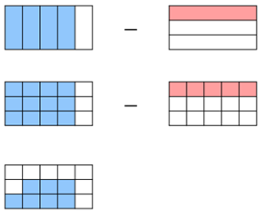 | $$\frac{1}{2}+\frac{1}{3}$$  $$=\frac{3}{6}+\frac{2}{6}$$  $$=\frac{5}{6}$$

- Guided Practice
Add and subtract these fractions.
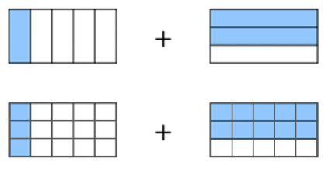  $$\frac{1}{5} +\frac{2}{3}$$  $$=\frac{}{15}+\frac{}{15}$$  $$=\frac{}{}$$ | 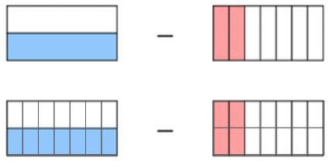  $$\frac{1}{2}- \frac{2}{7}$$  $$=\frac{}{14}-\frac{}{14}$$  $$=\frac{}{}$$
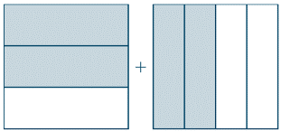  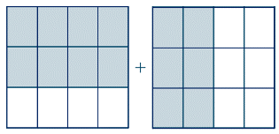  $$\frac{2}{3}+\frac{2}{4}$$  $$=\frac{}{}+\frac{}{}$$  $$=$$ | 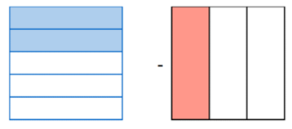  $$\frac{2}{5}-\frac{1}{3}$$  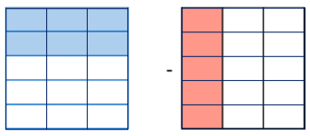  $$=\frac{}{}-\frac{}{}$$  $$=$$

- Example Add and subtract fractions with unrelated denominators
$$\frac{1}{5} + \frac{3}{4}$$  1. Same denominators $\frac{}{20}$ $+$ $\frac{}{20}$  $\frac{4}{20}$ $+$ $\frac{15}{20}$  2. Add numerators $\frac{19}{20}$ | $$\frac{9}{5} - \frac{5}{7}$$  1. Same denominators $\frac{}{35}$ $-$ $\frac{}{35}$  $\frac{63}{35}$ $-$ $\frac{25}{35}$  2. Subtract numerators $\frac{38}{35}$

- Guided Practice
Add and subtract these fractions.
$$\frac{1}{4} + \frac{1}{3}$$  $$=\frac{ }{12}+\frac{ }{12}$$  $$=\frac{ }{12}$$ | $$\frac{5}{4} - \frac{6}{7}$$  $$=\frac{ }{28}-\frac{ }{28}$$  $$=\frac{ }{28}$$ | $$\frac{3}{7} + \frac{2}{5}$$  $$=\frac{ }{ }+\frac{ }{ }$$  $$=$$ | $$\frac{7}{6} - \frac{2}{3}$$  $$=\frac{ }{ }-\frac{ }{ }$$  $$=$$

- Key Ideas
- To add or subtract fractions, the ………………… must be the same.
- To make the denominators the same, determine a ………………… ………………… of the two denominators.
- A quick way to make the denominators the same is to multiply the numerator and denominator of each fraction by the ………………… of the other.

Foundation
- Add and subtract these fractions using the visual models.
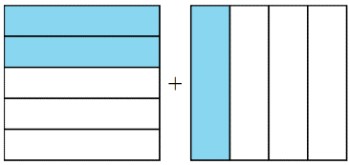  $$\frac{2}{5}+\frac{1}{4}$$  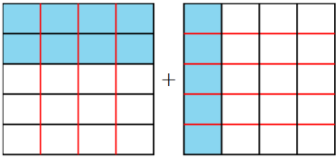  $$=\frac{}{20}+\frac{}{20}$$  $$=\frac{}{}$$  $$\frac{13}{20}$$ | 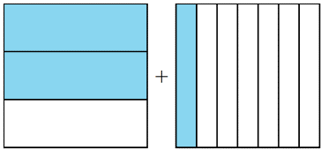  $$\frac{2}{3}+\frac{1}{7}$$  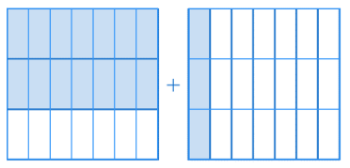  $$=\frac{}{21}+\frac{}{21}$$  $$=\frac{}{}$$  $$\frac{17}{21}$$
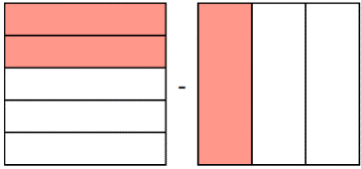  $$\frac{2}{5}-\frac{1}{3}$$  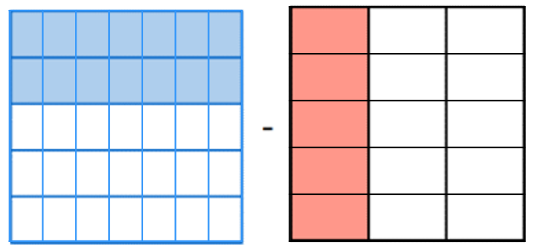  $$=\frac{}{}-\frac{}{}$$  $$=\frac{}{}$$  $$\frac{1}{15}$$ | 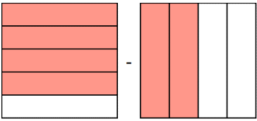  $$\frac{4}{5}-\frac{2}{4}$$  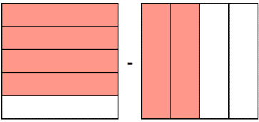  $$=\frac{}{}-\frac{}{}$$  $$=\frac{}{}$$  $$\frac{3}{10}$$
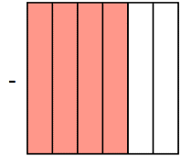  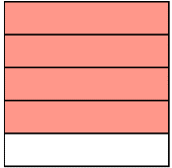  $$\frac{4}{5}-\frac{4}{6}$$  $$=\frac{}{}-\frac{}{}$$  $$=\frac{}{}$$  $$\frac{2}{15}$$ | 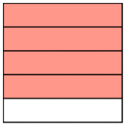  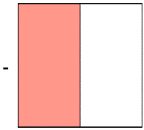  $$\frac{4}{5}-\frac{1}{2}$$  $$=\frac{}{}-\frac{}{}$$  $$=\frac{}{}$$  $$\frac{3}{10}$$

- Read Yetta’s work carefully and answer the questions.
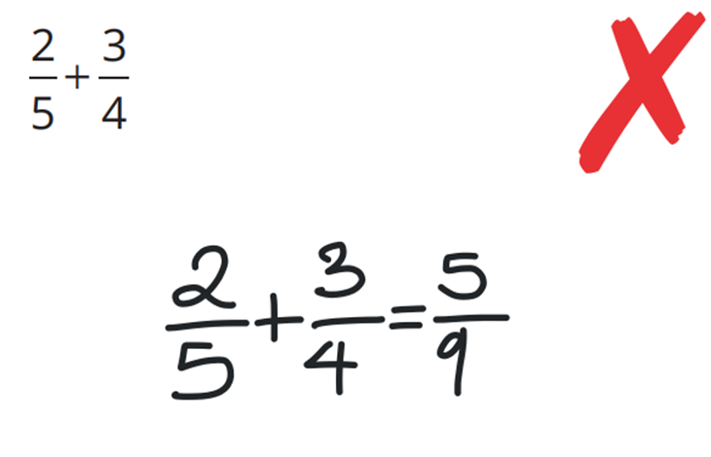 | What did Yetta do wrong while adding the fractions?  She added the numerator and denominator, which you can’t do.  You must make the denominators the same.  Is Yetta’s answer bigger or smaller than the correct answer? How can you tell?  Smaller. Five-ninths is less than three-quarters, the answer should be greater than three-quarters

- Add and subtract these fractions by first making the denominators the same.
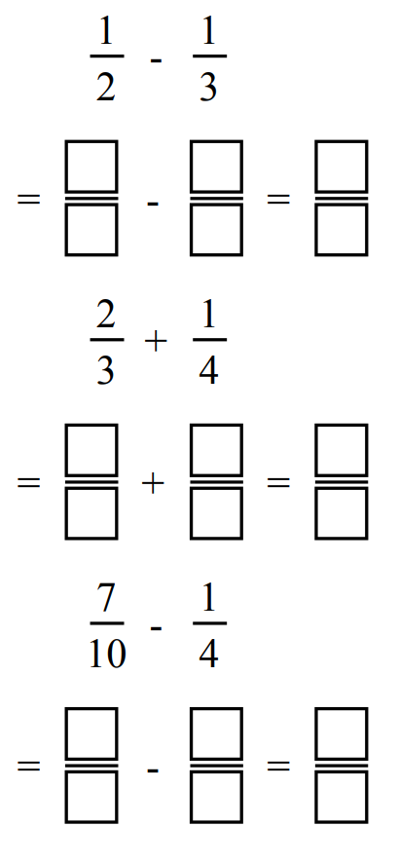  $$\frac{1}{6}$$ | $$\frac{11}{12}$$ | $$\frac{9}{20}$$
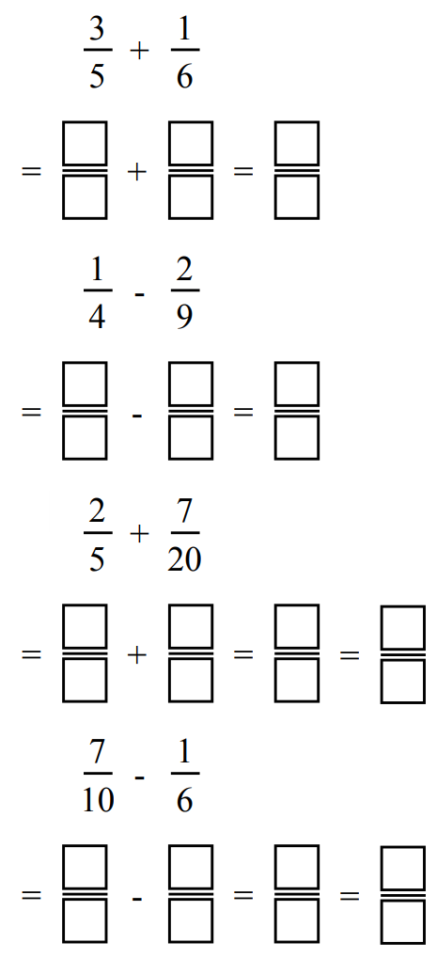  $$\frac{23}{30}$$ | $$\frac{1}{36}$$ | $$\frac{8}{15}$$
$$\frac{1}{4} + \frac{1}{3}$$  $$\frac{7}{12}$$ | $$\frac{2}{5} + \frac{1}{4}$$  $$\frac{13}{20}$$ | $$\frac{2}{7} + \frac{1}{3}$$  $$\frac{13}{21}$$
$$\frac{3}{8} + \frac{1}{5}$$  $$\frac{23}{40}$$ | $$\frac{3}{5} + \frac{5}{6}$$  $$\frac{43}{30}$$ | $$\frac{4}{7} + \frac{3}{4}$$  $$\frac{37}{28}$$
$$\frac{8}{11} + \frac{2}{3}$$  $$\frac{46}{33}$$ | $$\frac{2}{3} + \frac{3}{4}$$  $$\frac{17}{12}$$ | $$\frac{5}{12} + \frac{2}{5}$$  $$\frac{49}{60}$$

Development
- Add these fractions.
- $\frac{1}{7}+\frac{2}{5}$  $$\frac{19}{35}$$ | - $\frac{2}{5}+\frac{2}{3}$  $$\frac{16}{15}$$ | - $\frac{3}{4}+\frac{2}{5}$  $$\frac{23}{20}$$
- $\frac{2}{5}+\frac{1}{7}$  $$\frac{19}{35}$$ | - $\frac{1}{4}+\frac{2}{3}$  $$\frac{11}{12}$$ | - $\frac{3}{40}+\frac{2}{5}$  $$\frac{19}{40}$$
- $\frac{2}{5}+\frac{2}{7}$  $$\frac{24}{35}$$ | - $\frac{3}{4}+\frac{2}{3}$  $$\frac{17}{12}$$ | - $\frac{3}{40}+\frac{6}{10}$  $$\frac{27}{40}$$

- Subtract these fractions.
- $\frac{2}{5}-\frac{1}{7}$  $$\frac{9}{35}$$ | - $\frac{2}{3}-\frac{2}{5}$  $$\frac{4}{15}$$ | - $\frac{3}{4}-\frac{2}{3}$  $$\frac{1}{12}$$
- $\frac{1}{7}-\frac{2}{5}$  $$-\frac{9}{35}$$ | - $\frac{2}{3}-\frac{1}{4}$  $$\frac{5}{12}$$ | - $\frac{3}{4}-\frac{2}{30}$  $$\frac{41}{60}$$
- $\frac{2}{5}-\frac{2}{7}$  $$\frac{4}{35}$$ | - $\frac{2}{3}-\frac{3}{4}$  $$-\frac{1}{12}$$ | - $\frac{3}{4}-\frac{1}{15}$  $$\frac{41}{60}$$

- Add these fractions.
- $\frac{1}{8}+\frac{2}{8}$  $$\frac{3}{8}$$ | - $\frac{1}{4}+\frac{2}{5}$  $$\frac{13}{20}$$ | - $\frac{4}{9}+\frac{2}{5}$  $$\frac{38}{45}$$
- $\frac{1}{8}+\frac{4}{8}$  $$\frac{5}{8}$$ | - $\frac{1}{4}+\frac{3}{5}$  $$\frac{17}{20}$$ | - $\frac{4}{9}+\frac{2}{7}$  $$\frac{46}{63}$$
- $\frac{1}{8}+\frac{1}{2}$  $$\frac{5}{8}$$ | - $\frac{1}{9}+\frac{3}{5}$  $$\frac{32}{45}$$ | - $\frac{4}{9}+\frac{3}{7}$  $$\frac{55}{63}$$
- $\frac{1}{4}+\frac{1}{2}$  $$\frac{3}{4}$$ | - $\frac{1}{9}+\frac{2}{5}$  $$\frac{23}{45}$$ | - $\frac{3}{9}+\frac{3}{7}$  $$\frac{16}{21}$$
- $\frac{1}{4}+\frac{1}{3}$  $$\frac{7}{12}$$ | - $\frac{2}{9}+\frac{2}{5}$  $$\frac{28}{45}$$ | - $\frac{2}{9}+\frac{3}{7}$  $$\frac{41}{63}$$
- $\frac{1}{4}+\frac{1}{5}$  $$\frac{9}{20}$$ | - $\frac{3}{9}+\frac{2}{5}$  $$\frac{11}{15}$$ | - $\frac{x}{9}+\frac{3}{7}$  $$\frac{7x+27}{63}$$

- A survey of Year 7 students’ favourite sport is carried out.
One fifth reply that netball is their favourite, one-quarter rugby and one-third soccer.
The remainder of students leave the question unanswered.
  - What fraction of the Year 7 students answered the survey question?
$$\frac{47}{60}$$
  - What fraction of the Year 7 students left the question unanswered?
$$\frac{13}{60}$$

Mastery
- Seb reads $\frac{5}{36}$ of his book on Monday.
He reads $\frac{1}{9}$ of his book on Tuesday.
He reads $\frac{1}{6}$ of his book on Wednesday.
He reads the rest over the weekend.
How much of the book did he read over the weekend?

$$\frac{7}{12}$$
- Work out
$$\frac{3}{7}+\frac{4}{13}+\frac{5}{8}+\frac{9}{13}+\frac{4}{7}+\frac{1}{8}$$
Explain the most efficient method.

Do operators with fractions that have like numerators. The answer is $2$ $\frac{3}{4}$.

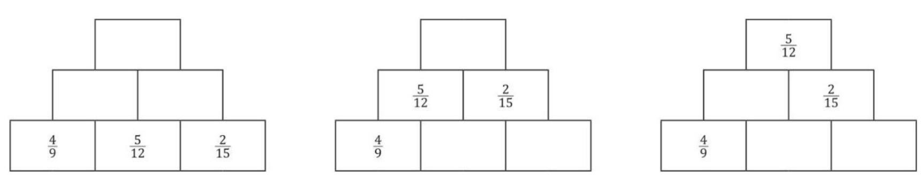
- Complete these expression pyramids. Each brick is the sum of the two below it.
$$\frac{16}{9}$$  $$\frac{31}{36},\frac{11}{20}$$ | $$\frac{11}{20}$$  $$-\frac{1}{36},\frac{29}{180}$$

- A runner covered $\frac{5}{9}$ of a marathon in 2 hours, then $\frac{1}{8}$ in half an hour.
What fraction of the course has he covered?

$$\frac{49}{72}$$
- A farmer sold $\frac{1}{3}$ of her cows then sent $\frac{2}{5}$ to another ranch for the winter.
What fraction of her herd is left?

$$\frac{4}{15}$$
- Two milk bottles are partially filled. Both milk bottles can hold 0.9 litres.
One bottle is $\frac{3}{8}$ full and the other is $\frac{5}{12}$ full.
Is it possible to combine the two partially filled bottles into a single bottle without overflowing?

$$\frac{3}{8}+\frac{5}{12}=\frac{19}{24}$$
Yes, they can fit into a single bottle
- There is a bag of sugar in a storage room. The bag contained $\frac{9}{10}$ kilograms of sugar.
The chef filled up a can with $\frac{1}{8}$ kilogram of sugar then used $\frac{3}{5}$ of a kilogram of sugar for cake. How much sugar was left in the bag?

$$\frac{7}{40}$$
- Find the missing denominators.
`15 | 7 | 4

- Fill in the empty boxes to make the equations correct.
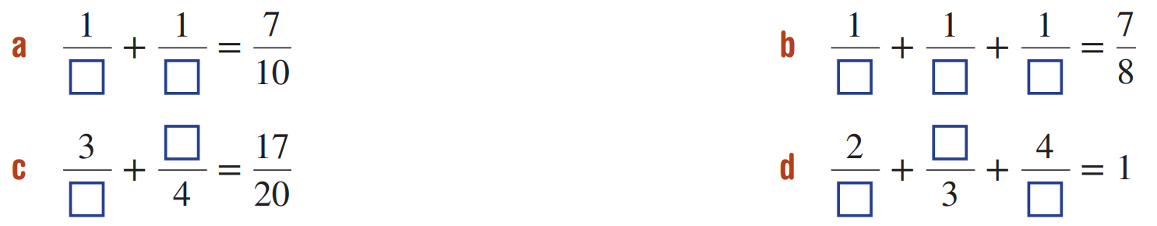  2, 5 | 2, 4, 8
5, 1 | 6, 1, 12

Fraction Addition: Mixed Numbers

- Adding and Subtracting Mixed Numbers
- Convert mixed numbers to improper fractions using the rule:
$$a\frac{b}{n}=\frac{a×n+b}{n}$$
- Make the denominators the same.
- Add or subtract the numerators.
- Simplify if possible.

- Example Add and subtract mixed numbers
$$4\frac{1}{5} +2\frac{3}{10}$$  1. Convert to improper $\frac{21}{5}$ $+$ $\frac{23}{10}$  2. Same denominators $\frac{42}{10}$ $+$ $\frac{23}{10}$  3. Add numerators $\frac{65}{10}$  4. Simplify $\frac{13}{2}$ $=6$ $\frac{1}{2}$ | $$3\frac{1}{4} -2\frac{1}{3}$$  1. Convert to improper $\frac{13}{4}$ $-$ $\frac{7}{3}$  2. Same denominators $\frac{39}{12}$ $-$ $\frac{28}{12}$  3. Subtract numerators $\frac{11}{12}$

- Guided Practice
Add and subtract these fractions.
$$2\frac{3}{4}+1\frac{2}{8}$$  $$=\frac{}{4} + \frac{}{8}$$  $$=\frac{}{8} + \frac{}{8}$$  $$=$$ | $$4\frac{1}{5}-2\frac{3}{4}$$  $$=\frac{}{5}- \frac{}{4}$$  $$=\frac{}{}- \frac{}{}$$  $$=$$ | $$3\frac{2}{5}-2\frac{3}{4}$$ | $$1\frac{2}{3}+6\frac{1}{2}$$

- Adding and Subtracting Mixed Numbers (Alternate Method)
- Split the mixed numbers to wholes and fractions. Keep the sign for subtraction.
- Sum the wholes and sum the fractions
- Simplify if possible.

- Example Add and subtract mixed numbers
$$4\frac{1}{5} +2\frac{3}{10}$$  1. Split $4+$ $\frac{1}{5}$ $+2+$ $\frac{3}{10}$  2. Sum separately $6+$ $\frac{2}{10}$ $+$ $\frac{3}{10}$  $6$ $\frac{5}{10}$  3. Simplify $6$ $\frac{1}{2}$ | $$150\frac{1}{4} -147\frac{1}{3}$$  1. Split $150+$ $\frac{1}{4}$ $-147-$ $\frac{1}{3}$  2. Sum separately $3+$ $\frac{3}{12}$ $-$ $\frac{4}{12}$  $3-$ $\frac{1}{12}$  $2$ $\frac{11}{12}$

- Guided Practice
Add and subtract these fractions
$$12\frac{1}{4}+15\frac{3}{7}$$ | $$18\frac{2}{3}-12\frac{1}{5}$$
$$2250\frac{3}{5}+700\frac{1}{25}$$ | $$950\frac{1}{2}-850\frac{2}{9}$$

Foundation
- Add and subtract these mixed numbers.
$$5\frac{5}{12}$$ | 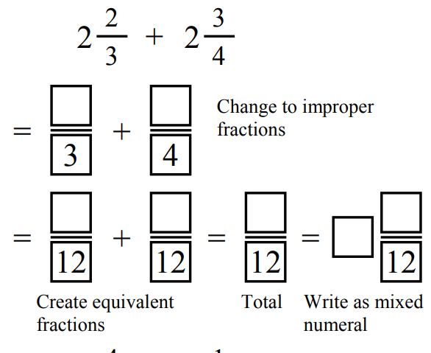  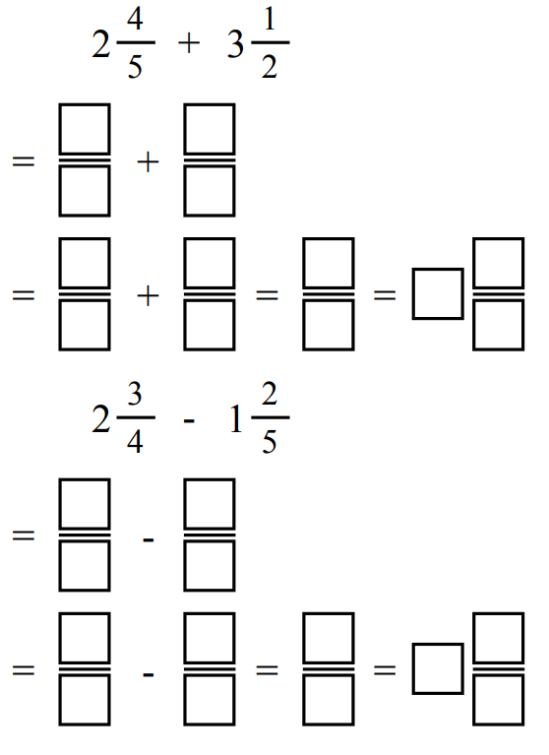  $$6\frac{3}{10}$$
$$1\frac{7}{20}$$ | 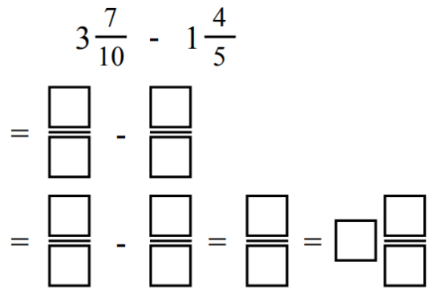  $$1\frac{9}{10}$$
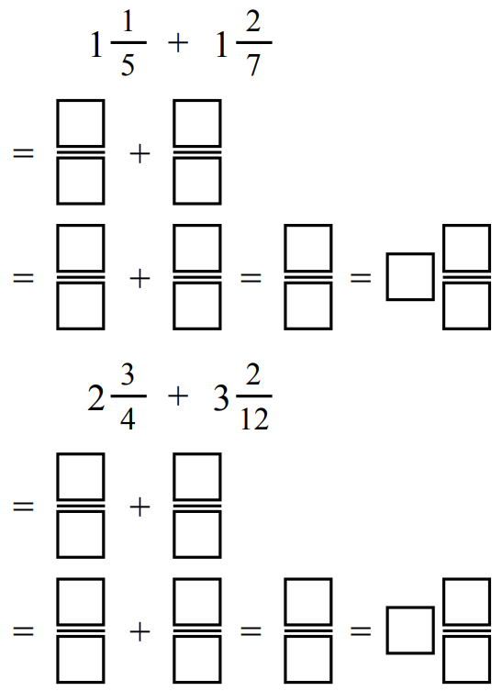  $$2\frac{17}{35}$$ | $$5\frac{11}{12}$$
- Add and subtract these fractions.
- $1$ $\frac{1}{2}$ $+$ $1$ $\frac{1}{3}$  $$2\frac{5}{6}$$ | - $2$ $\frac{1}{7}$ $+$ $1$ $\frac{1}{3}$  $$3\frac{10}{21}$$ | - $2$ $\frac{1}{2}$ $-$ $2$ $\frac{1}{4}$  $$\frac{1}{4}$$
- $1$ $\frac{1}{2}$ $+$ $1$ $\frac{1}{4}$  $$2\frac{3}{4}$$ | - $2$ $\frac{1}{7}$ $-$ $1$ $\frac{1}{3}$  $$\frac{17}{21}$$ | - $2$ $\frac{1}{4}$ $-$ $2$ $\frac{1}{2}$  $$-\frac{1}{4}$$
- $1$ $\frac{1}{2}$ $+$ $1$ $\frac{1}{5}$  $$2\frac{7}{10}$$ | - $2$ $\frac{1}{2}$ $-$ $1$ $\frac{1}{3}$  $$1\frac{1}{6}$$ | - $3$ $\frac{1}{5}$ $-$ $2$ $\frac{1}{2}$  $$\frac{7}{10}$$
- $2$ $\frac{1}{2}$ $+$ $1$ $\frac{1}{5}$  $$3\frac{7}{10}$$ | - $2$ $\frac{1}{2}$ $-$ $1$ $\frac{1}{4}$  $$1\frac{1}{4}$$ | - $3$ $\frac{1}{5}$ $+$ $2$ $\frac{1}{2}$  $$5\frac{7}{10}$$

  - Work out $1\frac{1}{6}+3\frac{3}{4}$ by converting each mixed number into an improper fraction.
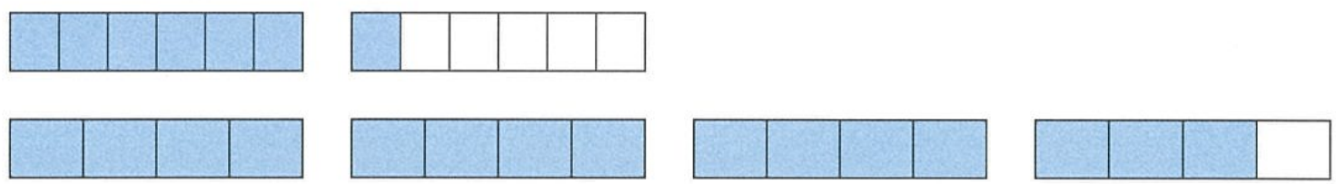
$$1\frac{1}{6}+3\frac{3}{4}$$
$$=\frac{7}{6}+\frac{15}{4}$$
$$=\frac{14}{12}+\frac{45}{12}$$
$$=\frac{59}{12}$$
$$=4\frac{11}{12}$$
  - Work out $1\frac{1}{6}+3\frac{3}{4}$ by first adding the wholes and then adding the fractions.
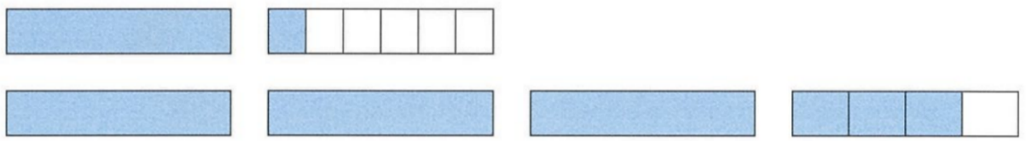
$$1+3+\frac{1}{6}+\frac{3}{4}$$
$$=4+\frac{2}{12}+\frac{9}{12}$$
$$=4\frac{11}{12}$$

  - Which method do you prefer?
The second method is a bit easier as you work with smaller numbers.

- It is also possible to subtract fractions by subtracting the wholes, subtracting the parts.
Worked Example | Your Turn
$$5\frac{2}{10}-4\frac{3}{10}$$  $$=5+\frac{2}{10}-4-\frac{3}{10}$$  $$=1+\frac{2}{10}-\frac{3}{10}$$  $$=1-\frac{1}{10}$$  $$=\frac{9}{10}$$ | $$4\frac{1}{5}-2\frac{3}{5}$$  $$\frac{8}{5}$$

Development
- Use your preferred method to answer these questions.
$$2\frac{1}{3}+2\frac{1}{4}$$  $$4\frac{7}{12}$$ | $$3\frac{2}{7}+1\frac{2}{5}$$  $$4\frac{24}{35}$$ | $$4\frac{7}{9}+3\frac{2}{3}$$  $$8\frac{4}{9}$$
$$1\frac{5}{6}-\frac{1}{3}$$  $$1\frac{1}{2}$$ | $$3\frac{7}{12}-1\frac{3}{8}$$  $$2\frac{5}{24}$$ | $$2\frac{4}{5}-2\frac{7}{9}$$  $$\frac{1}{45}$$
$$4\frac{1}{5}+2\frac{3}{10}$$  $$6\frac{1}{2}$$ | $$3\frac{1}{5}+1\frac{7}{15}$$  $$4\frac{2}{3}$$ | $$5\frac{1}{10}+6\frac{7}{15}$$  $$11\frac{17}{30}$$
$$12\frac{3}{10}+23\frac{7}{15}$$  $$35\frac{23}{30}$$ | $$9\frac{3}{4}+10\frac{5}{6}$$  $$20\frac{7}{12}$$ | $$4\frac{2}{3}+2\frac{3}{5}$$  $$7\frac{4}{15}$$
$$5\frac{3}{10}-3\frac{1}{5}$$  $$2\frac{1}{10}$$ | $$6\frac{7}{15}-1\frac{1}{5}$$  $$5\frac{4}{15}$$ | $$3\frac{7}{15}-2\frac{1}{10}$$  $$1\frac{11}{30}$$

- Work out the perimeter of each shape.
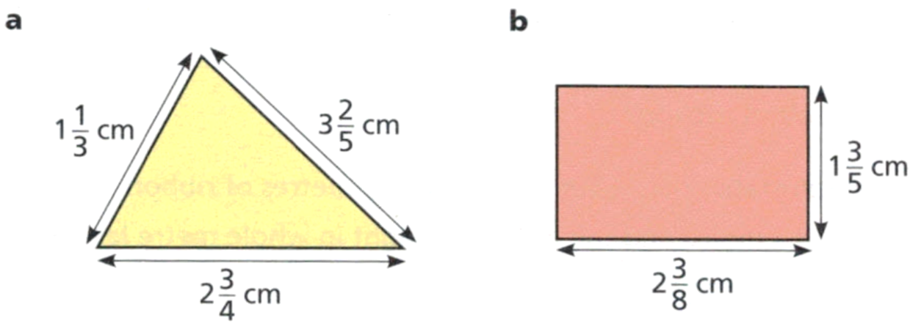  $$7\frac{29}{60}$$ | $$7\frac{19}{20}$$

- Martine ran for $2\frac{1}{4}$ kilometres, walked for $5\frac{2}{5}$ kilometres, and skipped for $\frac{1}{2}$ a kilometre.
What was the total distance that Martine ran, walked, and skipped?

$$8\frac{3}{20}$$
- Ed is calculating $3$ $\frac{2}{5}$ $-1$ $\frac{7}{8}$
He says: First I’ll subtract the wholes, then I’ll subtract the fractions.
  - Complete the subtraction using Ed’s method.

$$1\frac{21}{40}$$
  - Check your answer by redoing the question using the improper fractions method.

- Alexis runs part of a journey then walks the rest. She runs $4$ $\frac{6}{7}$ km then walks for $2$ $\frac{3}{4}$ km.
  - How far is the journey altogether?

$$7\frac{17}{28}$$
  - How much further does she run than walk?

$$2\frac{3}{28}$$

Mastery
- Find the missing numbers to make the equations true.
4, 3 | 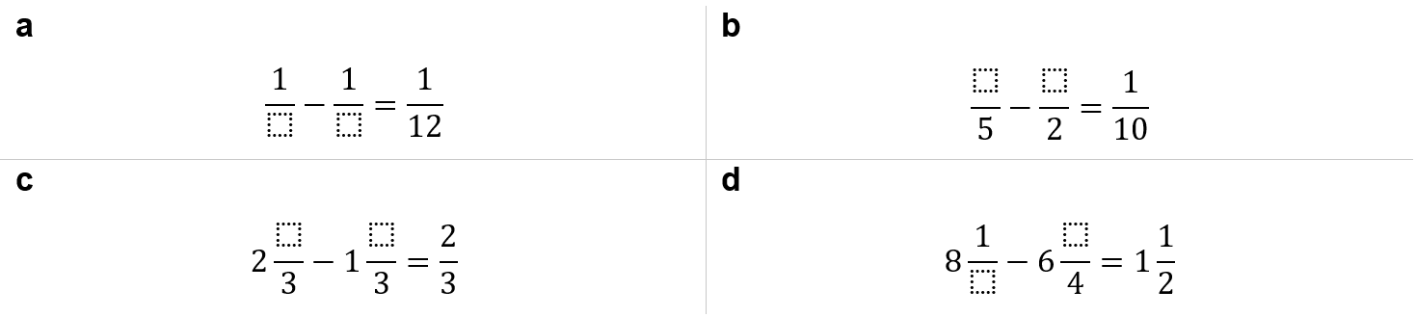  3, 1
1, 2 | 4, 3

- Fill in the diagram. Start from the centre and work outwards.
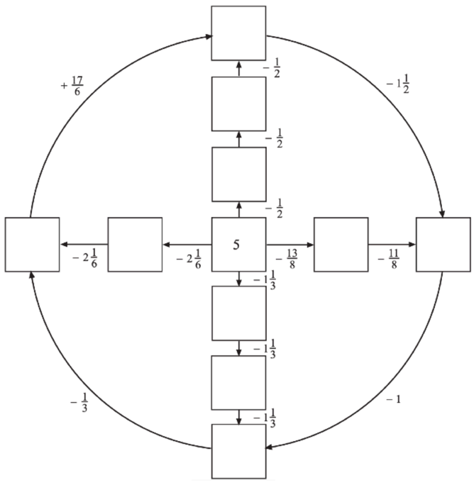
$$3\frac{1}{2}$$

$$4$$

$$4\frac{1}{2}$$

$$\frac{2}{3}, 2\frac{5}{6}, 3\frac{3}{8}, 2$$

$$3\frac{2}{3}$$

$$2\frac{1}{3}$$

$$1$$

- Consider the number line below.
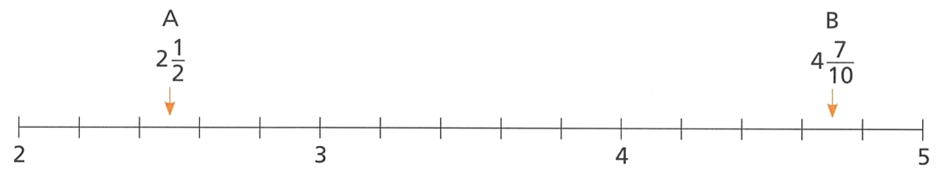

  - $C$ lies halfway between $A$ and $B$. Determine the value of $C$.
$$3\frac{3}{5}$$
  - $B$ lies halfway between $A$ and $C$. Determine the value of $B$.
$$6\frac{9}{10}$$
- Calculate the following:
$$1-\frac{11}{12}$$  $$\frac{1}{12}$$ | $$\frac{11}{12}-1$$  $$-\frac{1}{12}$$ | $$-1+\frac{11}{12}$$  $$-\frac{1}{12}$$ | $$\frac{11}{12}-(-1)$$  $$\frac{23}{12}$$
$$2-\frac{7}{5}$$  $$\frac{3}{5}$$ | $$\frac{7}{5}-2$$  $$-\frac{3}{5}$$ | $$-2-\frac{7}{5}$$  $$-\frac{17}{5}$$ | $$-2+\frac{7}{5}$$  $$-\frac{3}{5}$$
$$5-\frac{17}{5}$$  $$\frac{8}{5}$$ | $$\frac{17}{9}-5$$  $$-\frac{28}{9}$$ | $$-5-\frac{17}{9}$$  $$-\frac{62}{9}$$ | $$-\frac{17}{9}-5$$  $$-\frac{62}{9}$$
$$-\frac{6}{7}+\frac{2}{7}$$  $$-\frac{4}{7}$$ | $$-\frac{5}{9}-\frac{2}{9}$$  $$-\frac{7}{9}$$ | $$\frac{1}{3}+\left(-\frac{2}{3}\right)$$  $$-\frac{2}{3}$$ | $$\frac{1}{4}-\left(-\frac{5}{4}\right)$$  $$\frac{3}{2}$$
$$\frac{1}{4}+\left(-\frac{1}{3}\right)$$  $$-\frac{1}{12}$$ | $$\frac{1}{2}-\left(-\frac{3}{5}\right)$$  $$\frac{11}{10}$$ | $$-\frac{3}{2}-\left(-\frac{5}{4}\right)$$  $$-\frac{1}{4}$$ | $$-\frac{7}{5}-\left(-1\frac{1}{4}\right)$$  $$-\frac{3}{20}$$
$$\frac{13}{5}-\left(-\frac{17}{5}\right)$$  $$6$$ | $$-\frac{7}{13}+\left(-4\frac{2}{3}\right)$$  $$-\frac{203}{39}$$ | $$-\frac{8}{3}-\left(-2\frac{2}{5}\right)$$  $$-\frac{4}{15}$$ | $$-\frac{3}{2}-\left(-\frac{5}{2}\right)$$  $$1$$

Mixed Practice

Development
- Work out the following, using your knowledge of FDP conversions. Answer as a decimal.
$$7.36+\frac{17}{10}$$  9.06 | $$7.36+\frac{17}{100}$$  7.53 | $$7.36+\frac{17}{1000}$$  7.377 | $$7.36+\frac{17}{10 000}$$  7.3617
$$6.72-\frac{8}{10}$$  5.92 | $$6.72-\frac{8}{100}$$  6.64 | $$6.72-\frac{3}{5}$$  6.12 | $$6.72-\frac{3}{4}$$  5.97

- Work out the following. Answer as a mixed numeral.
$$1-\frac{11}{12}$$  $$\frac{1}{12}$$ | $$\frac{11}{12}-1$$  $$-\frac{1}{12}$$ | $$-1+\frac{11}{12}$$  $$-\frac{1}{12}$$ | $$\frac{11}{12}-(-1)$$  $$1\frac{11}{12}$$
$$2-\frac{7}{5}$$  $$\frac{3}{5}$$ | $$\frac{7}{5}-2$$  $$-\frac{3}{5}$$ | $$-2+\frac{7}{5}$$  $$-\frac{3}{5}$$ | $$-2-\left(-\frac{7}{5}\right)$$  $$-\frac{3}{5}$$
$$5-\frac{17}{9}$$  $$3\frac{1}{9}$$ | $$\frac{17}{9}-5$$  $$-3\frac{1}{9}$$ | $$-5-\frac{17}{9}$$  $$-6\frac{8}{9}$$ | $$-\frac{17}{9}-5$$  $$-6\frac{8}{9}$$
- All of these shapes have perimeter 50 cm. Find the lengths of the missing sides.
All lengths are given in centimetres.
14 cm | 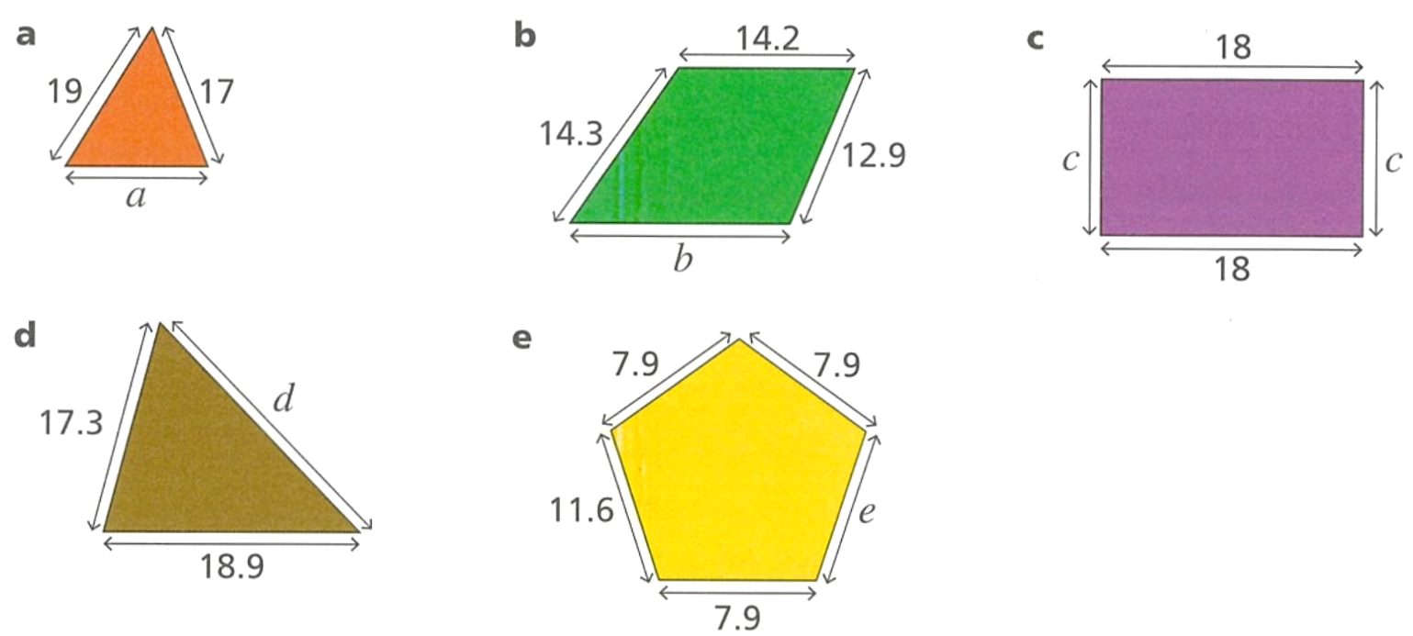  8.6 cm | 7 cm
13.8 cm | 14.7 cm

- A jug contains 2$\frac{1}{2}$ litres of juice. Marta pours herself 0.75 of a litre of juice from the jug.
Ed pours himself $\frac{2}{5}$ of a litre of juice from the jug. How much juice is left in the jug, as a decimal?

1.35 L
- Use the fact that $4+9=13$ to work out the following as decimals.
- $400+900$  1300 | - $0.4+0.9$  1.3 | - $\frac{9}{100}$ $+0.04$  0.13 | - $\frac{9}{10}$ $+0.4$  1.3

- Calculate the following, answer as a decimal.
- $6.72+$ $\frac{8}{100}$  6.8 | - $6.72+$ $\frac{8}{10}$  7.52 | - $6.72+8$  14.72 | - $6.72+$ $\frac{3}{4}$  7.47
- Add these numbers. Answer as a simplified fraction.
$$\frac{4}{10}+\frac{3}{10}$$  0.7 | $$\frac{40}{100}-\frac{3}{100}$$  0.37 | $1-$ $\left(\frac{7}{10}+\frac{3}{100}\right)$  0.27
$$0.4+\frac{3}{10}$$  0.7 | $$\frac{40}{100}-0.33$$  0.07 | $$1-\frac{7}{10}+\frac{3}{100}$$  0.33
$$0.4+\frac{30}{100}$$  0.7 | $$\frac{4}{10}-\frac{33}{100}$$  0.07 | $$0.76-0.3+\frac{4}{100}$$  0.5
$$0.4+\frac{3}{100}$$  0.43 | $$0.44+\frac{7}{100}+\frac{3}{10}$$  0.81 | $$0.76-\left(0.4+\frac{3}{10}\right)$$  0.06
$$0.04+\frac{3}{100}$$  0.07 | $$0.44+\frac{7}{10}+\frac{3}{100}$$  1.17 | $$0.76-\left(0.49+\frac{3}{10}\right)$$  $$-0.03$$
$$0.04-\frac{3}{100}$$  0.01 | $$1-\frac{7}{10}-\frac{3}{100}$$  0.27 | $$0.49-\left(0.76+\frac{3}{10}\right)$$  $$-0.57$$

Mastery
- Rectangles A and B have the same perimeter. Find the missing length.
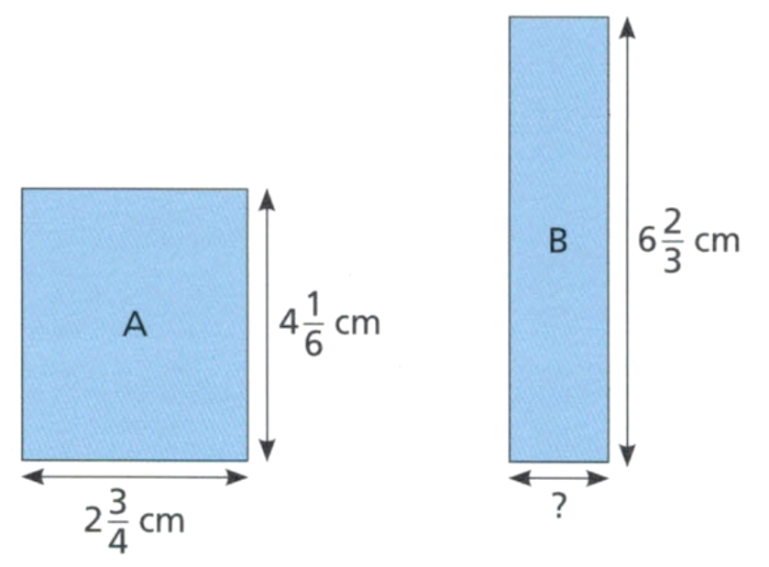

$$P_{A}=2\left(2\frac{3}{4}+4\frac{1}{6}\right)=13\frac{5}{6}$$
$$P_{B}=2x+2\left(6\frac{2}{3}\right)=2x+13\frac{1}{3}$$
$$2x=\frac{1}{2} cm$$
$$x=\frac{1}{4} cm$$
- Find the missing numbers.
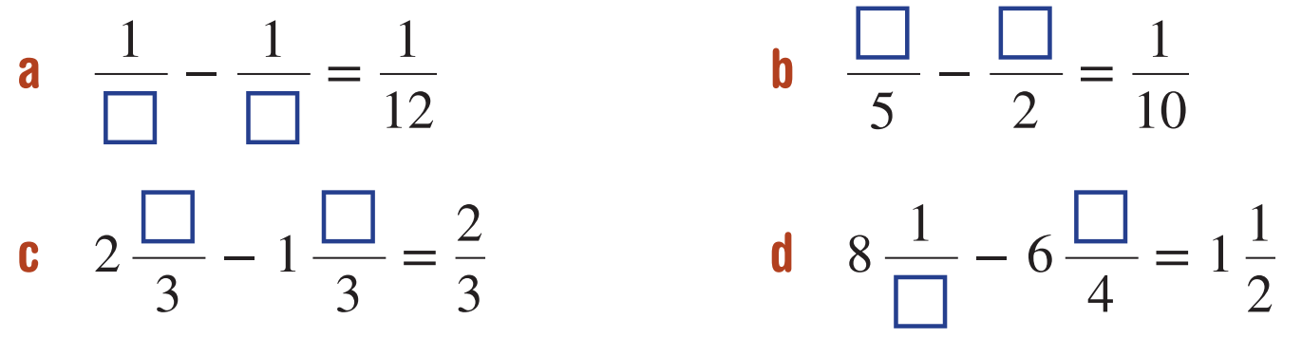  $$3, 4$$ | $$3, 1$$
$$1, 2$$ | $$4, 3$$

- Fill in the missing numbers to make the calculation true.
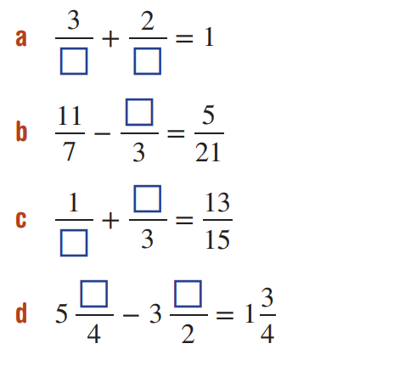  $$5, 5$$ | 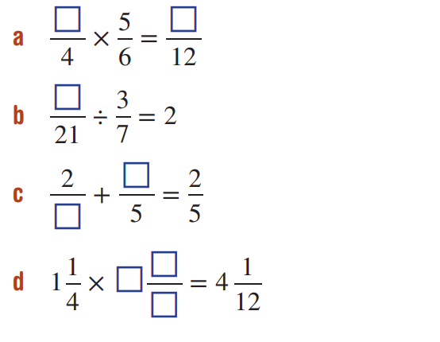  $$2, 5$$
$$4$$ | $$18$$
$$5, 2$$ | $$10, 1$$
$$1, 1$$ | $$3\frac{4}{5}$$

Multiplying and Dividing by Rational Numbers

- Multiplying by Rational Numbers
When you multiply a number by:
- A number less than 1, your answer is smaller than your starting number.
- The number 1, your answer equals your starting number.
- A number greater than 1, your answer is larger than your starting number.

- Identify the effect of multiplying by a rational number
$$×3$$  Result is larger | $$×0.3$$  Result is smaller |  | $$×\frac{1}{3}$$  Result is smaller |  | $$×3.3$$  Result is larger
Decide whether the results of these multiplications will be larger or smaller than the original
$$×10$$  Result is:  - Smaller  - Larger  - Same |  | $$×\frac{1}{10}$$  Result is:  - Smaller  - Larger  - Same |  | $$×\frac{11}{10}$$  Result is:  - Smaller  - Larger  - Same
$$×\frac{10}{10}$$  Result is:  - Smaller  - Larger  - Same |  | $$×0.10$$  Result is:  - Smaller  - Larger  - Same |  | $$×1.11$$  Result is:  - Smaller  - Larger  - Same

- Dividing by Rational Numbers
When you divide a number by:
- A number less than 1, your answer is larger than your starting number.
- The number 1, your answer equals your starting number.
- A number greater than 1, your answer is smaller than your starting number.

- Identify the effect of dividing by a rational number
$$÷3$$  Result is smaller | $$÷0.3$$  Result is larger |  | $$÷\frac{1}{3}$$  Result is larger |  | $$÷3.3$$  Result is smaller
Decide whether the results of these divisions will be larger or smaller than the original
$$÷7$$  Result is:  - Smaller  - Larger  - Same |  | $$÷\frac{1}{7}$$  Result is:  - Smaller  - Larger  - Same |  | $$÷\frac{6}{7}$$  Result is:  - Smaller  - Larger  - Same
$$÷\frac{8}{7}$$  Result is:  - Smaller  - Larger  - Same |  | $$÷0.87$$  Result is:  - Smaller  - Larger  - Same |  | $$÷\frac{8}{8}$$  Result is:  - Smaller  - Larger  - Same

Foundation
- Using a calculator, or mentally, complete the table.
Original number | Multiplier | Product | Smaller, equal, or larger compared to original?
12 | $$×0.5$$ | = 6 | smaller equal larger  smaller
7 | $$×1$$ | = | smaller equal larger  equal
15 | $$×1.5$$ | = | smaller equal larger  larger
$$20$$ | $$×0.2$$ | = | smaller equal larger  smaller
10 | $$×2.5$$ | = | smaller equal larger  larger
5 | $$×0.2$$ | = | smaller equal larger  smaller
40 | $$×0.9$$ | = | smaller equal larger  smaller
6 | $$×1.1$$ | = | smaller equal larger  larger
12 | $$×\frac{1}{3}$$ | = | smaller equal larger  smaller
20 | $$×\frac{3}{4}$$ | = | smaller equal larger  smaller
40 | $$×\frac{8}{8}$$ | = | smaller equal larger  equal
6 | $$×\frac{5}{4}$$ | = | smaller equal larger  larger
15 | $$×\frac{11}{5}$$ | = | smaller equal larger  larger
16 | $$×\frac{13}{13}$$ | = | smaller equal larger  equal

- Complete these sentences:
Word bank (reusing allowed): less, greater, smaller, equal, proper, improper, one

When we multiply numbers, the result depends on the multiplier involved.
If we multiply a number by a number that is ………………… than 1, such as a ……………… fraction like $\frac{3}{4}$ or a decimal like 0.8, the product will always be ………………… than the original number.
smaller, proper, smaller
If we multiply a number by a factor ………………… than 1, such as an ………………… fraction like $\frac{5}{4}$ or a whole number greater than 1, the product will always be ………………… than the original number.
greater, improper, greater
When we multiply a number by exactly ………………… the product is ………………… to the original number. This is true whether we express 1 as a whole number, a fraction like $\frac{5}{5}$, or a decimal like 1.00.
one, equal
- Predict whether the product will be smaller than, equal to, or larger than the original.
Multiplier | Smaller, equal, or larger compared to original?
$$×0.99$$ | smaller equal larger  smaller
$$×1.01$$ | smaller equal larger  larger
$$×1.0$$ | smaller equal larger  equal
$$×2.35$$ | smaller equal larger  larger
$$×0.82$$ | smaller equal larger  smaller
$$×\frac{89}{100}$$ | smaller equal larger  smaller
$$×\frac{7}{4}$$ | smaller equal larger  larger
$$×\frac{19}{19}$$ | smaller equal larger  equal
$$×\frac{3}{2}$$ | smaller equal larger  larger
$$×\frac{5}{6}$$ | smaller equal larger  smaller

- Using a calculator, or mentally, complete the table.
Original number | Divisor | Quotient | Smaller, equal, or larger compared to original?
6 | $$÷0.5$$ | = 12 | smaller equal larger  larger
7 | $$÷1$$ | = | smaller equal larger  equal
15 | $$÷1.5$$ | = | smaller equal larger  smaller
$$4$$ | $$÷0.2$$ | = | smaller equal larger  larger
25 | $$÷2.5$$ | = | smaller equal larger  smaller
2 | $$÷0.2$$ | = | smaller equal larger  larger
36 | $$÷0.9$$ | = | smaller equal larger  larger
6.6 | $$÷1.1$$ | = | smaller equal larger  smaller
8 | $$÷\frac{2}{3}$$ | = | smaller equal larger  larger
15 | $$÷\frac{3}{4}$$ | = | smaller equal larger  larger
30 | $$÷\frac{4}{4}$$ | = | smaller equal larger  equal
9 | $$÷\frac{5}{4}$$ | = | smaller equal larger  smaller
16 | $$÷\frac{11}{8}$$ | = | smaller equal larger  smaller
13 | $$÷\frac{2}{2}$$ | = | smaller equal larger  equal

- Complete these sentences:
Word bank: less, greater, smaller, equal, proper, improper, one, opposite

When we divide numbers, the result depends on the divisor involved.
If we divide a number by a number that is ……………… than 1, such as a ……………… fraction like $\frac{3}{4}$ or a decimal like 0.8, the quotient will always be ……………… than the original number.
Smaller, proper, greater
If we divide a number by a number ……………… than 1, such as an ……………… fraction like
$\frac{5}{4}$ or a whole number greater than 1, the quotient will always be ……………… than the original number.
Greater, improper, smaller
When we divide a number by exactly ……………… the quotient is ……………… to the original number. This is true whether we express 1 as a whole number, a fraction like $\frac{5}{5}$, or a decimal like 1.00.
one, equal
It's important to note that these rules for division are the ……………… of those for multiplication. While multiplication by a number less than 1 makes the result smaller, division by a number less than 1 makes the result larger.
opposite
- Predict whether the quotient will be smaller than, equal to, or larger than the original.
Multiplier | Smaller, equal, or larger compared to original?
$$÷0.5$$ | smaller equal larger  larger
$$÷1.6$$ | smaller equal larger  smaller
$$÷1.0$$ | smaller equal larger  equal
$$÷3.21$$ | smaller equal larger  smaller
$$÷0.26$$ | smaller equal larger  larger
$$÷\frac{28}{41}$$ | smaller equal larger  larger
$$÷\frac{8}{3}$$ | smaller equal larger  smaller
$$÷\frac{23}{23}$$ | smaller equal larger  equal

Multiplying Fractions and Integers

- Multiplying Fractions and Integers
When multiplying a fraction and a whole number, we can think of it as repeated addition.

$$\frac{a}{b}×c=\frac{a×c}{b}$$

- Example Multiply fractions using visual models
$$\frac{2}{5}×3$$  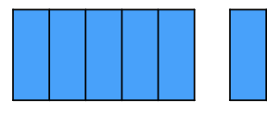  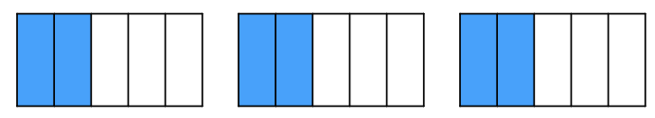  $$=\frac{6}{5}$$ | Why does the denominator not change when multiplying fractions by whole numbers?  Multiplying by a whole number means repeated ………………; when we ……… fractions, we do not change the denominator.
$$6×\frac{2}{3}$$  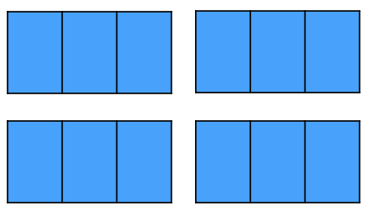  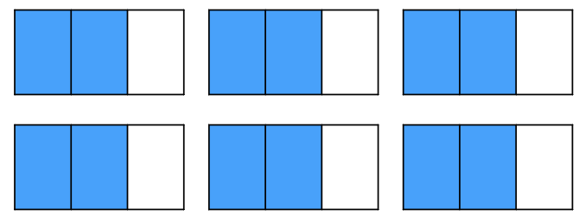  $$=\frac{12}{3}$$  $=4$ | Why does the order not matter when multiplying integers and fractions?  We can …………… numbers in any order and the answer is the same.

- Guided Practice
- $\frac{3}{4}$ $×3$  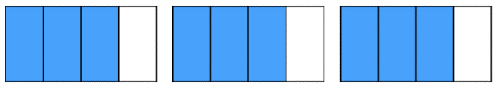  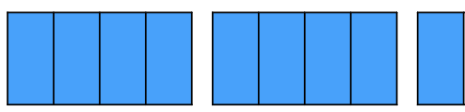  $=$ $\frac{}{4}$ | 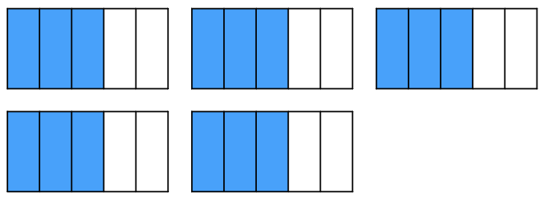  - $5×$ $\frac{3}{5}$  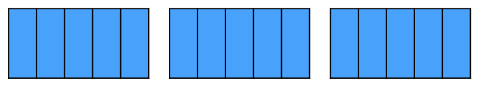  $=$ $\frac{}{5}$
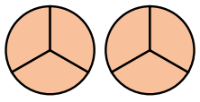  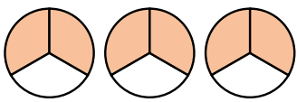  - $6×$ $\frac{2}{3}$  $=$ | - $\frac{2}{5}$ $×3$  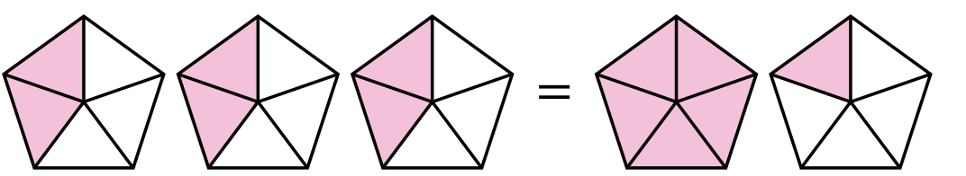  $=$
$$3×\frac{4}{5}$$ | $$\frac{2}{3}×13$$

Foundation
- Multiply these fractions using the diagrams.
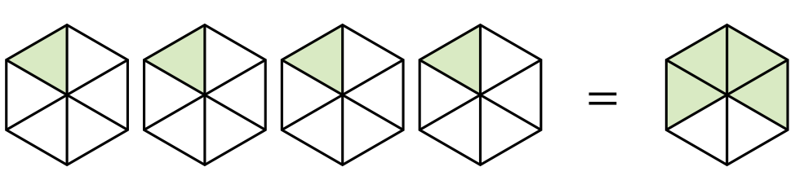  $$\frac{1}{6}×4$$  $$=\frac{}{6}$$  $$\frac{4}{6}=\frac{2}{3}$$ | 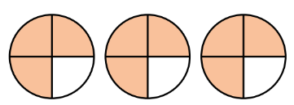  $$3×\frac{3}{4}$$  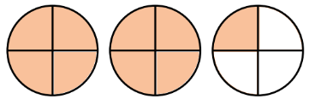  $$=$$  $$\frac{9}{4}=2\frac{1}{4}$$
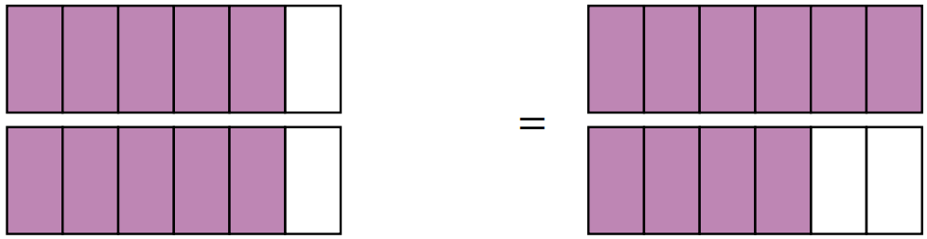  $$\frac{5}{6}×2$$  $$=$$  $$\frac{10}{6}=\frac{5}{3}$$ | 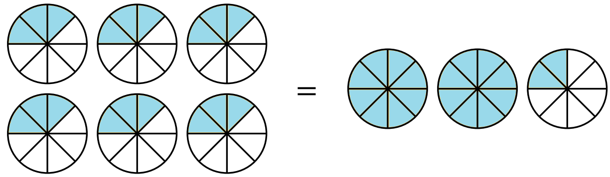  $$6×\frac{3}{8}$$  $$=$$  $$\frac{18}{8}=\frac{9}{4}=2\frac{1}{4}$$

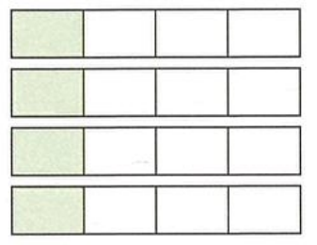
- Write down the multiplication represented in each diagram and write down the answer.
$$\frac{1}{4}×4=1$$ | $$\frac{2}{9}×4=\frac{8}{9}$$ | 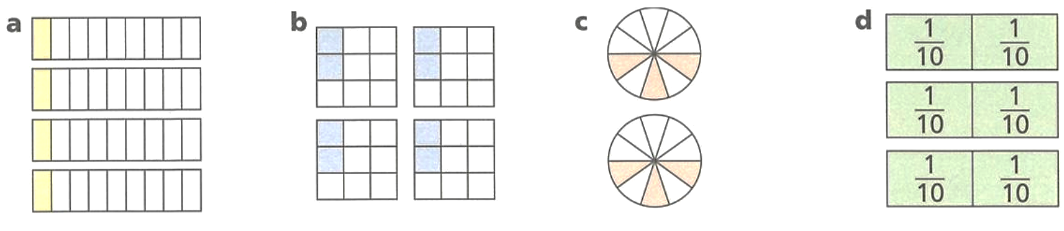  $$\frac{3}{10}×2=\frac{6}{10}=\frac{3}{5}$$

- Multiply these fractions.
- $\frac{1}{5}$ $×2$  $$\frac{2}{5}$$ | - $2×$ $\frac{1}{7}$  $$\frac{2}{7}$$ | - $\frac{1}{16}$ $×3$  $$\frac{3}{16}$$
- $7×$ $\frac{1}{19}$  $$\frac{7}{19}$$ | - $\frac{1}{100}$ $×9$  $$\frac{9}{100}$$ | - $\frac{2}{5}$ $×2$  $$\frac{4}{5}$$
- $\frac{3}{7}$ $×2$  $$\frac{6}{7}$$ | - $3×$ $\frac{5}{13}$  $$\frac{15}{13}=1\frac{2}{13}$$ | - $\frac{2}{19}$ $×7$  $$\frac{14}{19}$$

Development
- Read the example carefully and answer the questions.
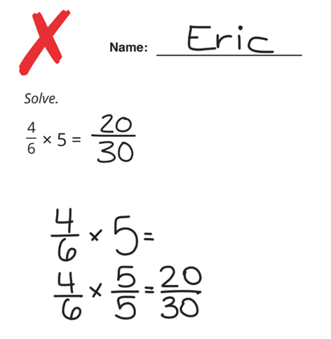 | What whole number is equivalent to $\frac{5}{5}$?  1  Why is it not correct to multiply by $\frac{5}{5}$ if we want to multiply by 5?  If we multiply by $\frac{5}{5}$ , we are multiplying by 1, which has no effect.  Work out:  $$\frac{3}{4}×7$$  $$\frac{21}{4}$$

- Multiply these fractions.
- $6×\frac{1}{3}$  $$2$$ | - $-6×\frac{1}{3}$  $$-2$$ | - $\frac{-7}{3}×6$  $$-14$$
- $6×\frac{2}{3}$  $$4$$ | - $6×\frac{0.1}{3}$  $$\frac{1}{5}$$ | - $\frac{-0.2}{3}×6$  $$-\frac{2}{5}$$
- $6×\frac{4}{3}$  $$8$$ | - $6×\frac{-0.1}{3}$  $$-\frac{1}{5}$$ | - $\frac{x}{3}×6$  $$2x$$
- $6×\frac{6}{3}$  $$12$$ | - $6×\frac{1}{0.3}$  $$20$$ | - $\frac{2x}{3}×-6$  $$-4x$$
- $6×\frac{5}{3}$  $$10$$ | - $\frac{1}{3}×6$  $$2$$ | - $\frac{0.2x}{3}×6$  $$\frac{2x}{5}$$
- $6×\frac{-1}{3}$  $$-2$$ | - $\frac{2}{3}×6$  $$4$$ | - $\frac{-0.2x}{3}×-6$  $$\frac{2x}{5}$$

- There are 9 identical pieces of ribbon, each $\frac{7}{20}$ metres long.
The 9 pieces of ribbon are placed end to end. What is the total length of the ribbon?
Give your answer as a mixed number.

$$3\frac{3}{20}$$
- Tom spends $\frac{3}{4}$ of an hour doing homework 5 times a week.
How long does he spend doing homework in 6 weeks? Answer as a mixed number.
$$22\frac{1}{2}$$

Mastery
- Work out the missing numbers.
5 | 7 | 3 | 9

- When multiplying by a fraction, we can multiply by the numerator then divide by the denominator, or we can do it the other way around.
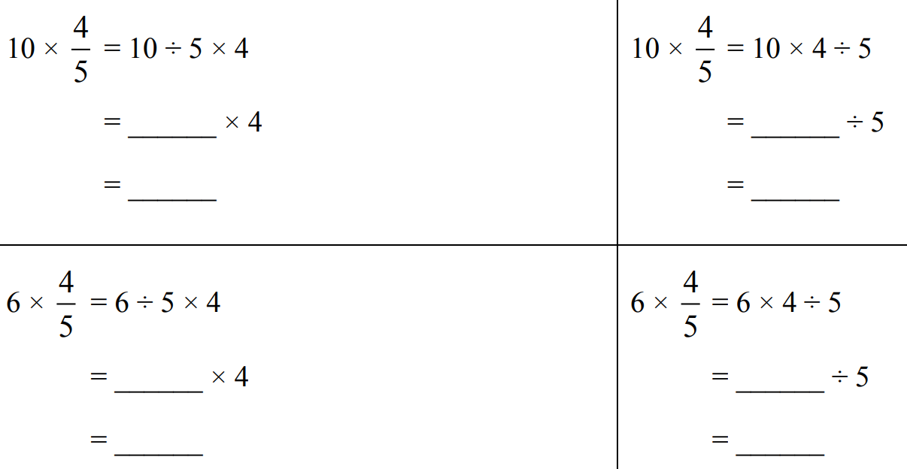
Which method was easiest for $10×$ $\frac{4}{5}$?
Divide, then multiply
Which method was easiest for $6×$ $\frac{4}{5}$?
Multiply, then divide
How might you decide whether to multiply first or divide first?
Divide first if the quotient will be a whole number.
Solve these problems, choosing whether to divide or multiply first.
- 40 $×$ $\frac{3}{4}$  30 | - 18 $×$ $\frac{2}{3}$  12 | - 5 $×$ $\frac{5}{6}$  $$\frac{25}{6}$$
- $\frac{6}{7}$ $×$ 21  $$18$$ | - $\frac{7}{9}$ $×$ 90  $$70$$ | - $\frac{5}{8}$ $×$ 30  $$\frac{75}{4}$$

- Calculate these answers by splitting the mixed numeral, then using the distributive law.
- $8×5\frac{1}{2}=8×\left(5+\frac{1}{2}\right)$  $=$ $\left(8×5\right)+\left(8×\frac{1}{2}\right)$  $=$ ………………  44 | - $20×3\frac{1}{4}$  65
- $12×2\frac{1}{3}$  28 | - $60×1\frac{1}{10}$  66

Multiplying Fractions using Models

- Multiplication of Fractions
We can think of multiplication in two ways:
$$2×\frac{1}{3}=\frac{2}{3}$$  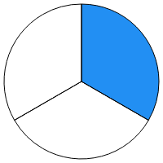  “what is two lots of one third?” | $$\frac{1}{3}×\frac{1}{2}=\frac{1}{6}$$  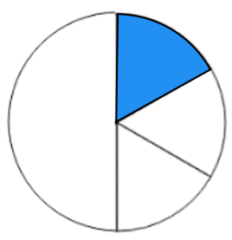  “what is one-third of one-half?”
- Fraction Multiplication: https://www.geogebra.org/m/f526fmeh

- Example Multiply fractions using visual models
$$\frac{1}{2}×\frac{1}{3}$$  $$=\frac{1}{6}$$ | $$\frac{2}{3}×\frac{3}{5}$$  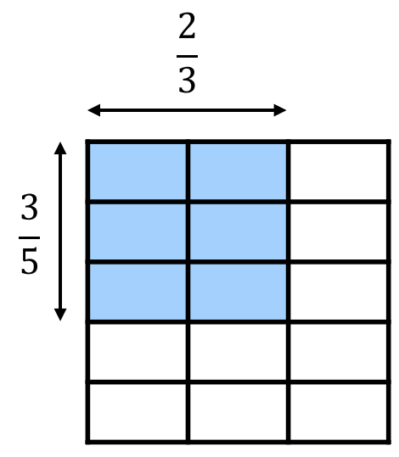  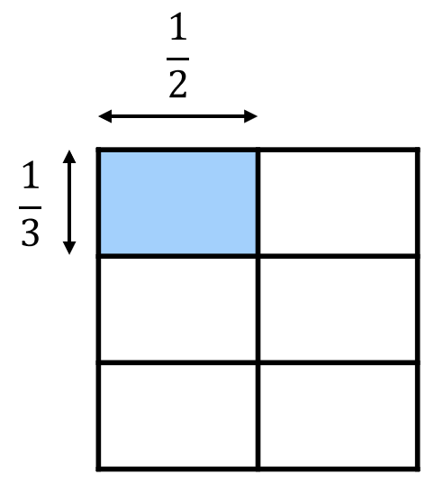  $$=\frac{6}{15}$$

- Guided Practice
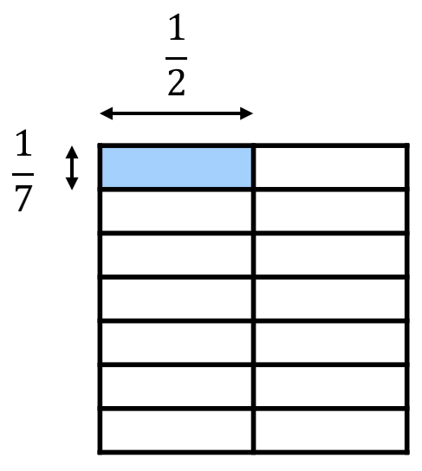  $$\frac{1}{2}×\frac{1}{7}$$  $$=\frac{}{}$$ | 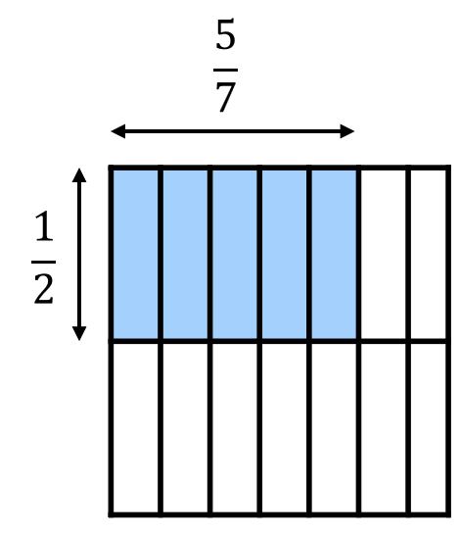  $$\frac{5}{7}×\frac{1}{2}$$  $$=\frac{}{}$$
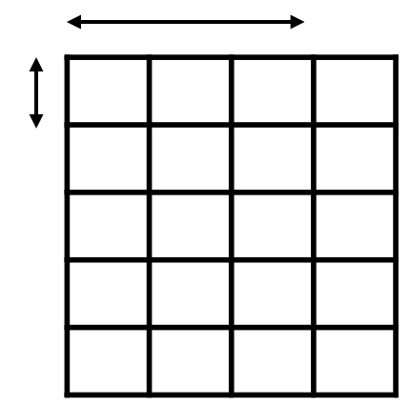    $$\frac{3}{4}×\frac{1}{5}$$  $$=\frac{}{}$$ | $$\frac{2}{3}×\frac{1}{4}$$  $$=\frac{}{}$$

Foundation
- Use the diagrams to help you complete these calculations.
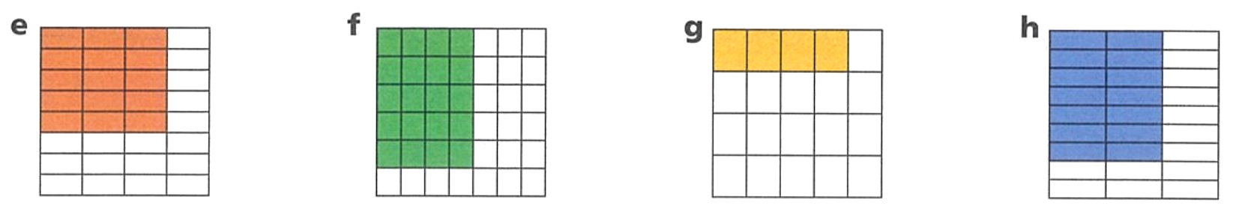  $$\frac{3}{4}×\frac{5}{8}$$  $$=\frac{}{32}$$  $$\frac{15}{32}$$ | $$\frac{5}{6}×\frac{4}{7}$$  $$=\frac{}{}$$  $$\frac{20}{42}=\frac{10}{21}$$
$$\frac{4}{5}×\frac{1}{4}$$  $$=\frac{}{}$$  $$\frac{1}{5}$$ | $$\frac{2}{3}×\frac{8}{9}$$  $$=\frac{}{}$$  $$\frac{16}{27}$$

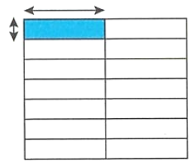
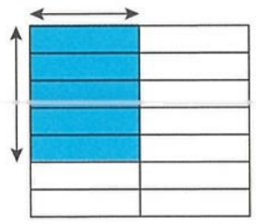
- What multiplication does this represent?
- V  $$\frac{1}{7}×\frac{1}{2}$$ | $$\frac{5}{7}×\frac{1}{2}$$

- Complete these calculations using the diagrams.
$$\frac{1}{21}$$ | $$\frac{1}{10}$$ | $$\frac{1}{12}$$ | 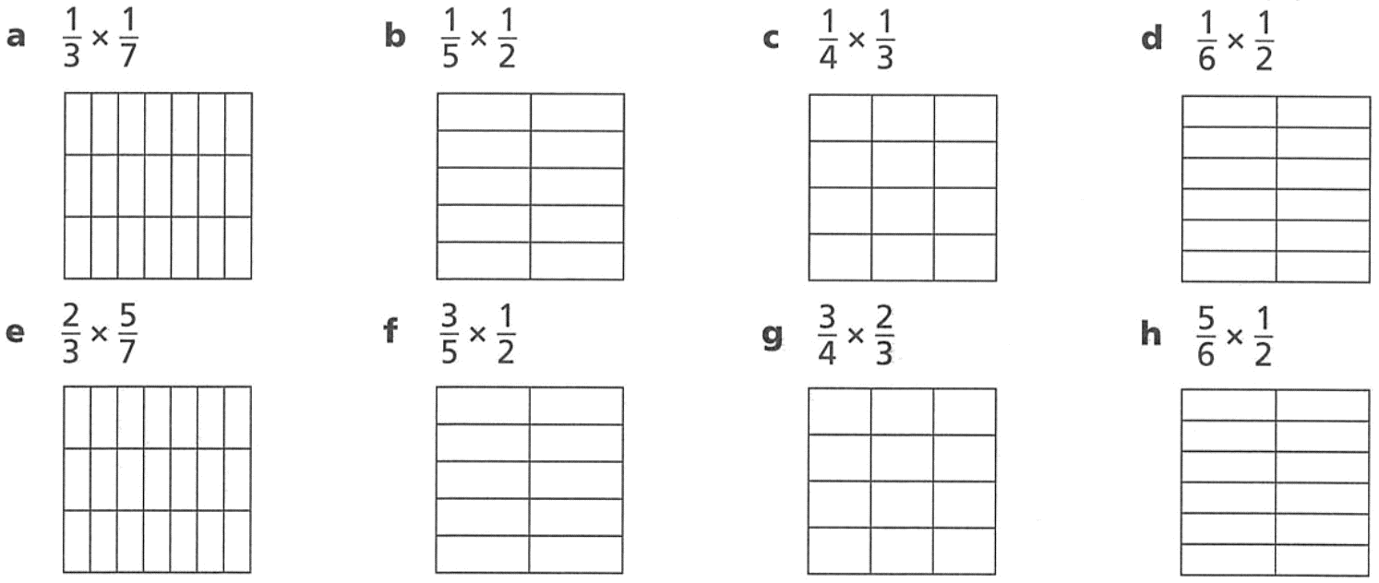  $$\frac{1}{12}$$
$$\frac{10}{21}$$ | $$\frac{3}{10}$$ | $$\frac{1}{2}$$ | $$\frac{5}{12}$$

Multiplying Fractions using the Rule

- Multiplying Fractions
Multiply the numerators and multiply the denominators
The word ‘of’ means to multiply.
$$\frac{a}{b}×\frac{c}{d}=\frac{a×c}{b×d}$$

- Example Multiply fractions using the rule
$$\frac{1}{2}×\frac{1}{3}$$  $$=\frac{1×1}{2×3}$$  $$=\frac{1}{6}$$ | $$\frac{2}{3}×\frac{3}{5}$$  $$=\frac{2×3}{3×5}$$  $$=\frac{6}{15}=\frac{2}{5}$$

- Guided Practice
$$\frac{1}{5}×\frac{3}{4}$$  $$=\frac{ × }{ × }$$  $$=\frac{ }{ }$$ | $$\frac{2}{3}×\frac{3}{4}$$  $$=\frac{ × }{ × }$$  $$=\frac{ }{ }$$
$$\frac{2}{5}×3$$ | $$\frac{5}{2}×\frac{3}{4}$$
$\frac{1}{3}$ of 12 | $\frac{3}{4}$ of $\frac{1}{5}$

Foundation
- Multiply these fractions
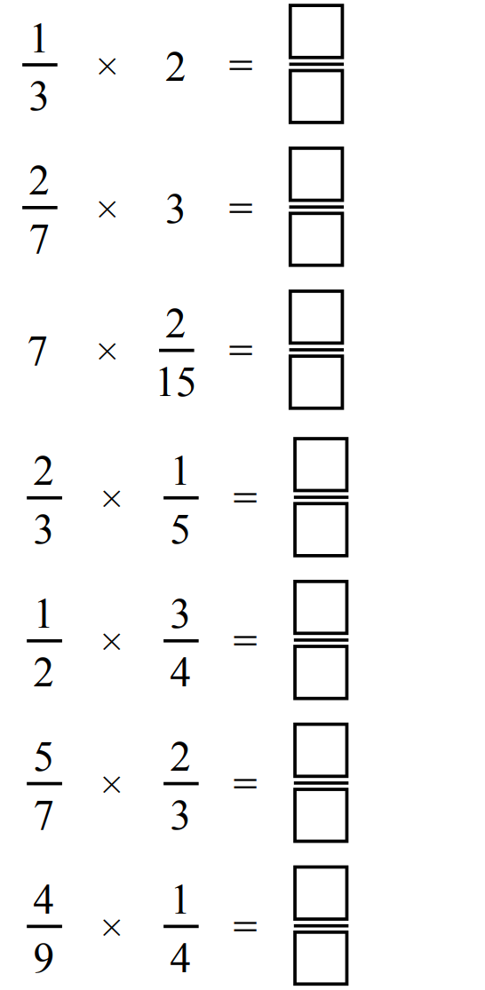  $$\frac{2}{3}$$ | $$\frac{6}{7}$$ | $$\frac{14}{15}$$
$$\frac{2}{15}$$ | $$\frac{3}{8}$$ | $$\frac{10}{21}$$
$$\frac{10}{21}$$ | $$\frac{1}{9}$$ | 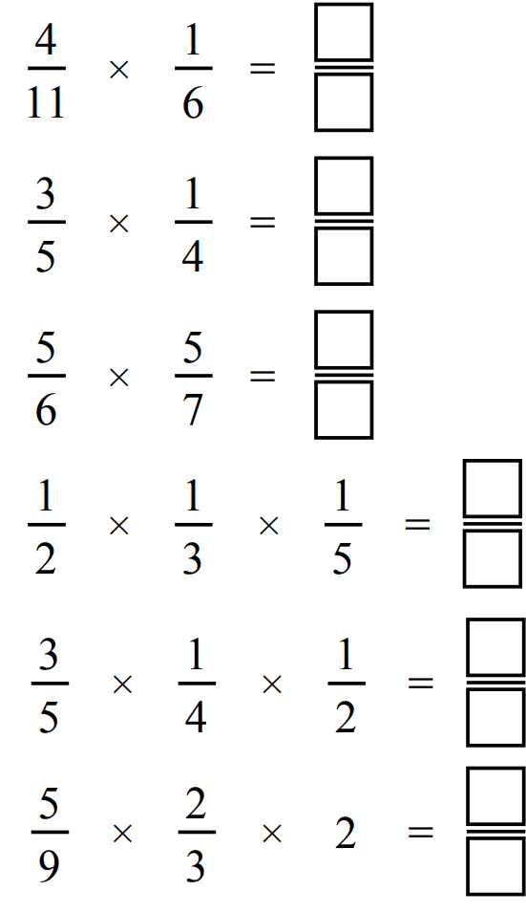  $$\frac{25}{42}$$
$$\frac{1}{30}$$ | $$\frac{3}{40}$$ | $$\frac{20}{27}$$

- Multiply these fractions then simplify the result.
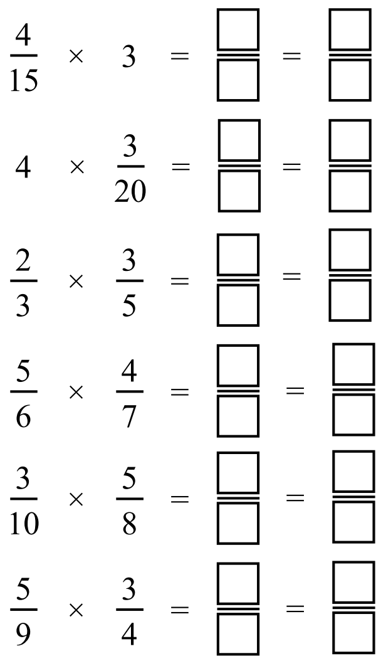  $$\frac{4}{5}$$ | $$\frac{3}{5}$$ | $$\frac{2}{5}$$
$$\frac{10}{21}$$ | $$\frac{3}{16}$$ | $$\frac{5}{12}$$

- “of” means to multiply. Find:
- $\frac{1}{2}$ of $\frac{1}{3}$  $$\frac{1}{2}×\frac{1}{3}=$$  $$\frac{1}{6}$$ | - $\frac{1}{3}$ of $\frac{1}{5}$  $$\frac{1}{15}$$ | - $\frac{2}{3}$ of $\frac{5}{7}$  $$\frac{10}{21}$$
- $\frac{2}{3}$of $\frac{3}{5}$  $$\frac{2}{5}$$ | - $\frac{1}{3}$ of $18$  $$6$$ | - $\frac{4}{5}$ of 100  $$80$$

Development
- Show these multiplications by writing the whole number as a fraction over 1.
$$\frac{1}{2}×5=\frac{1}{2}×\frac{5}{1}$$  $=$  $$\frac{5}{2}$$ | $$\frac{2}{3}×24$$  $$16$$ | $$25×\frac{3}{5}$$  $$15$$
$$\frac{2}{7} of 42$$  12 | $$\frac{1}{4} of 16$$  4 | $$\frac{1}{5} of 45$$  9

Explain why the rule “multiply by the numerator and keep the denominator the same”
works when multiplying a whole number and a fraction.

When multiplying by a whole number, you can think of it as repeated addition. When you add fractions, the denominator doesn’t change.
- Multiply these fractions.
$$\frac{1}{2}×\frac{2}{5}=$$  $$\frac{1}{5}$$ | $$\frac{0}{5}×\frac{3}{4}$$  0 | $$\frac{a}{b}×\frac{a}{b}=$$  $$\frac{a^{2}}{b^{2}}$$
$$\frac{2}{5}×\frac{1}{2}=$$  $$\frac{1}{5}$$ | $$\frac{2}{3}×\frac{5}{7}$$  $$\frac{10}{21}$$ | $$\frac{b}{a}×\frac{a}{b}=$$  $$1$$
$$\frac{2}{5}×\frac{1}{3}=$$  $$\frac{2}{15}$$ | $$\frac{2}{3}×\frac{5}{}=\frac{10}{12}$$  4 | $$\frac{2}{3}×\frac{3}{5}×\frac{4}{7}=$$  $$\frac{8}{35}$$
$$\frac{2}{5}×\frac{1}{4}=$$  $$\frac{1}{10}$$ | $$\frac{2}{3}×\frac{}{}=\frac{2}{6}$$  $$\frac{1}{2}$$ | $$\frac{2}{3}×\frac{3}{5}×\frac{9}{11}=$$  $$\frac{18}{55}$$
$$\frac{2}{5}×\frac{3}{4}=$$  $$\frac{3}{10}$$ | $$\frac{2}{}×\frac{5}{}=\frac{10}{9}$$  3, 3 | $${\left(\frac{2}{3}\right)}^{2}=$$  $$\frac{4}{9}$$
$${\left(\frac{3}{4}\right)}^{2}=$$  $$\frac{9}{16}$$ | $$\frac{2}{3}×\frac{a}{b}=$$  $$\frac{2a}{3b}$$ | $$\frac{2}{3}×{\left(\frac{3}{5}\right)}^{2}=$$  $$\frac{6}{25}$$

Mastery
- Work out the missing numbers.
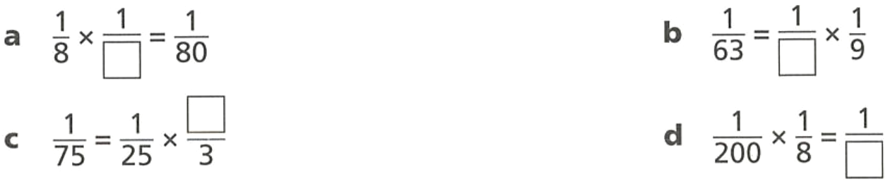  10 | 1 | 7 | 1600
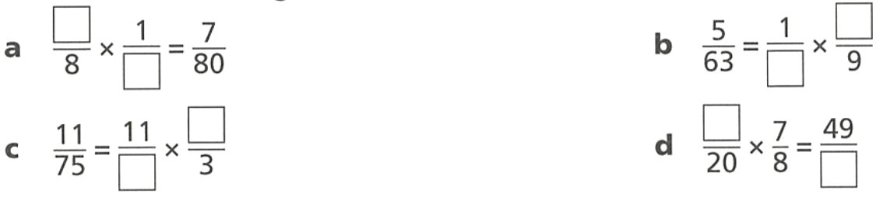  7, 10 | 7, 5 | 25, 1 | 7, 160

- Find the missing number in each calculation.
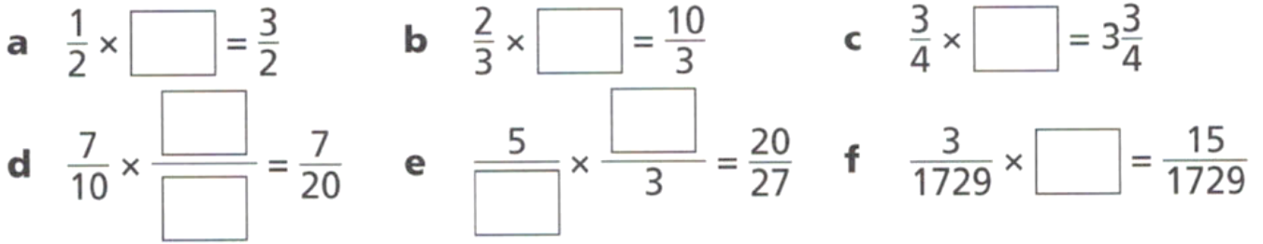  $$3$$ | $$5$$ | $$5$$
$$\frac{1}{2}$$ | 9, 4 | 5

- Determine the missing values in these equations.
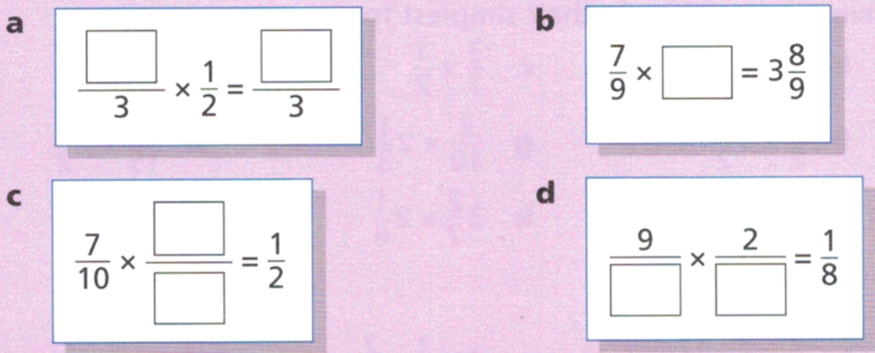  Any pair of numbers where the first number is double the second. | 5
$$\frac{5}{7}$$ | Any factor pair of 144 will work

- [JMO 1996 A4] Evaluate
$$\left[\left(\frac{1}{2}+\frac{1}{3}\right)+\frac{1}{4}\right]×\frac{1}{5}-\frac{1}{6}$$
$$\left[\left(\frac{3}{6}+\frac{2}{6}\right)+\frac{1}{4}\right]×\frac{1}{5}-\frac{1}{6}$$
$$=\left(\frac{5}{6}+\frac{1}{4}\right)×\frac{1}{5}-\frac{1}{6}$$
$$=\left(\frac{20}{24}+\frac{6}{24}\right)×\frac{1}{5}-\frac{1}{6}$$
$$=\frac{26}{24}×\frac{1}{5}-\frac{1}{6}$$
$$=\frac{13}{12}×\frac{1}{5}-\frac{1}{6}$$
$$=\frac{13}{60}-\frac{1}{6}$$
$$=\frac{13}{60}-\frac{10}{60}$$
$$=\frac{3}{60}$$
$$=\frac{1}{20}$$

- To find half of a fraction, you can either halve the numerator or double the denominator:
Half of $\frac{4}{5}=\frac{2}{5}$ (halve the numerator) | Half of $\frac{7}{10}=\frac{3.5}{10}$ (halve the numerator)  $=\frac{7}{20}$ (simplify)
Half of $\frac{4}{5}=\frac{1}{2}×\frac{4}{5}$  $=\frac{4}{10}$ (double the denominator)  $=\frac{2}{5}$ (simplify) | Half of $\frac{7}{10}=\frac{1}{2}×\frac{7}{10}$  $=\frac{7}{20}$ (double the denominator)
Find half of these fractions by either halving the denominator or multiplying by $\frac{1}{2}$
- Half of $\frac{8}{9}$  Halve the numerator:  $$\frac{4}{9}$$  Double the denominator:  $$\frac{8}{18}=\frac{4}{9}$$ | - Half of $\frac{5}{9}$  Halve the numerator:  $$\frac{2.5}{9}=\frac{5}{18}$$  Double the denominator:  $$\frac{5}{18}$$
When might it be easier to halve the numerator and when might it be easier to double the denominator?
Halve the numerator if the quotient will be a whole number.
Calculate the following using the easier method:
- Half of $\frac{3}{4}$  $$\frac{3}{8}$$ | - Half of $\frac{20}{21}$  $$\frac{10}{21}$$ | - Half of $8\frac{9}{11}$  $$4\frac{9}{22}$$
- A third of $\frac{3}{4}$  $$\frac{1}{4}$$ | - A third of $\frac{7}{10}$  $$\frac{7}{30}$$ | - A quarter of $\frac{1}{5}$  $$\frac{1}{20}$$
- A quarter of $\frac{12}{13}$  $$\frac{3}{13}$$ | - A fifth of $\frac{15}{16}$  $$\frac{3}{16}$$ | - A fifth of $20\frac{1}{3}$  $$4\frac{1}{15}$$

Multiplying Mixed Numerals

- Multiplying Mixed Numerals
- Convert mixed numbers to improper fractions: $a$ $\frac{b}{n}=\frac{a×n+b}{n}$
- Multiply the numerators and multiply the denominators.
- Simplify if possible.

- Example Multiply mixed numbers using the rule
$$1\frac{3}{5}×2\frac{1}{3}$$  1. Convert to improper $\frac{8}{5}$ $×$ $\frac{7}{3}$  2. Multiply $\frac{56}{15}$ | $$2\frac{2}{3}×3\frac{1}{2}$$  1. Convert to improper $\frac{8}{3}$ $×$ $\frac{7}{2}$  2. Multiply $\frac{56}{6}$  3. Simplify $\frac{28}{3}$

- Guided Practice
$$1\frac{1}{5}×2\frac{3}{4}$$  $$= \frac{6}{5} × \frac{11}{4}$$  $$=\frac{ }{ }$$  $=\frac{ }{ }$l | $$2\frac{2}{5}×1\frac{1}{6}$$  $$=\frac{ }{5} × \frac{ }{6}$$
$$2×3\frac{2}{7}$$ | $$2\frac{1}{5}×4\frac{3}{4}$$

- Key Ideas
- It is most efficient to convert any mixed numbers to ……………… ……………… before multiplying.

Foundation
- Multiply these fractions.
$$4\frac{2}{3}×\frac{5}{6}$$  $$3\frac{8}{9}$$ | 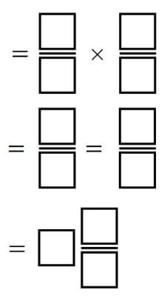  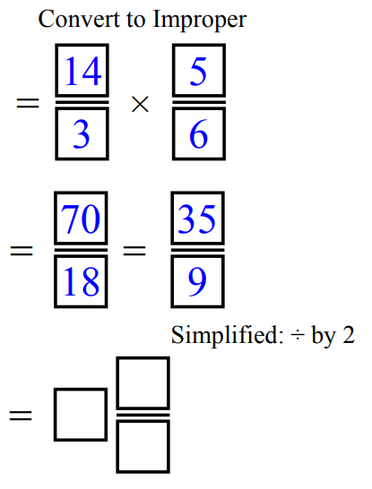  $$\frac{2}{3}×2\frac{1}{2}$$  $$1\frac{2}{3}$$ | $$4\frac{3}{4}×\frac{2}{5}$$  $$1\frac{9}{10}$$
$$\frac{5}{12}×2\frac{3}{5}$$  $$1\frac{1}{12}$$ | $$6\frac{1}{2}×\frac{2}{7}$$  $$1\frac{6}{7}$$ | $$2\frac{3}{4}×1\frac{3}{5}$$  $$4\frac{2}{5}$$
$$5\frac{1}{3}×1\frac{1}{2}$$  $$8$$ | $$1\frac{2}{3}×2\frac{1}{4}$$  $$3\frac{3}{4}$$ | $$2\frac{2}{5}×1\frac{1}{2}$$  $$3\frac{3}{5}$$

- To paint one classroom, 2 $\frac{1}{3}$ litres of paint are required.
How many litres of paint are required to paint five identical classrooms?
$$11\frac{2}{3} litres$$
- A scone recipe requires 1 $\frac{3}{4}$ cups of flour and $\frac{3}{4}$ of a cup of cream.
Jamie is catering for a large group and needs to quadruple the recipe.
How much flour and how much cream will she need?

7 cups flour and 3 cups cream

Development
- It takes $2\frac{1}{4}$ hours to paint a fence. One quarter of this time is spent sanding the wood down. What fraction of an hour is spent in sanding the wood?

$$\frac{9}{16} hours$$
- $\frac{3}{5}$ of a road is to be resurfaced.
If the road is $1\frac{1}{2}$ km long, what length in kilometres is to be resurfaced?

$$\frac{9}{10}$$
- If you spent $1\frac{1}{2}$ hours on homework last night and $\frac{1}{4}$ of that time was on history,
how long did you spend on history?

$$\frac{3}{8}$$
- Read the example carefully and answer the questions.
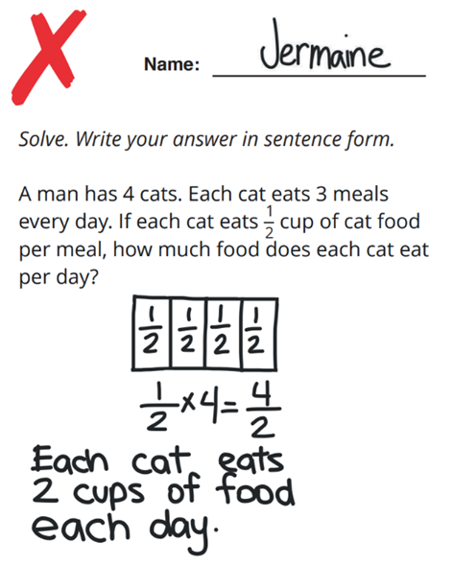 | Circle the pieces of information below that Jermaine used to solve the problem.  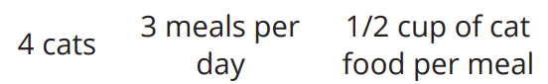  What does Jermaine’s answer actually represent?  How many cups of food is eaten by all the cats each day.  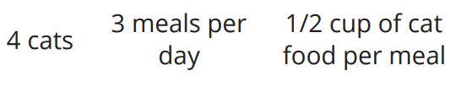  Circle the pieces of information below that Jermaine should have used.  There should be one piece of information that you did not circle. Explain why that information is not needed.  4 cats. You are only interested in how much 1 cat eats per day.
A man is baking 5 cakes. Each cake has 2 layers of frosting. If each layer of frosting uses $\frac{1}{3}$ teaspoon of food colouring, how much food colouring does he need for one cake?

$$\frac{2}{3} teaspoon$$

Simplify Before You Multiply

- Simplifying Fractions Before You Multiply
- Fraction multiplication is easier if you simplify or “cancel” the fractions before multiplying.
- Simplifying means to divide the numerator and denominator by a common factor.
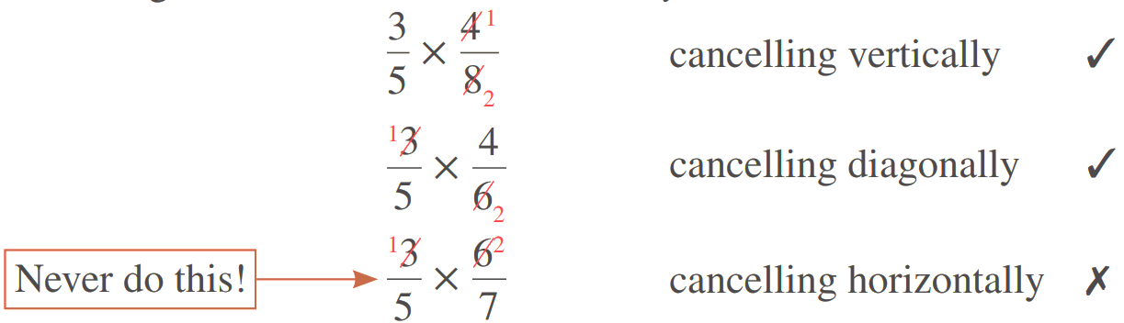

- Example Simplify fraction before multiplying
$$\frac{4}{8} × \frac{3}{2}$$  1. Simplify $\frac{1}{2}$ $×$ $\frac{3}{2}$  2. Multiply $\frac{3}{4}$ | $$\frac{2}{3} × \frac{12}{5}$$  1. Simplify $\frac{2}{1}$ $×$ $\frac{4}{5}$  2. Multiply $\frac{8}{5}$

- Guided Practice
Simplify these fractions before multiplying them.
- $\frac{7}{3}×\frac{2}{6}$  $$=\frac{7}{3}×\frac{ }{ }$$ | - $\frac{3}{4}×\frac{4}{7}$  $$=\frac{3}{ }×\frac{ }{7}$$
- $\frac{5}{9}×\frac{7}{10}$ | - $\frac{8}{11}×\frac{3}{4}$

- Key Ideas
- It is most efficient to simplify fractions before you ………………… so you work with smaller numbers.
- You can simplify …………………… or ……………………, but not ………………………

Foundation
- Multiply by simplifying the highlighted values first.
$$\frac{5}{7}×\frac{13}{15}=$$  $$\frac{13}{21}$$ | $$\frac{3}{8}×\frac{11}{12}=$$  $$\frac{11}{32}$$ | $$\frac{12}{18}×\frac{5}{7}=$$  $$\frac{10}{21}$$ | $$\frac{4}{16}×\frac{2}{3}=$$  $$\frac{1}{6}$$
$$\frac{3}{4}×\frac{12}{48}=$$  $$\frac{3}{16}$$ | $$\frac{2}{5}×\frac{15}{24}=$$  $$\frac{1}{4}$$ | $$\frac{8}{12}×\frac{4}{64}=$$  $$\frac{1}{24}$$ | $$\frac{6}{56}×\frac{7}{12}=$$  $$\frac{1}{16}$$

- Simplify these fractions by cancelling.
 | $$\frac{11}{4}$$ | 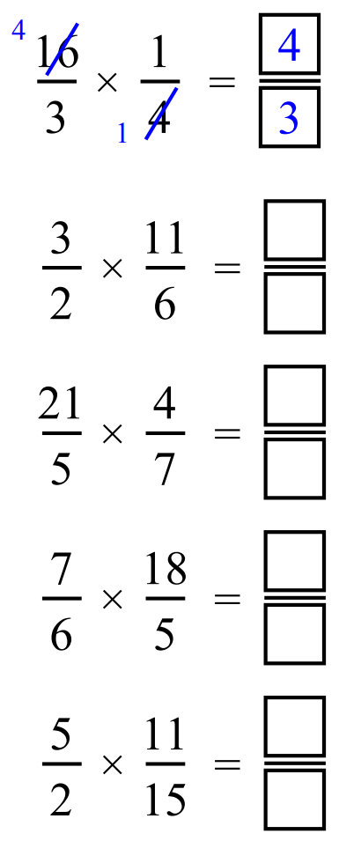  $$\frac{12}{5}$$
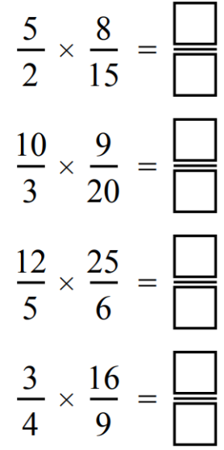  $$\frac{21}{5}$$ | $$\frac{11}{6}$$ | $$\frac{4}{3}$$
$$\frac{3}{2}$$ | $$\frac{10}{1}$$ | 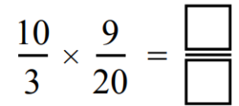  $$\frac{4}{3}$$

- “fraction of” questions can be turned into multiplication.
- $\frac{3}{7}$ of 42  $$=\frac{3}{7}×\frac{42}{1}$$ | - $\frac{1}{4}$ of 32  $$8$$ | - $\frac{4}{5}$ of 120  $$96$$ | - $\frac{3}{7}$ of 77  $$33$$
- $\frac{5}{10}$ of $\frac{4}{7}$  $$\frac{2}{7}$$ | - $\frac{6}{9}$ of $\frac{3}{12}$  $$\frac{1}{6}$$ | - $\frac{3}{4}$ of $\frac{2}{5}$  $$\frac{3}{10}$$ | - $\frac{2}{5}$ of $\frac{10}{11}$  $$\frac{4}{11}$$

Development
- Multiply these mixed numbers by first converting to an improper fraction.
$$\frac{14}{5}$$ | $$\frac{7}{5}$$ | 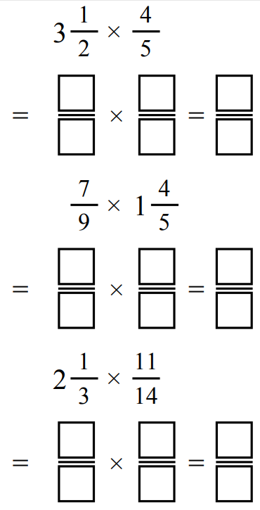  $$\frac{11}{6}$$
$$\frac{26}{11}$$ | $$\frac{4}{3}$$ | 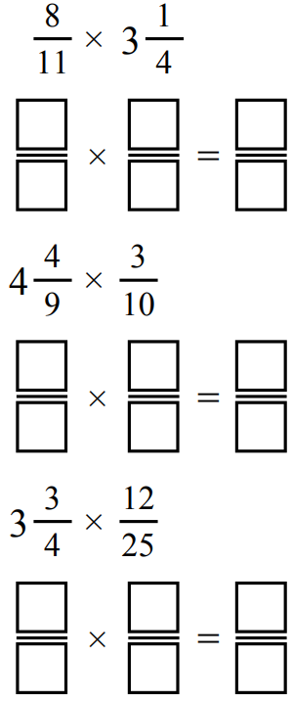  $$\frac{9}{5}$$
$$\frac{9}{4}$$ | $$\frac{36}{7}$$ | 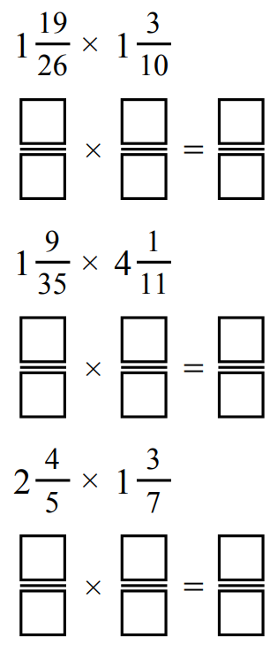  $$4$$
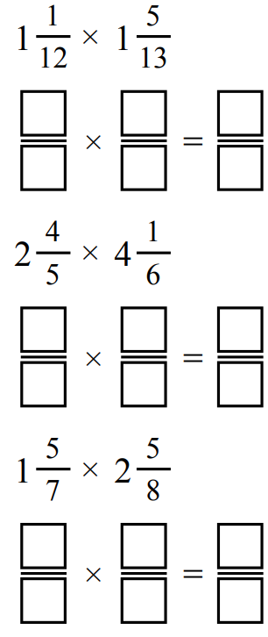  $$\frac{3}{2}$$ | $$\frac{35}{3}$$ | $$\frac{9}{2}$$

- Multiply these fractions by cancelling first.
$$\frac{2}{9}×\frac{3}{4}$$  $$\frac{1}{6}$$ | $$\frac{4}{27}×\frac{9}{16}$$  $$\frac{1}{12}$$ | $$\frac{27}{8}×\frac{16}{15}$$  $$\frac{18}{5}$$
$$\frac{2}{9}×\frac{3}{8}$$  $$\frac{1}{12}$$ | $$\frac{8}{27}×\frac{9}{16}$$  $$\frac{1}{6}$$ | $$3\frac{3}{8}×\frac{16}{15}$$  $$\frac{18}{5}$$
$$\frac{4}{9}×\frac{3}{16}$$  $$\frac{1}{12}$$ | $$\frac{8}{27}×\frac{15}{16}$$  $$\frac{5}{18}$$ | $$3\frac{3}{8}×1\frac{1}{15}$$  $$\frac{18}{5}$$
$$\frac{4}{27}×\frac{3}{16}$$  $$\frac{1}{36}$$ | $$\frac{16}{27}×\frac{15}{16}$$  $$\frac{5}{9}$$ | $$3\frac{3}{8}×1\frac{2}{30}$$  $$\frac{36}{10}$$

Mastery
- Multiply these fractions. It is a good idea to simplify first.
Your final answer should be fully simplified.
$$\frac{12}{16}×\frac{15}{20}$$  $$\frac{9}{16}$$ | $$\frac{15}{12}×\frac{24}{45}$$  $$\frac{2}{3}$$ | $$\frac{6}{8}×\frac{17}{5}×\frac{10}{17}$$  $$\frac{3}{2}$$

- Find the value of:
$$2×\frac{25}{9}×\frac{16}{26}×\frac{18}{8}×\frac{13}{50}×\frac{1}{2}$$

$$1$$
- Simplify:
$$\frac{1}{2}×\frac{2}{3}×\frac{3}{4}×…\frac{n-1}{n}$$

$$\frac{1}{n}$$
- [JMC 2004 Q15] Granny spends one third of her weekly pension on Thursday night,
and one quarter of what remains on Friday.
What fraction of the original amount is left for her big night out on Saturday?

$$\frac{2}{3}×\frac{3}{4}=\frac{1}{2}$$
She has half remaining.
- [JMO 2014 A10] My four pet monkeys and I harvested a large pile of peanuts.
Monkey A woke in the night and ate half of them;
then Monkey B woke and ate one third of what remained;
then Monkey C woke and ate one quarter of the rest;
finally Monkey D ate one fifth of the much diminished remaining pile.
What fraction of the original harvest was left in the morning?

$$\frac{1}{2}×\frac{2}{3}×\frac{3}{4}×\frac{4}{5}=\frac{1}{5}$$
One fifth remains

Dividing Fractions using Visual Models

- Division of Fractions
We can think of division in two ways:
Quotition division  (divisor less than original)  how many parts are there?  $3÷$ $\frac{1}{2}$ $=6$  “how many halves are in three wholes?”  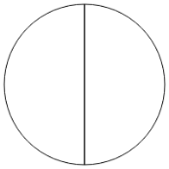 | Partition division  (divisor greater than original)  what is the size of each part?  $\frac{1}{2}$ $÷3=$ $\frac{1}{6}$  “If I divide half into three pieces,  what is the size of each part?”  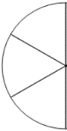

- Example Divide fractions using quotation division
$$1÷\frac{1}{2}$$  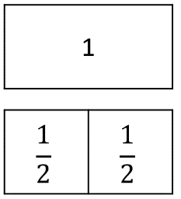  $$=2$$ | $$2÷\frac{2}{3}$$  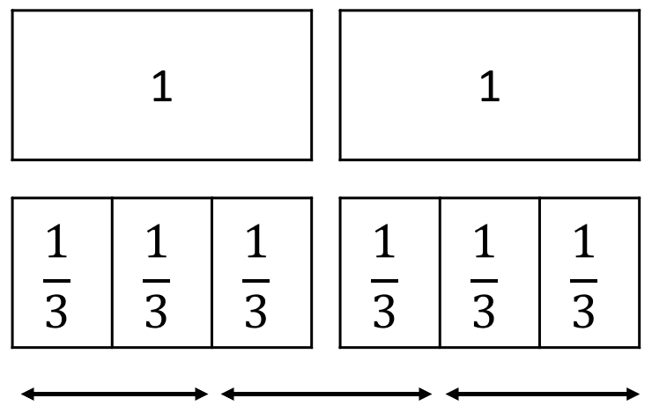  $$=3$$

- Guided Practice
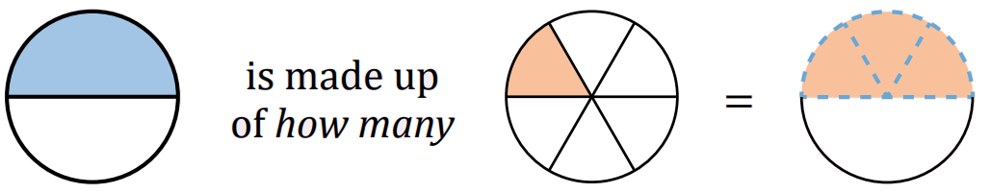  - “how many sixths in a half?”  $$\frac{1}{2}÷\frac{1}{6}$$ | 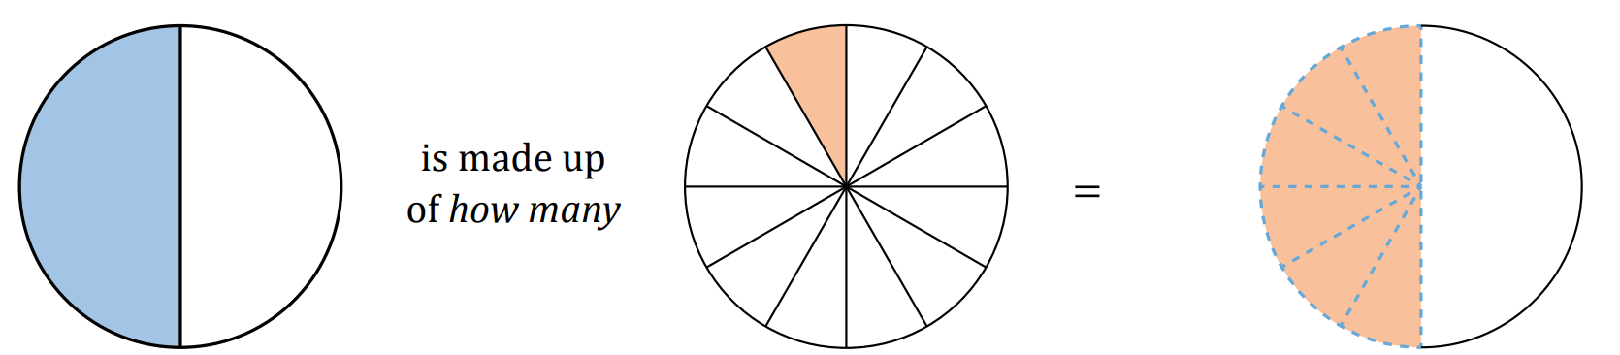  - “how many twelfths in a half?”  $$\frac{1}{2}÷\frac{1}{12}$$
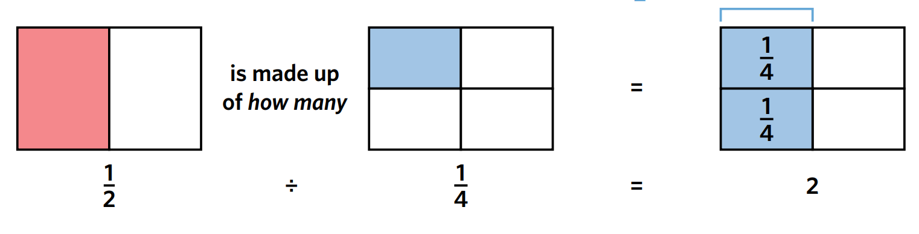  - “……………………………………………”  $$\frac{1}{2}÷\frac{1}{4}$$ | 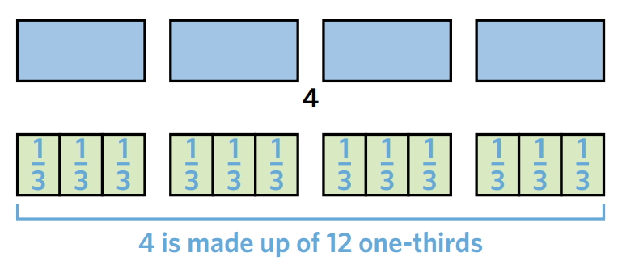  - “……………………………………………”  $$4÷\frac{2}{3}$$

Foundation
- Using the diagram, how many fifths are there in
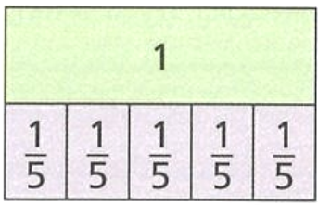
  - 1 whole? ……………………
5
  - 2 wholes? ……………………
10
  - 4 wholes? ……………………
20
  - 10 wholes? ……………………
50
Hence complete these calculations.
- $1÷$ $\frac{1}{5}$ ……………………  5 | - $2÷$ $\frac{1}{5}$ ……………………  10
- $4÷$ $\frac{1}{5}$ ……………………  20 | - $10÷$ $\frac{1}{5}$ ……………………  50

- Consider the diagram.
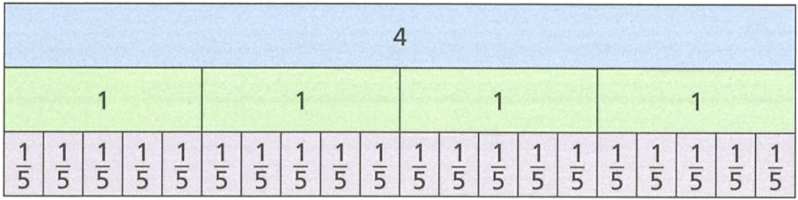
  - How many fifths are there in 4 wholes?
20
  - How many two-fifths are
there in 4 wholes?
10
Hence complete these calculations.
- $4÷$ $\frac{1}{5}$ ……………………  20 | - $4÷$ $\frac{2}{5}$ ……………………  10

- Consider the diagram.
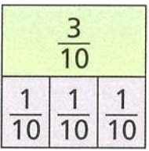
  - How many lots of one-tenth are in three-tenths?
3
  - Calculate $\frac{3}{10}÷\frac{1}{10}$
3

- Consider the diagram.
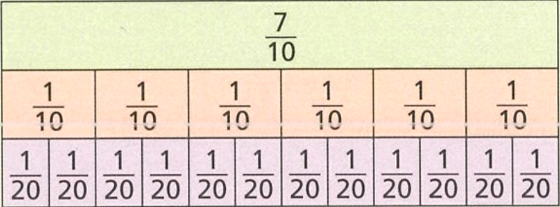
  - Calculate $\frac{7}{10}÷\frac{1}{10}$

7
  - Calculate $\frac{7}{10}÷\frac{1}{20}$
14

Development
- Consider the fraction wall.
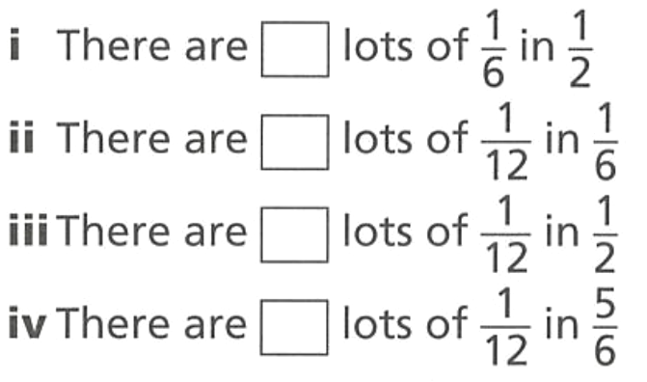
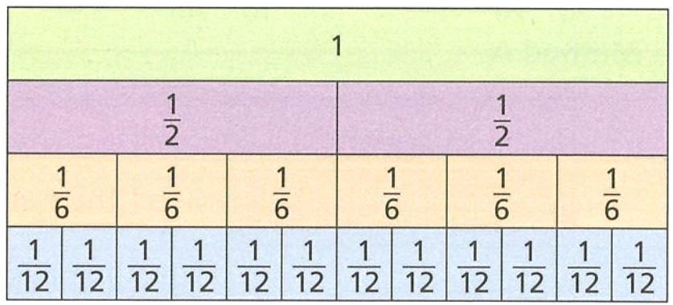
  - Complete these sentences
3
2
6
10

- $\frac{1}{2}÷\frac{1}{6}$  3 | - $\frac{1}{6}÷\frac{1}{12}$  6
- $\frac{1}{2}÷\frac{1}{12}$  6 | - $\frac{5}{6}÷\frac{1}{12}$  10

- Complete the table.
Division | Diagram | Meaning | Answer
$$\frac{3}{4}÷\frac{1}{4}$$ | 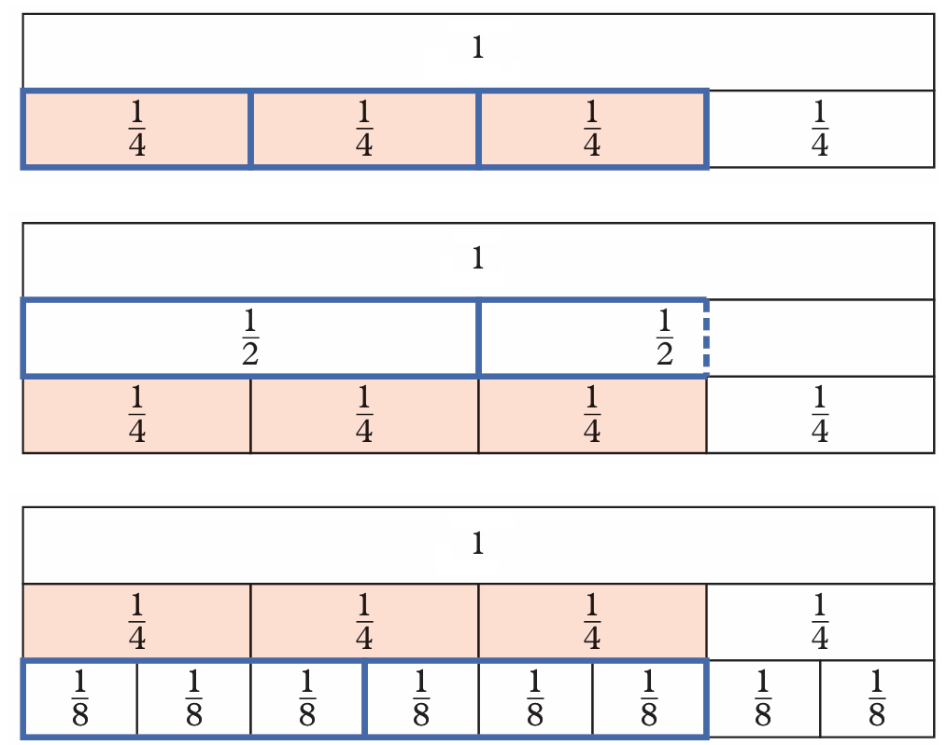 | How many ……… are in …………  How many quarters in three quarters? | $$\frac{3}{4}÷\frac{1}{4}=3$$
$$\frac{3}{4}÷\frac{3}{8}$$ |  | How many ……… are in …………?  How many three-eighths in three quarters? | 2
$$\frac{3}{4}÷\frac{1}{2}$$ |  | How many ……… are in …………?  How many halves in three-quarters? | $$1\frac{1}{2}$$

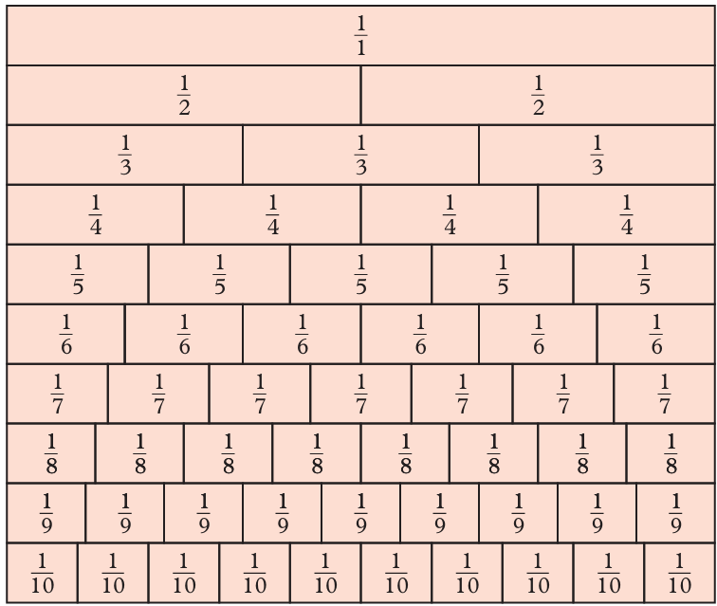
- Use the fraction wall to find the quotient.
  - $\frac{2}{3}$ $÷$ $\frac{1}{9}$ $=$
6
  - $\frac{8}{10}$ $÷$ $\frac{1}{5}$ $=$
4
  - $\frac{4}{6}$ $÷$ $\frac{2}{9}$ $=$
3
  - 1 $÷$ $\frac{3}{8}$ $=$
$$2\frac{2}{3}$$
  - $\frac{5}{6}$ $÷$ $\frac{1}{3}$ $=$
$$2\frac{1}{2}$$
  - $\frac{9}{10}$ $÷$ $\frac{2}{5}$ $=$
$$2\frac{1}{4}$$

Mastery
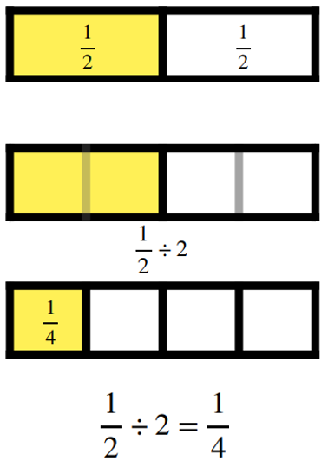
- Complete the pattern below. These show partition division. “what is the size of each part?”
- $\frac{1}{2}$ $÷2$ | 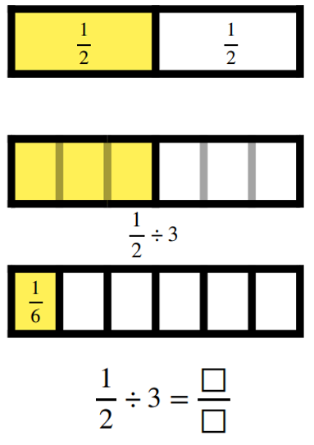  - $\frac{1}{2}$ $÷$$3$  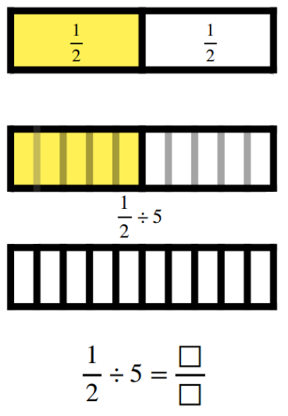  $$\frac{1}{6}$$ | - $\frac{1}{2}$ $÷4$  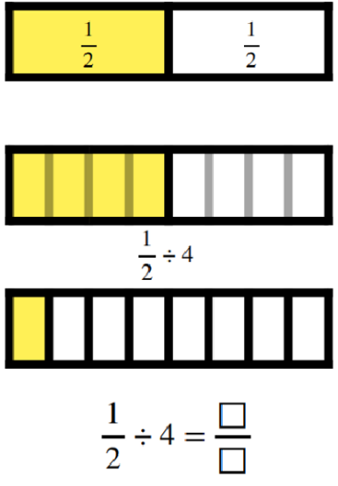  $$\frac{1}{8}$$
- $\frac{1}{2}$ $÷5$  $$\frac{1}{10}$$ | - $\frac{1}{2}$ $÷6$  $$\frac{1}{12}$$ | 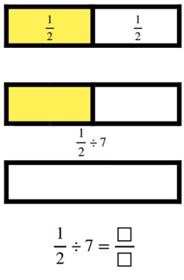  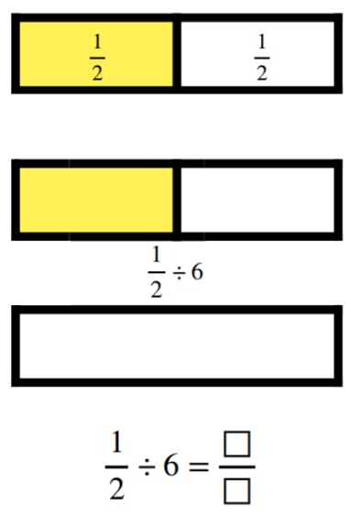  - $\frac{1}{2}$ $÷7$  $$\frac{1}{14}$$
- $\frac{1}{3}$ $÷2$  $$\frac{1}{6}$$ | - $\frac{1}{3}$ $÷3$  $$\frac{1}{9}$$ | 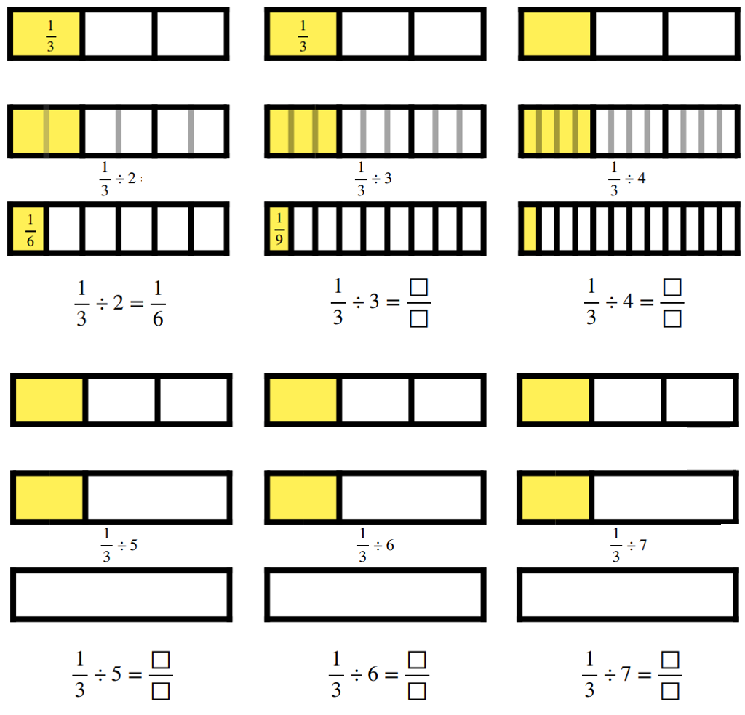  - $\frac{1}{3}$ $÷4$  $$\frac{1}{12}$$

Reciprocals

- Reciprocals
Two numbers are reciprocals of each other if they multiply to 1.
You can think of the reciprocal as swapping the numerator and denominator.

- Identify reciprocal of a number
$$\frac{1}{8}×8=1$$  The reciprocal of $\frac{1}{8}$ is 8.  The reciprocal of 8 is $\frac{1}{8}$ |  | $$\frac{2}{3}×\frac{3}{2}=1$$  The reciprocal of $\frac{2}{3}$ is $\frac{3}{2}$.  The reciprocal of $\frac{3}{2}$ is $\frac{2}{3}$
Identify the reciprocal of these numbers.
$$5$$ | $$3$$ |  | $$113$$
$$1$$ | $$\frac{1}{5}$$ |  | $$\frac{1}{7}$$
$$\frac{1}{2754}$$ | $$\frac{3}{1}$$ |  | $$\frac{3}{3}$$
$$1\frac{1}{3}$$ | $$2\frac{3}{5}$$ |  | $$0.5$$
$$n$$ | $$\frac{1}{n}$$ |  | $$\frac{a}{b}$$

- Key Ideas
- The product of a number and its ……………… is 1.
- An easy way to determine the reciprocal of a fraction is to ………… the numerator and denominator.

Foundation
- Write the reciprocals of these fractions.
$$\frac{1}{3}→$$  $$3$$ | $$\frac{4}{3}→$$  $$\frac{3}{4}$$ | $$\frac{4}{5}→$$  $$\frac{5}{4}$$ | $$\frac{7}{2}→$$  $$\frac{2}{7}$$
$$\frac{3}{1}→$$  $$3$$ | $$3→$$  $$\frac{1}{3}$$ | $$5→$$  $$\frac{1}{5}$$ | $$12→$$  $$\frac{1}{12}$$
$$\frac{3}{2}→$$  $$\frac{2}{3}$$ | $$1\frac{1}{2}→$$  $$\frac{2}{3}$$ | $$2\frac{1}{2}→$$  $$\frac{2}{5}$$ | $$2\frac{3}{4}→$$  $$\frac{4}{11}$$
$$5\frac{3}{4}→$$  $$\frac{4}{23}$$ | $$7→$$  $$\frac{1}{7}$$ | $$9\frac{2}{3}→$$  $$\frac{3}{29}$$ | $$5\frac{5}{8}→$$  $$\frac{8}{45}$$

- Work out the missing numbers
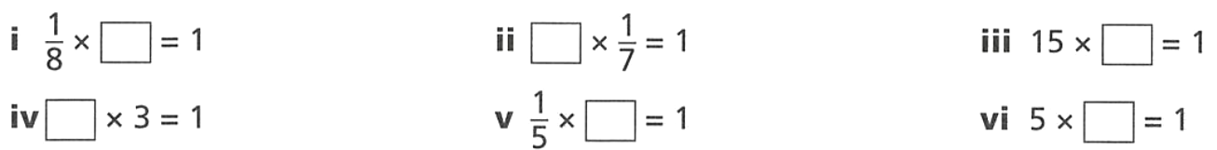  8 | 7 | $$\frac{1}{15}$$
$$\frac{1}{3}$$ | $$5$$ | $$\frac{1}{5}$$
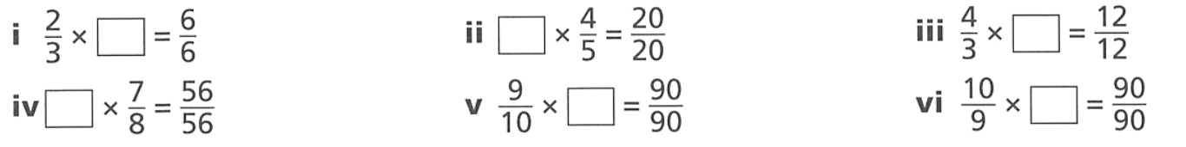  $$\frac{3}{2}$$ | $$\frac{5}{4}$$ | $$\frac{3}{4}$$
$$\frac{8}{7}$$ | $$\frac{10}{9}$$ | $$\frac{9}{10}$$
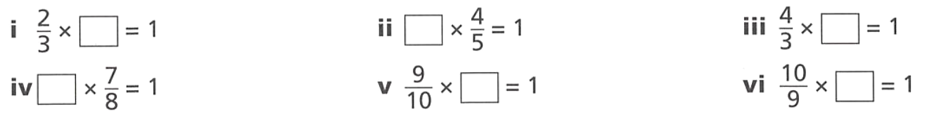  $$\frac{3}{2}$$ | $$\frac{5}{4}$$ | $$\frac{3}{4}$$
$$\frac{8}{7}$$ | $$\frac{10}{9}$$ | $$\frac{9}{10}$$

Dividing Fractions using the Reciprocal

- Dividing a Fraction
To divide by a fraction, multiply by its reciprocal.
$$\frac{a}{b}÷\frac{c}{d}$$
$$=\frac{a}{b}×\frac{d}{c}$$

- Example Dividing fractions using the rule
$$\frac{3}{4}÷\frac{2}{7}$$  $$=\frac{3}{4}×\frac{7}{2}$$  $$=\frac{21}{8}$$ | $$\frac{2}{5}÷2$$  $$=\frac{2}{5}×\frac{1}{2}$$  $$=\frac{2}{10}=\frac{1}{5}$$

- Guided Practice
$$1÷\frac{1}{2}$$  $$=\frac{1}{1}×\frac{}{}$$  $$=$$ | $$2÷\frac{1}{4}$$  $$=\frac{2}{1}×\frac{}{}$$  $$=$$
$$\frac{6}{13}÷3$$ | $$\frac{5}{7}÷\frac{3}{10}$$
$$\frac{7}{8}÷\frac{14}{2}$$ | $$\frac{5}{4}÷\frac{1}{2}÷\frac{3}{5}$$

- Key Ideas
- Dividing a number by a fraction is the same as …………………… by the reciprocal.

Foundation
- Complete the table.
Fraction Division | Diagram | Meaning
$$2÷\frac{2}{3}$$  $$=\frac{2}{1}×\frac{3}{2}$$  $=$  $$3$$ |  | $\frac{2}{3}$ fits into 2 wholes  …… times  3
$$2÷\frac{2}{5}$$  $$=\frac{2}{1}×\frac{}{}$$  $=$  5 |  | $\frac{2}{5}$ fits into 2 wholes  …… times  5
$$2÷\frac{4}{5}$$  $$=\frac{2}{1}×\frac{}{}$$  $=$  $$2\frac{1}{2}$$ |  | $\frac{4}{5}$ fits into 2 wholes  …… times  $$2\frac{1}{2}$$
$$\frac{3}{4}÷\frac{1}{4}$$  $$=\frac{3}{4}×\frac{}{}$$  $=$  3 |  | $\frac{1}{4}$ fits into $\frac{3}{4}$  …… times  $$3$$
$$\frac{5}{4}÷\frac{1}{2}$$  $$=\frac{5}{4}×\frac{}{}$$  $=$  $$2\frac{1}{2}$$ | 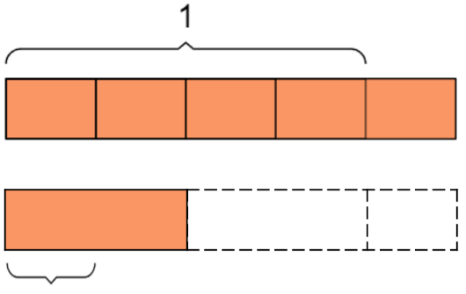  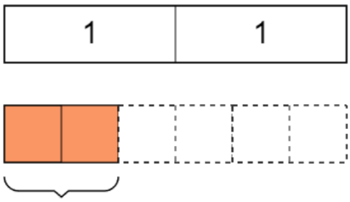  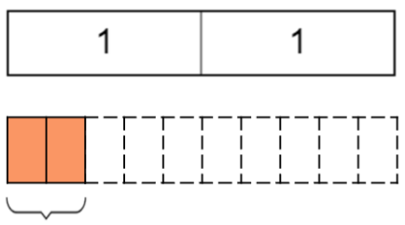  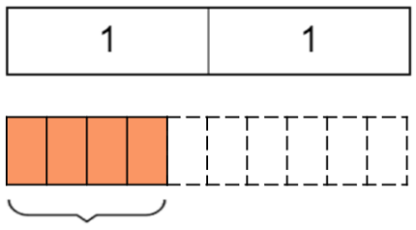  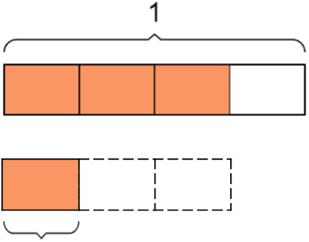  $$\frac{1}{2}$$  $$\frac{2}{3}$$  $$\frac{2}{5}$$  $$\frac{4}{5}$$  $$\frac{1}{4}$$ | $\frac{1}{2}$ fits into $\frac{5}{4}$  …… times  $$2\frac{1}{2}$$

- Complete each calculation by first rewriting it as a multiplication.
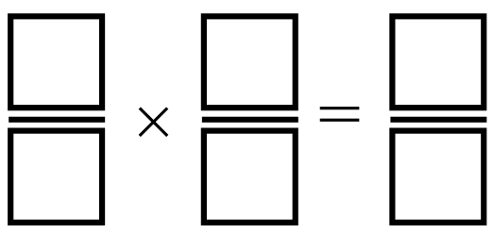  $$6÷\frac{1}{5}=$$  $$30$$ | $$9÷\frac{1}{4}=$$  $$36$$ | $$4÷\frac{1}{9}=$$  $$36$$
$$10÷\frac{1}{8}=$$  $$80$$ | $$24÷\frac{1}{7}=$$  $$168$$ | $$15÷\frac{1}{6}=$$  $$90$$

- Complete each calculation by first rewriting it as a multiplication.
$$6÷\frac{2}{5}=$$  $$15$$ | $$9÷\frac{3}{4}=$$  $$12$$ | $$4÷\frac{4}{9}=$$  $$9$$
$$10÷\frac{5}{8}=$$  $$16$$ | $$24÷\frac{6}{7}=$$  $$28$$ | $$15÷\frac{5}{6}=$$  $$18$$

- Complete each calculation by first rewriting it as a multiplication.
$$\frac{1}{4}÷\frac{3}{5}=$$  $$\frac{5}{12}$$ | $$\frac{3}{8}÷\frac{4}{7}=$$  $$\frac{21}{32}$$ | $$\frac{1}{2}÷\frac{5}{9}=$$  $$\frac{9}{10}$$
$$\frac{2}{5}÷\frac{7}{5}=$$  $$\frac{2}{7}$$ | $$\frac{7}{11}÷\frac{3}{4}=$$  $$\frac{28}{33}$$ | $$\frac{4}{9}÷\frac{10}{15}=$$  $$\frac{2}{3}$$

Development
- Complete each calculation by first rewriting it as a multiplication. It will be useful to cancel first.
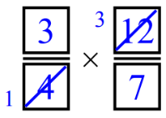  $$\frac{3}{4}÷\frac{7}{12}=$$  $$\frac{9}{7}$$ | $$\frac{3}{4}÷\frac{6}{11}=$$  $$\frac{11}{8}$$ | $$\frac{8}{5}÷\frac{8}{11}=$$  $$\frac{11}{5}$$
$$\frac{15}{4}÷\frac{20}{7}=$$  $$\frac{21}{16}$$ | $$\frac{9}{8}÷\frac{1}{2}=$$  $$\frac{9}{4}$$ | $$\frac{6}{5}÷\frac{18}{15}=$$  $$1$$

- Divide these fractions.
- $\frac{2}{5}$ $÷3$  $$\frac{2}{15}$$ | - $\frac{5}{6}$ $÷3$  $$\frac{5}{18}$$ | - $\frac{5}{6}$ $÷15$  $$\frac{1}{18}$$
- $\frac{3}{5}$ $÷3$  $$\frac{1}{5}$$ | - $\frac{10}{12}$ $÷3$  $$\frac{5}{18}$$ | - $\frac{10}{6}$ $÷15$  $$\frac{1}{9}$$
- $\frac{5}{3}$ $÷3$  $$\frac{5}{9}$$ | - $\frac{10}{12}$ $÷30$  $$\frac{1}{36}$$ | - $\frac{8}{6}$ $÷15$  $$\frac{4}{45}$$
- $\frac{3}{6}$ $÷3$  $$\frac{1}{6}$$ | - $\frac{5}{6}$ $÷30$  $$\frac{1}{36}$$

- Divide these fractions.
- $3÷$ $\frac{2}{5}$  $$\frac{15}{2}$$ | - $3÷$ $\frac{5}{6}$  $$\frac{18}{5}$$ | - $15÷$ $\frac{5}{6}$  $$18$$
- $3÷$ $\frac{3}{5}$  $$5$$ | - $3÷$ $\frac{10}{12}$  $$\frac{18}{5}$$ | - $15÷$ $\frac{10}{6}$  $$9$$
- $3÷$ $\frac{5}{3}$  $$\frac{9}{5}$$ | - $30÷$ $\frac{10}{12}$  $$36$$ | - $15÷$ $\frac{8}{6}$  $$\frac{45}{4}$$
- $3÷$ $\frac{3}{6}$  $$6$$ | - $30÷$ $\frac{5}{6}$  $$36$$
- Complete the pattern:
$12÷4=$ ……………………  3  $12÷2=$ ……………………  6  $12÷1=$ ……………………  12  $12÷$ $\frac{1}{2}$ $=$ ……………………  24  $12÷$ $\frac{1}{4}$ $=$ ……………………  48 | Circle the correct word in each sentence:  When dividing by a number more than one, the result is greater | less than the original number.  less  When dividing by a number less than one, the result is greater | less than the original number.  greater
- Complete the following sentences with greater or less without calculating the answer.
  - $5×\frac{3}{2}$ gives an answer that is ……………… than $5.$
greater
  - $5×\frac{2}{3}$ gives an answer that is ……………… than $5$.
less
  - $5÷\frac{3}{2}$ gives an answer that is ……………… than $5$.
less
  - $5÷\frac{2}{3}$ gives an answer that is ……………… than $5$.
greater
- Fill in the missing numbers to make these equations true.
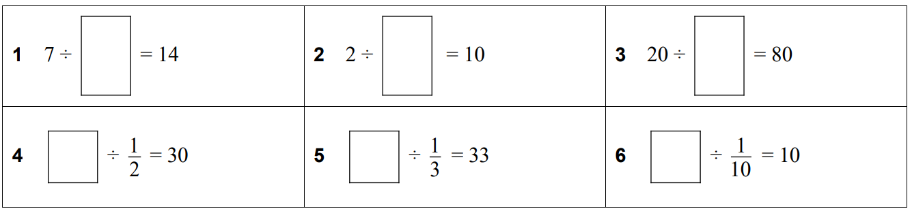  $$\frac{1}{2}$$ | $$\frac{1}{5}$$ | $$\frac{1}{4}$$
15 | 11 | 1

- If $2$ $\frac{1}{4}$ of a pizza is to be shared between three friends.
What fraction of pizza will each friend receive?

$$\frac{3}{4}$$
- A carpenter takes $\frac{3}{4}$ of an hour to make a chair. How many chairs can he make in 6 hours?

$$8$$

- Divide these fractions
$$\frac{2}{3}÷\frac{4}{5}=$$  $$\frac{5}{6}$$ | $$\frac{1}{2}÷\frac{3}{4}=$$  $$\frac{2}{3}$$ | $$5÷\frac{7}{12}=$$  $$\frac{60}{7}$$
$$\frac{4}{6}÷\frac{4}{5}=$$  $$\frac{5}{6}$$ | $$\frac{1}{2}÷\frac{1}{4}=$$  $$2$$ | $$\frac{1}{5}÷\frac{7}{15}=$$  $$\frac{3}{7}$$
$$\frac{4}{3}÷\frac{4}{5}=$$  $$\frac{5}{3}$$ | $$\frac{1}{2}÷4=$$  $$\frac{1}{8}$$ | $$\frac{1}{5}÷1\frac{13}{15}=$$  $$\frac{3}{28}$$
$$\frac{4}{3}÷\frac{2}{5}=$$  $$\frac{10}{3}$$ | $$\frac{1}{3}÷4=$$  $$\frac{1}{12}$$ | $$\frac{1}{5}÷1\frac{15}{13}=$$  $$\frac{13}{140}$$
$$\frac{3}{4}÷\frac{2}{5}=$$  $$\frac{15}{8}$$ | $$4÷\frac{1}{3}=$$  $$12$$ | $$1\frac{13}{15}÷\frac{1}{5}=$$  $$\frac{28}{3}$$
$$\frac{3}{4}÷\frac{5}{2}=$$  $$\frac{3}{10}$$ | $$4÷\frac{7}{3}=$$  $$\frac{12}{7}$$ | $$2\frac{13}{15}÷\frac{1}{5}=$$  $$\frac{43}{3}$$
$$\frac{3}{4}÷\frac{1}{2}=$$  $$\frac{3}{2}$$ | $$20÷\frac{7}{3}=$$  $$\frac{60}{7}$$ | $$2\frac{13}{15}÷1\frac{1}{5}=$$  $$\frac{43}{18}$$
- Apples are sold in bags weighing $1$ $\frac{1}{2}$ kg. How many bags can be made from 45 kg of apples?

$$30$$
- James takes $2$ $\frac{3}{4}$ minutes to assemble a wooden train.
How many trains can he assembled in one and a half hours?

$$32\frac{8}{11}$$

Mastery
- Calculate the following:
- $$\frac{3}{8}×\frac{4}{5}÷\frac{2}{3}$$  $$\frac{9}{20}$$ | - $$\frac{3}{8}÷\frac{4}{5}×\frac{2}{3}$$  $$\frac{5}{16}$$ | - $$\frac{3}{8}÷\frac{4}{5}÷\frac{2}{3}$$  $$\frac{45}{64}$$

- Find the missing number.
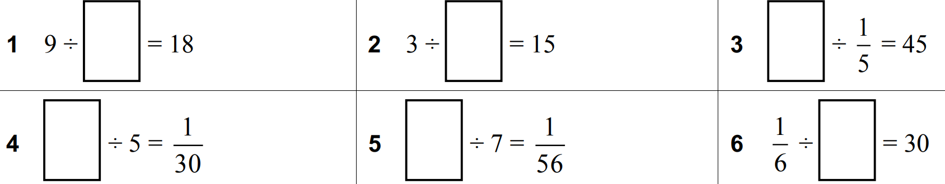  $$\frac{1}{2}$$ | $$\frac{1}{5}$$ | $$9$$
$$\frac{1}{6}$$ | $$\frac{1}{8}$$ | $$\frac{1}{180}$$
$$6$$ | $$\frac{3}{2}$$ | $$\frac{13}{10}$$

- For each equation, write at least two different solutions that make them true.
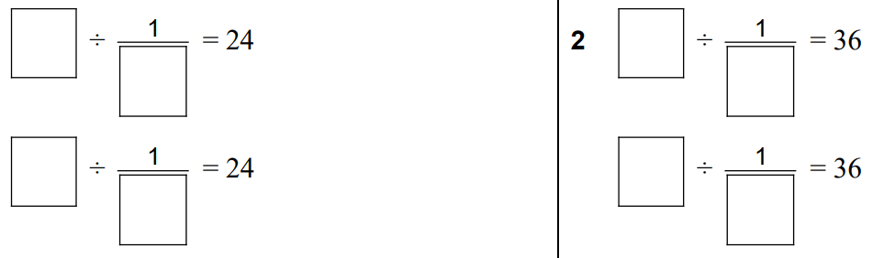  The two numbers should be a factor pair of 24 | The two numbers should be a factor pair of 36

- Mary asks her dad to buy 18 bottles of soft drink for her party.
Each bottle contains 1 $\frac{1}{4}$ litres.
The glasses they have for the party can hold $\frac{1}{5}$ of a litre.
How many glasses could be filled from the 18 bottles of soft drink?

$$112\frac{1}{2} glasses$$
- Evaluate
$$\left[\left(\frac{1}{9}-\frac{1}{10}\right)÷\frac{1}{8}\right]×\frac{1}{7}+\frac{1}{6}$$
$$\left[\left(\frac{10}{90}-\frac{1}{90}\right)÷\frac{1}{8}\right]×\frac{1}{7}+\frac{1}{6}$$
$$=\left(\frac{1}{90}÷\frac{1}{8}\right)×\frac{1}{7}+\frac{1}{6}$$
$$=\left(\frac{1}{90}×\frac{8}{1}\right)×\frac{1}{7}+\frac{1}{6}$$
$$=\frac{8}{90}×\frac{1}{7}+\frac{1}{6}$$
$$=\frac{8}{630}+\frac{1}{6}$$
$$=\frac{8}{630}+\frac{105}{630}=\frac{113}{630}$$
- [JMC 1997] What is the value of:
$$\frac{4}{1-\frac{3}{4}}$$

$$\frac{4}{\left(\frac{1}{4}\right)}=4÷\frac{1}{4}=16$$
- [JMO 2010] What is the value of:
$$\frac{1}{1}+\frac{2}{\frac{1}{2}}+\frac{3}{\frac{1}{3}}+\frac{4}{\frac{1}{4}}+\frac{5}{\frac{1}{5}}$$

$$1+4+9+16+25=55$$
- Calculate
$$\frac{3}{\frac{1}{4}+\frac{1}{3}}$$
$$\frac{3}{\frac{3}{12}+\frac{4}{12}}=\frac{3}{\left(\frac{7}{12}\right)}$$
$$=3÷\frac{7}{12}$$
$$=3×\frac{12}{7}$$
$$=\frac{36}{7}$$
- Calculate
$$\frac{3}{1-\frac{1}{1-\frac{1}{3}}}$$
$$\frac{3}{1-\frac{1}{\left(\frac{2}{3}\right)}}$$
$$=\frac{3}{1-\frac{3}{2}}$$
$$=\frac{3}{\left(-\frac{1}{2}\right)}$$
$$=-6$$

Multiplying and Dividing by Powers of 10

- Powers of 10
Powers of 10 | Expanded Form | Value
$${10}^{1}$$ | $10$ | $10$
$${10}^{2}$$ | $10×10$ | $100$
$${10}^{3}$$ | $10×10×10$ | $1000$
$${10}^{4}$$ | $10×10×10×10$ | $10 000$

- Multiplying by Powers of 10
When multiplying by ${10}^{n}$, the digits move $n$ place values to the left.

- Example Multiplying by Powers of 10
$6.7×10$  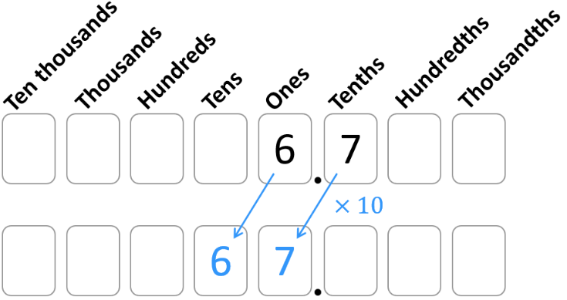 | $4.63×1000$  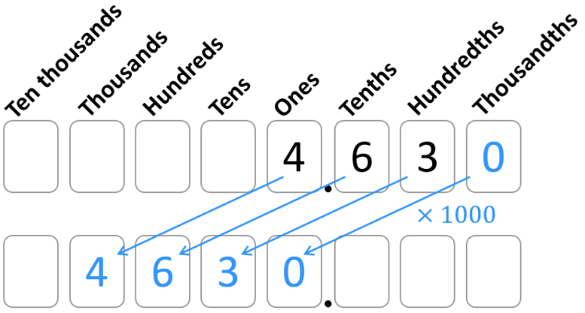

- Guided Practice
- $4.63×10$  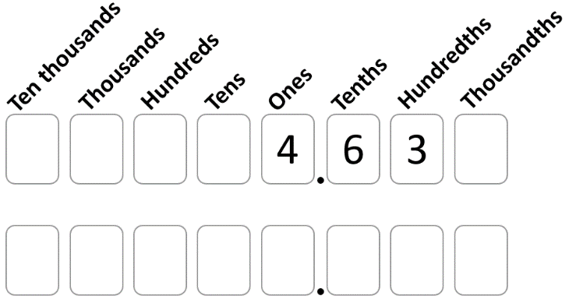 | - $67.3×100$  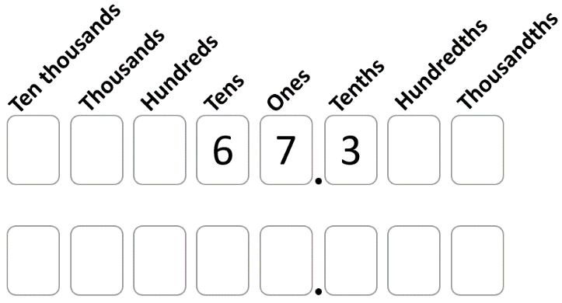
- $0.05×1000$  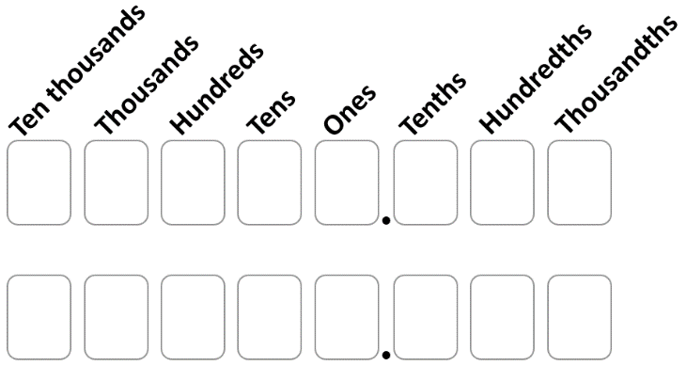 | - $0.23×10$
- Dividing by Powers of 10
When dividing by ${10}^{n}$, the digits move $n$ place values to the right.

- Example Dividing by Powers of 10
$6.7÷10$  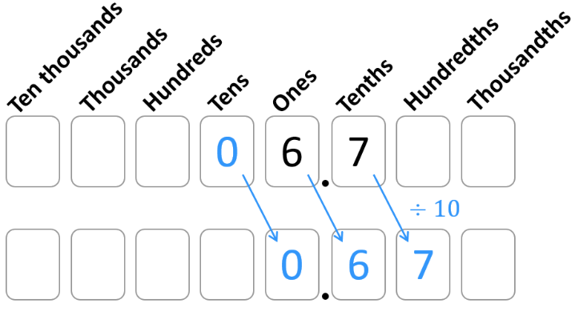 | $4.6÷100$  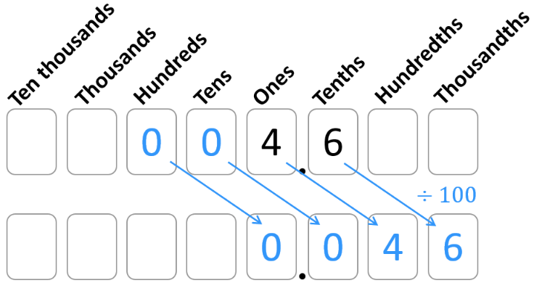

- Guided Practice
- $4.63÷10$ | - $67.3÷100$
- $0.23÷10$ | - $59÷1000$

Foundation
- Use the place value tables to multiply or divide these numbers.
- $5.718×10$  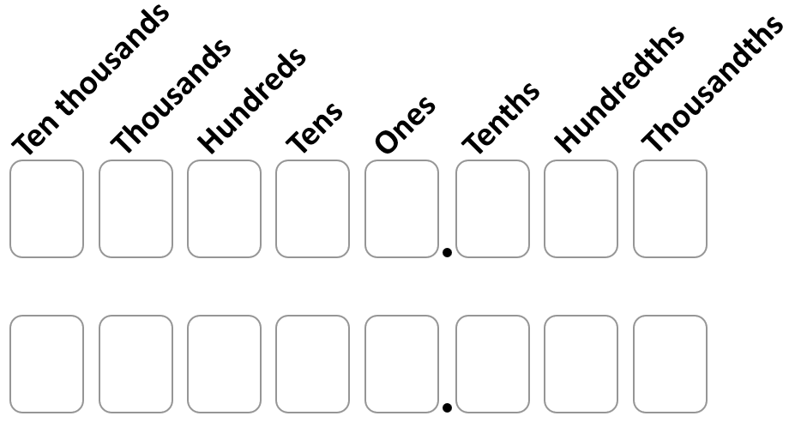  57.18 | - $0.837×100$  83.7
- $12.97×100$  1297 | - $98.03×1000$  98030
- $59.76÷10$  5.976 | - $2351÷100$  23.51
- $4.93÷100$  0.0493 | - $57240÷100$  572.4

Multiplying and Dividing by Powers of 10 using the Rule

- Multiplying by Powers of 10
When multiplying by ${10}^{n}$, move the decimal $n$ place values to the right.
Additional zeroes may be required.

- Example Multiplying by Powers of 10
$$23.758×1000$$  $=23758.$ | $$4.31×10 000$$  $=43100.$

- Guided Practice
- $72.3×100$  $=$ | - $0.3×1000$  $=$
- $25.2×1000$  $=$ | - $0.676×10$  $=$

- Dividing by Powers of 10
When dividing by ${10}^{n}$, move the decimal $n$ place values to the left.
Additional zeroes may be required.

- Example Dividing by Powers of 10
$268.15÷10$  $=26.815$ | $7.82÷1000$  $=0.00782$

- Guided Practice
- $425.3÷100$  $=$ | - $82 162÷100$  $=$
- $34÷1000$  $=$ | - $388.13÷10 000$  $=$

Foundation
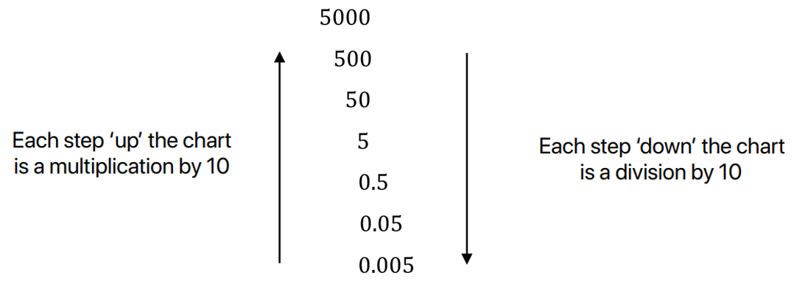
- Consider the chart:

Use the diagram above to help you answer these questions:
- $50×10$  500 | - $500×10$  5000 | - $0.005×10$  0.05 | - $0.5×10$  5
- $50÷10$  5 | - $5000÷10$  500 | - $5÷10$  0.5 | - $0.05÷10$  0.005

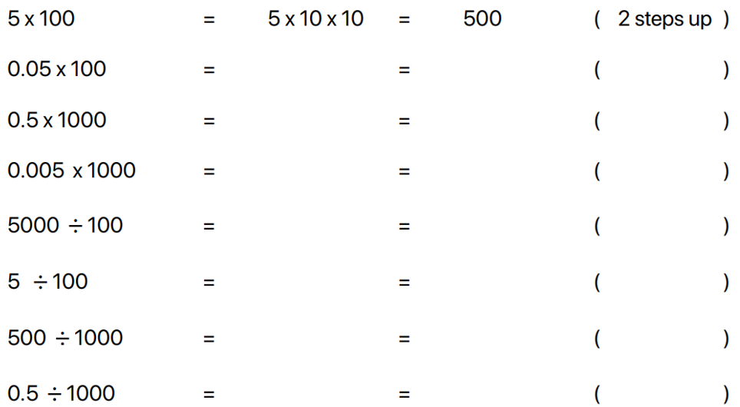
- Complete the following, stating how many steps up or down the chart. The first one is done for you.

500

5

500

5

50

0.05

0.5

0.0005

- What is the overall effect if you
  - multiply a number by 10 and then multiply the result by 10
multiply by 100
  - multiply a number by 10 and then divide the result by 10
multiply by 1, no change
  - multiply a number by 10, multiply the result by 10, and then multiply that result by 10?
multiply by 1000

- What is the overall effect if you
  - divide a number by 10 and then divide the result by 10
divide by 100
  - divide a number by 10 and then divide the result by 100
divide by 1000
  - divide a number by 10, divide the result by 10, and then multiply that result by 100?
Multiply/divide by 1, no change.

- Multiply each number by 10.
- 37  370 | - 0.37  3.7 | - 307  3070 | - 30.7  307
- 3.07  30.7 | - 0.0307  0.307 | - 370  3700 | - 0.0037  0.037

- Divide each number by 10.
- 37  3.7 | - 0.37  0.037 | - 307  30.7 | - 30.7  3.07
- 3.07  0.307 | - 0.0307  0.00307 | - 370  37 | - 0.0037  0.00037

- Work out the following.
- $46×100$  4600 | - $4.06×100$  406 | - $406×10$  4060 | - $460×100$  46000
- $4.6×1000$  4600 | - $4.06×1000$  4060 | - $10×4.006$  40.06 | - $1000×0.46$  460

- Work out the following.
- $46÷100$  0.46 | - $4.06÷100$  0.0406 | - $406÷10$  40.6 | - $460÷100$  4.6
- $4.6÷1000$  0.0046 | - $4.06÷1000$  0.00406 | - $4.006÷10$  0.4006 | - $0.46÷1000$  0.00046

Development
- Calculate each of the following mentally.
- $76×10$  760 | - $56÷10$  5.6 | - $230×100$  23000 | - $48000÷100$  480
- $4.5×100$  450 | - $312÷10$  31.2 | - $50.59×100$  5059 | - $0.9÷10$  0.09
- $3.005×10$  30.05 | - $8001÷1000$  8.001 | - $0.028×100$  2.8 | - $25÷100$  0.25
- $3094.5÷100$  30.945 | - $0.005×100$  0.5 | - $39.01÷1000$  0.03901 | - $4.99×100$  499

- Determine the answer to the following:
- $4.87×100$  487 | - $35.283×10$  352.83 | - $5.69923×1000$  5699.23 | - $42.7÷100$  0.427
- $353.1÷10$  35.31 | - $24.422÷10$  2.4422 | - $12.7×1000$  12700 | - $1215.18÷1000$  1.21518

- A large bee farm produces 1200 litres of honey per day.
  - If there are 1000 millilitres in 1 litre, how many millilitres of honey can the farm’s bees produce in one day?
1 200 000 mL
  - The farm’s honey is sold in 100-millilitre jars. How many jars of honey can the farm’s bees fill in one day?
12 000 jars

- A service station charges 147 cents per litre of petrol. How much will it cost Trish to fill her car with 100 litres of petrol? Answer in dollars.

147 dollars

Mastery
- Determine the answer to the following, using the order of operations.
- $1.56×100+24÷10$  $$158.4$$ | - $16÷100+32÷10$  $$3.36$$
- $3+10×(24÷100+8)$  $$85.4$$ | - $10×(6.734×100+32)$  $$7054$$
- $35.4+4.2×10-63.4÷10$  $$71.06$$ | - $4.7-24÷10+0.52×10$  $$7.5$$
- $14÷100+1897÷1000$  $$2.037$$ | - $78.1-10×(64÷100+5)$  $$21.7$$

100 | 1000 | 0.58
10 | 5.08 | 0.0508

100 | 100 | 920
1000 | 0.92 | 9020

$$×10$$ | $$÷100$$ | $$÷100$$
$$÷100$$ | $$×10$$ | $$×1000$$

$$1000$$ | $$10$$ | $$10$$
$$10 000$$ | $$100$$ | $$530 000$$

- The weight of a matchstick is 0.00015 kg.
Find the weight of 10 000 boxes of matches, with each box containing 100 matches.
The weight of one empty match box is 0.0075 kg.
225 kg

Multiplying Decimals

- Review
- Multiply fractions
- $\frac{2}{10}×\frac{3}{10}$ | - $\frac{5}{10}×\frac{8}{10}$ | - $\frac{21}{100}×\frac{3}{10}$
- $\frac{5}{10}×\frac{7}{100}$ | - $\frac{80}{100}×\frac{12}{100}$ | - $\frac{192}{1000}×\frac{2}{100}$

- Multiply and divide by powers of 10
- $27×10$ | - $2.7×10$ | - $0.27×100$
- $5700÷10$ | - $570÷10$ | - $57÷100$
- $10÷2$ | - $1÷2$ | - $1÷0.2$

- Multiplying Decimals
- Convert decimals to fractions.
- Multiply the fractions.
Use the algorithm if necessary.
Do not simplify the fraction; keep the denominator a power of 10.
- Convert back to decimal.

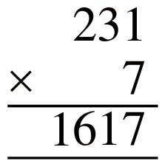
- Example Multiply decimals by converting to fractions
$0.4×0.2$  $$1. =\frac{4}{10}×\frac{2}{10}$$$2. =$ $\frac{8}{100}$  $$3. =0.08$$ | $$2.31×7$$  $$1. =\frac{231}{100}×\frac{7}{1}$$  $$2. =\frac{1617}{100}$$  $$3. =16.17$$

- Guided Practice
- $0.3×0.7$  $$=\frac{3}{10}×\frac{7}{10}$$  $=$  0.21 | - $0.4×0.03$  0.012
- $0.06×0.02$  0.0012 | - $0.04×1.3$  0.052

Foundation
- Complete these decimal multiplications.
- 0.1 × 0.3  0.03 | - 0.2 × 0.5  0.1 | - 0.12 × 0.02  0.0024
- 2.25 × 1.2  2.7 | - 4.3 × 1.2  5.16 | - 12.45 × 0.2  2.49
- 4 × 0.2  0.8 | - 6 × 0.5  3 | - 3.11 × 6  18.66
- 0.126 × 0.3  0.0378 | - 12.2 × 4.6  56.12 | - 46.2 × 5.4  249.48

[Algorithmic method for multiplying decimals]
- Ignore the decimal points and perform the multiplication as usual.
- Place the decimal point in the correct position.
  - Count the total number of decimal places in the numbers in the question.
  - The position of the decimal point in the answer should match this total count.
Worked Solution | Your Turn
$5.34×1.2$  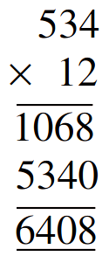  1.  2.  5.34 has 2 decimal places.  1.2 has 1 decimal place.  The answer should have 3 decimal places.  $∴5.34×1.2=6.408$ | $12.31×0.07$  1.  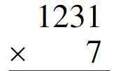  2.  12.31 has …… decimal places.  0.07 has …… decimal places.  The answer should have …... decimal places.  $∴12.31×0.07=$ …………  0.8617

Development
- Multiply these decimals using the algorithm method.
- 5.21 × 4  20.84 | - 3.8 × 7  26.6 | - 22.93 × 8  183.44
- 3.4 × 6.8  23.12 | - 5.4 × 2.3  12.42 | - 0.34 × 16  5.44
- 14 × 7.2  100.8 | - 3 × 72.8  218.4 | - 1.29 × 12  15.48
- 3.21 × 7.2  23.112 | - 0.023 × 0.042  0.000 966 | - 8.61 × 0.07  0.6027

- Desmond is a casual worker, earning $20.50 per hour.
How much does earn in a week if he works 7.6 hours?

$155.80
- Using fractions, show that:
- Multiplying by 0.1 is the same as  dividing by 10.  $$1500×0.1=1500×\frac{1}{10}$$  $=$ | - Multiplying by 0.01 is the same as dividing by 100.  $$1500×0.01=1500×\frac{1}{100}$$  $=$

- Multiply each number by 0.1. This is the same as dividing by 10.
- $2000×0.1$  200 | - $204×0.1$  20.4 | - $24×0.1$  2.4
- $2.04×0.1$  0.204 | - $0.24×0.1$  0.024 | - $0.0204×0.1$  0.00204

- Multiply each number by 0.01. This is the same as dividing by 100.
- $70×0.01$  0.7 | - $7000×0.01$  70 | - $78×0.01$  0.78
- $708×0.01$  7.08 | - $7.8×0.01$  0.078 | - $0.708×0.01$  0.00708

- Consider the “factorisation” strategy for multiplying:
$$17×20=17×2×10 \\ =34×10 \\ =340$$
Use the above strategy to work out:
- $36×20$  720 | - $14×30$  420 | - $59×20$  1180 | - $31×40$  1240

- Consider the “factorisation” strategy for dividing:
$$64÷20=64÷2÷10 \\ =32÷10 \\ =3.2$$
Use the above strategy to work out:
- $36÷20$  1.8 | - $45÷30$  1.5 | - $28÷400$  0.07 | - $8÷4000$  0.002

- Consider the following strategy for multiplying by a decimal.

Use the above strategy to work out:
- $430×0.2$  86 | - $12×0.3$  3.6 | - $31×0.03$  0.93 | - $22×0.4$  8.8
- $13×0.04$  0.52 | - $0.2×24$  4.8 | - $0.03×21$  0.63 | - $0.004×12$  0.048

- Work out these calculations.
- $30×4=120$  $30×0.4=$ …………  12 | - $6×40=$ …………  $0.6×40=$ …………  24 | - $7×400=$ …………  $0.07×400=$ …………  28
- $800×0.04$  32 | - $9000×0.7$  6300 | - $400×0.07$  28
- $0.08×70$  5.6 | - $6000×0.3$  1800 | - $0.04×6000$  240

- Calculate the following:
- $7×6$  42 | - $7×0.6$  4.2 | - $0.7×0.6$  0.42 | - $0.07×0.6$  0.042

Count the number of decimal places in each question and the number of decimal places in each answer. What do you notice?

They’re the same.
Calculate the following:
- $0.07×6$  0.42 | - $0.007×6$  0.042 | - $0.007×0.006$  0.000042 | - $70×0.6$  42
In part h, explain why there are no decimal places in the answer.

$$70×6=420,$$
$$70×0.6=42.0=42$$

Mastery
- Use the fact that $7×8=56$ to write down the answers to
- $70×8$  560 | - $7×80$  560 | - $70×80$  5600 | - $7×800$  5600
- $70×800$  56 000 | - $80×7$  560 | - $800×70$  56000 | - $0.7×8$  5.6
- $0.8×0.7$  0.56 | - $0.08×0.07$  0.0056

- Work out:
- $30×400$  12 000 | - $60×30$  1800 | - $0.7×4$  2.8 | - $8×0.3$  2.4
- $9×0.7$  6.3 | - $60×7$  420 | - $0.8×0.9$  0.72 | - $0.3×0.7$  0.21
- $20×700$  14 000 | - $0.07×0.6$  0.042

- Given that $67×28=1876$, work out:
- $67×2.8$  187.6 | - $0.67×28$  18.76 | - $6.7×0.28$  1.876
- $28×0.067$  1.876 | - $2.8×0.067$  0.1876 | - $0.067×280$  18.76

- Complete these calculations using known facts.
- $3×4$  12 | - $6×5$  30 | - $0.7×50$  35
- $3×0.4$  1.2 | - $6×0.5$  3 | - $0.7×5$  3.5
- $3×0.04$  0.12 | - $60×0.5$  30 | - $0.7×0.5$  0.35
- $0.3×4$  1.2 | - $60×0.05$  3 | - $7×0.05$  0.35
- $0.03×4$  0.12 | - $6×0.05$  0.3 | - $0.7×0.05$  0.035
- $0.003×4$  0.012 | - $0.6×0.05$  0.03 | - $0.07×0.05$  0.0035
- $0.003×0.4$  0.0012 | - $0.6×0.5$  0.3 | - $0.007×0.5$  0.0035
- $0.03×0.4$  0.012 | - $0.06×0.5$  0.03 | - $0.0007×5$  0.0035
- $0.03×40$  0.12 | - $0.06×5$  0.3 | - $0.00007×50$  0.0035

Dividing Decimals

- Dividing Decimals
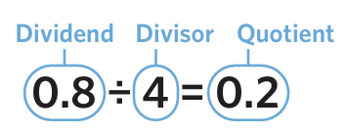

- If the divisor is a decimal,
Adjust the divisor to a whole number by multiplying the dividend and divisor by a power of 10.
- Divide using the algorithm, keeping the decimal point lined up.

- Example Divide decimals
$2.4÷6$  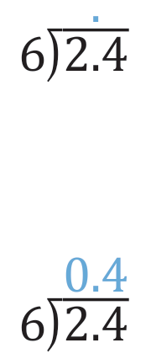  2.  $2.4÷6=0.4$ | $5.085÷0.03$  1. $↓ ↓ ×100$  2. $508.5÷3$  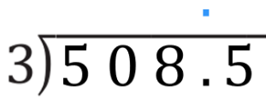  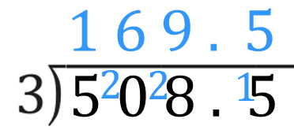  $5.085÷0.03=169.5$

- Guided Practice
- $6.3÷7$  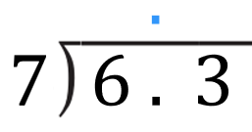  0.9 | - $13.125÷5$  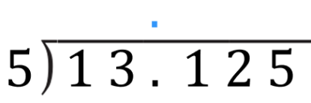  2.625
- $0.486÷0.3$  $↓ ↓ ×$ ……  $4.86÷3$  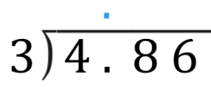  1.62 | - $0.063÷0.03$  2.1

Foundation
- Divide these decimals.
- $1.56÷4$  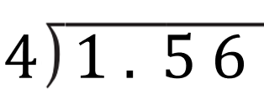  0.39 | - $2.56÷8$  0.32 | - $9.45÷3$  3.15
- $0.572÷4$  0.143 | - $45.87÷3$  15.29 | - $105.6÷8$  13.2
- $3.45÷8$  0.43125 | - $2.63÷5$  0.526 | - $19.3÷4$  4.825

- Divide these decimals.
- $52.1÷0.8$  65.125 | - $17÷0.4$  42.5 | - $0.72÷0.5$  1.44
- $1.16÷0.04$  29 | - $18.32÷0.08$  229 | - $23.457÷0.07$  335.1

- Divide these decimals; the answer will be a recurring decimal.
- $35.5÷3$  $$11.8\dot{3}$$ | - $7.1÷0.3$  $$23.\dot{6}$$ | - $287÷1.2$  $$239.1\dot{6}$$

- Divide these decimals, find the third decimal place then round your answer to 2 decimal places.
- $14.531÷9$  1.61 | - $1.736÷0.9$  1.93 | - $2.54÷1.3$  1.95

Development
- Place either a multiplication $×$ or division $÷$ sign in the box to make the equation true.
80 | $$×$$ | 0.5 = 40
80 | $$÷$$ | 0.5 = 160
8 | $$÷$$ | 0.5 = 16
8 | $$×$$ | 0.5 = 4
0.8 | $$÷$$ | 0.5 = 1.6
0.08 | $$÷$$ | 0.5 = 0.16
0.08 | $$×$$ | 0.5 = 0.04

- Using fractions, show that:
- Dividing by 0.1 is the same as  multiplying by 10.  $$1500÷0.1=1500÷\frac{1}{10}$$  $=1500×$ | - Dividing by 0.01 is the same as  multiplying by 100.  $$1500÷0.01=1500÷\frac{1}{100}$$  $=$

- Dividing by 0.1 is the same as multiplying by …………
10
Write down the answers to:
60 | 2 | 62 | 0.7 | 8.3

- Complete these calculations using known facts.
- $80÷2$  40 | - $8÷2$  4 | - $0.8÷2$  0.4 | - $0.08÷2$  0.04
- $80÷0.2$  400 | - $8÷0.2$  40 | - $0.8÷0.2$  4 | - $0.08÷0.2$  0.4
- $80÷0.02$  4000 | - $8÷0.02$  400 | - $0.8÷0.02$  40 | - $0.08÷0.02$  4
- $80÷0.002$  40000 | - $8÷0.002$  4000 | - $0.8÷0.002$  400 | - $0.08÷0.002$  40

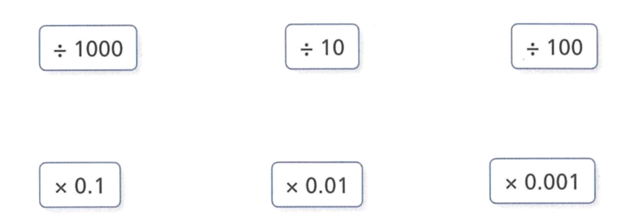
- Match the cards that show equivalent calculations.

$$÷1000→ ×0.00$$
$$÷10→×0.1$$
$$÷100→×0.01$$
- Find the missing numbers.
0.1 | 260
0.1 | 10000

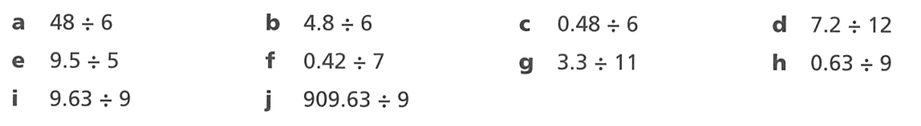
- Divide these numbers using your multiplication knowledge.
8 | 0.8 | 0.08 | 0.6
1.9 | 0.06 | 0.3 | 0.07
1.07 | 101.07

- $204÷6=34$. Write down the answer to
- $20.4÷6$  3.4 | - $2.04÷6$  0.34 | - $2040÷6$  340 | - $408÷6$  68

- Given that $2.7×4.8=12.96$, work out:
- $27×4.8$  129.6 | - $0.27×0.48$  0.1296 | - $12.96÷4.8$  2.7 | - $12.96÷2.7$  4.8
- $2.7×48$  129.6 | - $2.7×0.48$  1.296 | - $129.6÷4.8$  27 | - $12.96÷27$  0.48
- $0.27×48$  12.96 | - $270×0.48$  129.6 | - $129.6÷48$  2.7 | - $1.296÷27$  0.048
- $0.27×4.8$  1.296 | - $2700×0.48$  1296 | - $129.6÷0.48$  270 | - $1.296÷0.27$  4.8

- Given that $2.7×4.8=12.96$, work out:
- ………… $×4.8=129.6$  27 | - ………… $×0.48=129.6$  270 | - ………… $×0.48=1.296$  2.7
- $2.7×$ ………… $=1296$  480 | - $27×$ ………… $=12.96$  0.48 | - $0.27×$ ………… $=12.96$  48

- Divide these numbers.
- $50÷10$  5 | - $0.5÷0.1$  5 | - $0.1÷0.05$  2
- $50÷20$  2.5 | - $0.5÷1$  0.5 | - $0.2÷0.05$  4
- $50÷2$  25 | - $5÷0.1$  50 | - $0.2÷5$  0.04
- $50÷0.2$  250 | - $1÷0.5$  2 | - $5÷0.2$  25
- $5÷0.2$  25 | - $0.1÷0.5$  0.2 | - $0.5÷0.2$  2.5
- $0.5÷0.2$  2.5 | - $0.1÷5$  0.02 | - $0.05÷0.2$  0.25

- Complete the multiplication table.
$$×$$ | 0.8 | 0.6 | 0.1
2 | 1.6 | 1.2 | 0.2
5.5 | 4.4 | 3.3 | 0.55
0.35 | 0.28 | 0.21 | 0.035

Mixed Practice

Foundation
- Work out:
$$\frac{3}{4}×\frac{2}{7}$$  $$\frac{3}{14}$$ | $$\frac{3}{4}÷\frac{2}{7}$$  $$\frac{21}{8}$$ | $$\frac{3}{4}+\frac{2}{7}$$  $$\frac{29}{28}$$ | $$\frac{3}{4}-\frac{2}{7}$$  $$\frac{13}{28}$$

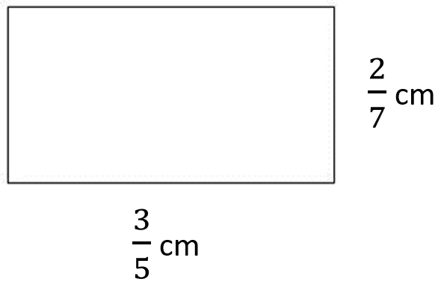
- Consider the rectangle.

- Find the area of the rectangle  $$\frac{3}{5}×\frac{2}{7}=\frac{6}{35} {cm}^{2}$$ | - Find the perimeter of the rectangle  $$2\left(\frac{3}{5}+\frac{2}{7}\right)= 2\left(\frac{21}{35}+\frac{10}{35}\right)=\frac{62}{35} cm$$
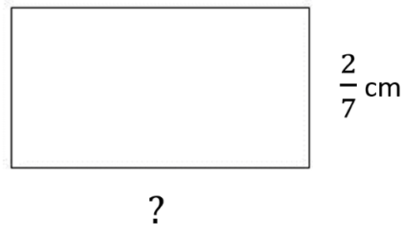  - The area of the rectangle is 8 cm².  Find the missing length.  $$8 ÷\frac{2}{7}=28 cm$$ | 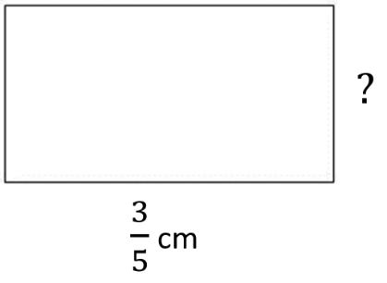  - The perimeter of the rectangle is 12 cm.  Find the missing length.  $$\frac{27}{5} cm$$

- The area of the rectangle is 10 m². What fraction of a metre is the width of the rectangle?
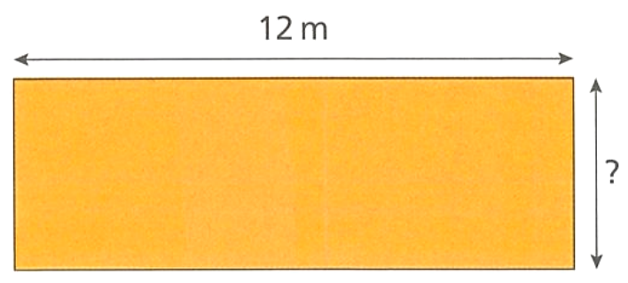

$$10÷12=\frac{5}{6} m$$

Development
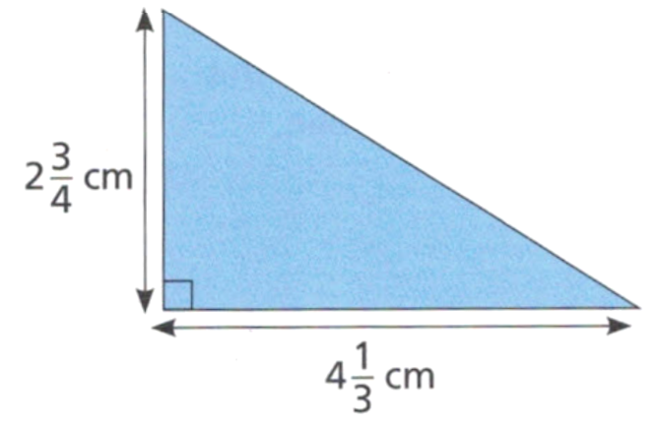
- Find the area of the triangle. The area of a triangle is: $Area=\frac{1}{2}×Base×Height$

$$\frac{1}{2}×\frac{13}{3}×\frac{11}{4}=\frac{143}{24}= 5\frac{23}{24}$$
- Fill in the empty boxes to make these fraction operations true.
5 | 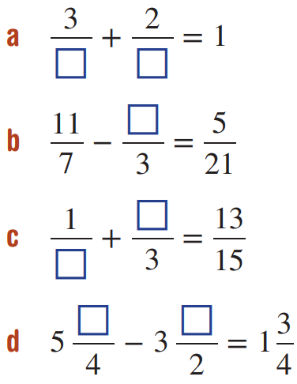  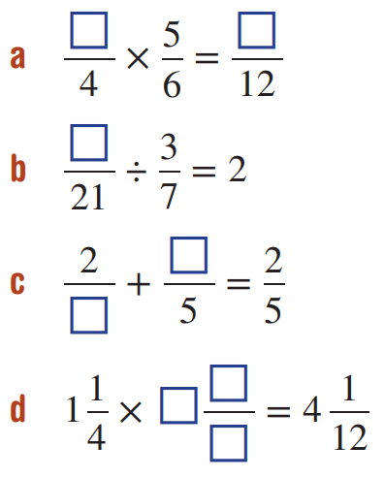  2 and 5
4 | 18
5 and 2 | 10 and 1
1 and 1 | 3, 4 and 15

- Using the unitary method, find the number if
$\frac{1}{7}$ of the number is ……  So, the number is ……  3, 21 | $\frac{1}{8}$ of the number is ……  So, the number is ……  8, 64 | 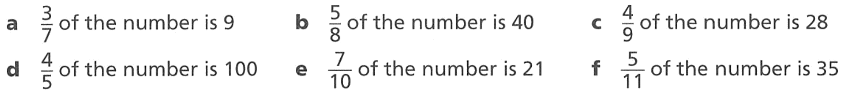  63
125 | 30 | 77
- Find the answer to each calculation. Follow the order of operations.
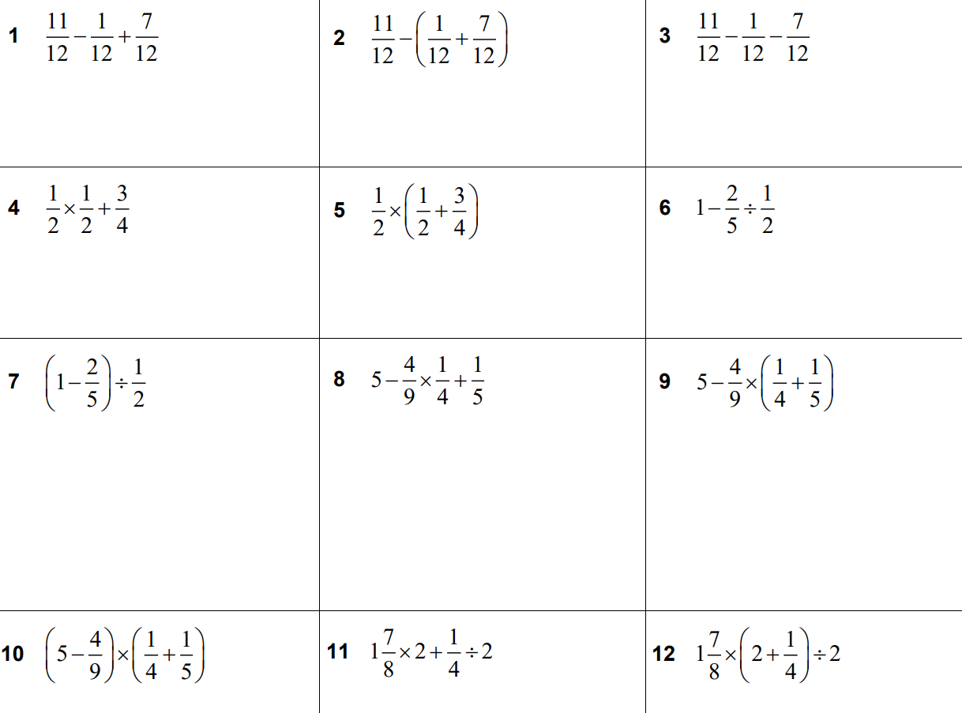  $$\frac{1}{4}$$ | 1
$$\frac{5}{8}$$ | $$\frac{1}{5}$$
$$\frac{6}{5}$$ | $$\frac{229}{45}$$
$$\frac{24}{5}$$ | $$\frac{41}{20}$$
$$\frac{31}{8}$$ | $$\frac{135}{64}$$

- Find the operation that makes these operations true.
$$×$$ | $$-,÷$$ | $$+,÷,-$$

- Evaluate the following:
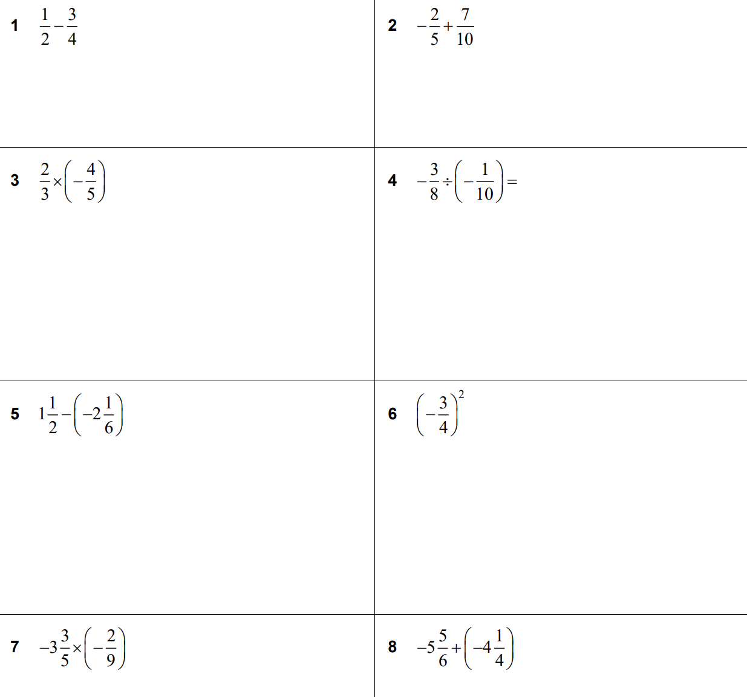  $$\frac{3}{10}$$ | $$-\frac{8}{15}$$ | $$\frac{15}{4}$$
$$\frac{11}{3}$$ | $$\frac{9}{16}$$ | $$-\frac{121}{12}$$

- Using the clues provided, work out which two fractions are being discussed.
• We are two proper fractions.
• Altogether we consist of four different digits.
• When added together our answer will still be a proper fraction.
• When multiplied together you could carry out some cancelling.
• The result of our product, when simplified, contains no new digits from our original four.
• Three of our digits are prime numbers and the fourth digit is a cube number.

$$\frac{2}{5} and \frac{3}{8}$$

Challenge Exercise
- A tank when $\frac{3}{4}$ full contains 81 litres. What is the capacity of the tank?
$\frac{1}{4}$ tank contains 27 L
full tank contains 108 L

- If $\frac{2}{5}$ of my pocket money is $6, how much do I receive altogether?

$\frac{1}{5}$ of pocket money is $3
total pocket money is $15
- A car travels 180 km in $1\frac{1}{2}$ hours.
How far will it travel in two hours, if it continues at the same speed?

60 km in $\frac{1}{2}$ hour
240 km in 2 hours
- A car travels 180 km in $2\frac{1}{4}$ hours.
How far did it travel in two hours, if its speed was constant?
20 km in $\frac{1}{4}$ hour
80 km in 1 hour
160 km in 2 hours

- A carpenter takes 36 minutes to make a chair. How many chairs can he make in 4 $\frac{1}{2}$ hours?
$$4\frac{1}{2}÷\frac{3}{5}$$
$$=\frac{9}{2}×\frac{5}{3}$$
$$= 7\frac{1}{2}chairs$$

- A container when half full holds 3.6 litres. How much more fluid is needed to make it $\frac{2}{3}$ full?
$$\frac{1}{2}=\frac{3}{6}full holds 3.6 L$$
$$\frac{1}{6}full holds 1.2 L$$
$$1.2 L of extra fluid are needed$$

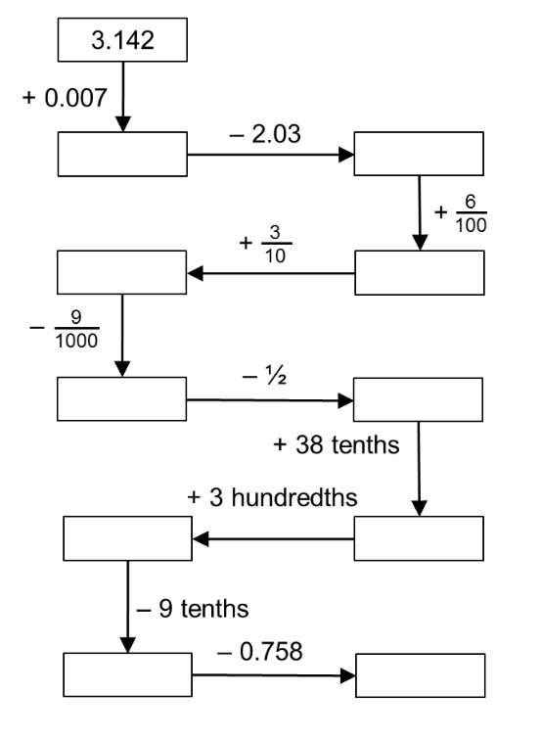
- Complete the diagram. What do you notice about your answer?

The final answer should be 3.142.

- Find three fractions between $\frac{1}{4}$ and $\frac{1}{2}$.

$$Convert to a common denominator:\frac{1}{4}=\frac{4}{16}and\frac{1}{2}=\frac{8}{16}.$$
$$Three fractions between these are\frac{5}{16},\frac{6}{16}\left(or\frac{3}{8}\right), and\frac{7}{16}. (Note: Various answers are possible).$$
- Find $x$ if $\frac{1}{3}+\frac{1}{4}+\frac{1}{x}$ $= 1$.

$$\frac{1}{x}= 1 - \left(\frac{1}{3}+\frac{1}{4}\right)$$
$$\frac{1}{x}= 1 -\frac{7}{12}=\frac{5}{12}$$
$$x =\frac{12}{5}$$
- Of the marbles in a bag, $\frac{1}{5}$ are blue and $\frac{2}{3}$ are red. The remaining marbles are yellow, and there are 6 of these. How many marbles are in the bag?

$$Fraction yellow = 1 - \left(\frac{1}{5}+\frac{2}{3}\right)= 1 -\frac{13}{15}=\frac{2}{15}$$
$$Let total marbles = x$$
$$\left(\frac{2}{15}\right)x = 6$$
$$x = 45 marbles$$
- There are 50 black sheep and 42 white sheep in a paddock. How many black sheep must be removed so that $\frac{1}{3}$ of the remaining sheep are black?

White sheep remain unchanged at 42.
If $\frac{1}{3}$ of remaining are black, $\frac{2}{3}$ are white.
Total remaining sheep = $\frac{42}{\left(\frac{2}{3}\right)}$ $= 63$
Remaining black sheep = 63 − 42 = 21
Black sheep removed = 50 − 21 = 29 black sheep

- A half is a third of the number $x$. What is the number $x$?
$$\frac{1}{2}=\frac{x}{3}$$
$$x =\frac{1}{2}× 3 =\frac{3}{2}$$
- A quarter is a third of the number $x$. What is the number $x$?
$$\frac{1}{4}=\frac{x}{3}$$
$$x = 3 ×\frac{1}{4}=\frac{3}{4}$$
- An important formula is physics is $\frac{1}{f}$ $=$ $\frac{1}{d}$ $+$ $\frac{1}{p}$. Given $d = 1$ $\frac{3}{4}$ and $p =$ $\frac{2}{3}$, find $f$.

$$\frac{1}{f}=\frac{4}{7}+\frac{3}{2}$$
$$\frac{1}{f}=\frac{29}{14}$$
$$f =\frac{14}{29}$$

  - It costs a family of two adults and three children $28 to go to a show.
If a child's ticket costs $\frac{1}{2}$ of the price of an adult's ticket, find the cost of an adult's ticket.

$$Let \$y be child ticket, adult is \$2y$$
$$2\left(2y\right)+ 3y = 28$$
$$y = \$4, adult is \$8$$

  - If the same family spent $68 to go to a concert and a child's ticket costs 3/4 of the price of an adult's ticket, find the price of a child's ticket.
$$Let \$y be adult ticket, child is\frac{\$3}{4y}$$
$$2y + 3\left(\frac{3}{4}\right)y= 68$$
$$8y + 9y = 4×68$$
$$y = \$16, child is \$12$$

- Which of the two fractions $\frac{3004}{3005}$ and $\frac{3005}{3006}$ is larger? Carefully explain why.
$$\frac{3004}{3005}= 1 -\frac{1}{3005}$$
$$\frac{3005}{3006}= 1 -\frac{1}{3006}$$
$$Since\frac{1}{3006}<\frac{1}{3005}, it follows that 1 -\frac{1}{3006}> 1 -\frac{1}{3005}.$$
$$Therefore,\frac{3005}{3006}is larger.$$

- Two fractions are equally spaced between $\frac{1}{4}$ and $\frac{4}{5}$. Find the two fractions.
$$Gap between\frac{1}{4}and\frac{4}{5}: \frac{4}{5}-\frac{1}{4}=\frac{11}{20}$$
$$Gap between each fraction: \frac{\frac{11}{20}}{3} =\frac{11}{60}$$
$$First fraction =\frac{1}{4}+\frac{11}{60}=\frac{15}{60}+\frac{11}{60}=\frac{26}{60}=\frac{13}{30}$$
$$Second fraction =\frac{26}{60}+\frac{11}{60}=\frac{37}{60}$$

- What is the value of $\left(1 -\frac{1}{2}\right)× \left(1 -\frac{1}{3}\right)× \left(1 -\frac{1}{4}\right)× \left(1 -\frac{1}{5}\right)?$

$$\frac{1}{2}×\frac{2}{3}×\frac{3}{4}×\frac{4}{5}=\frac{1}{5}$$
- What is the value of $\left(1 +\frac{1}{5}\right)× \left(1 +\frac{1}{6}\right)× \left(1 +\frac{1}{7}\right)× \left(1 +\frac{1}{8}\right)× \left(1 +\frac{1}{9}\right)$?

$$\frac{6}{5}×\frac{7}{6}×\frac{8}{7}×\frac{9}{8}×\frac{10}{9}=\frac{10}{5}= 2$$

- The school lap-a-thon circuit is $2\frac{3}{4}$ kilometres in length.
Benjamin walked $4\frac{1}{3}$ laps, Nathan walked $5\frac{1}{2}$ laps and Alicia walked $3\frac{1}{4}$ laps.
  - What was the total distance walked by the three students?
  - How much farther than Benjamin did Nathan walk?
$$Total laps = 4\frac{1}{3}+ 5\frac{1}{2}+ 3\frac{1}{4}=\frac{13}{3}+\frac{11}{2}+\frac{13}{4}=\frac{52}{12}+\frac{66}{12}+\frac{39}{12}=\frac{157}{12}laps.$$
$$Total dist =\frac{157}{12}×\frac{11}{4}=\frac{1727}{48}= 35\frac{47}{48}km$$
$$Lap diff = 5\frac{1}{2}- 4\frac{1}{3}=\frac{11}{2}-\frac{13}{3}=\frac{7}{6}laps.$$
$$Dist diff =\frac{7}{6}×\frac{11}{4}=\frac{77}{24}= 3\frac{5}{24}km$$

- In a cricket test match, $\frac{1}{6}$ of the runs were scored in the first day, $\frac{1}{5}$ in the second day, $\frac{2}{5}$ in the third day, $\frac{7}{32}$ in the fourth day and remaining 21 runs on the last day.
How many runs were scored on each day?
$$Fraction on day 5 = 1 - \left(\frac{1}{6}+\frac{1}{5}+\frac{2}{5}+\frac{7}{32}\right)$$
$$= 1 - \left(\frac{80}{480}+\frac{96}{480}+\frac{192}{480}+\frac{105}{480}\right)$$
$$= 1 -\frac{473}{480}=\frac{7}{480}$$
$$Let x = total runs.$$
$$\left(\frac{7}{480}\right)x = 21$$
$$x = 1440.$$
$$Day 1:\frac{1}{6}× 1440 = 240, Day 2:\frac{1}{5}× 1440 = 288, Day 3:\frac{2}{5}× 1440 = 576, Day 4:\frac{7}{32}× 1440 = 315$$
$Day 5: 21$
- Complete the following tables
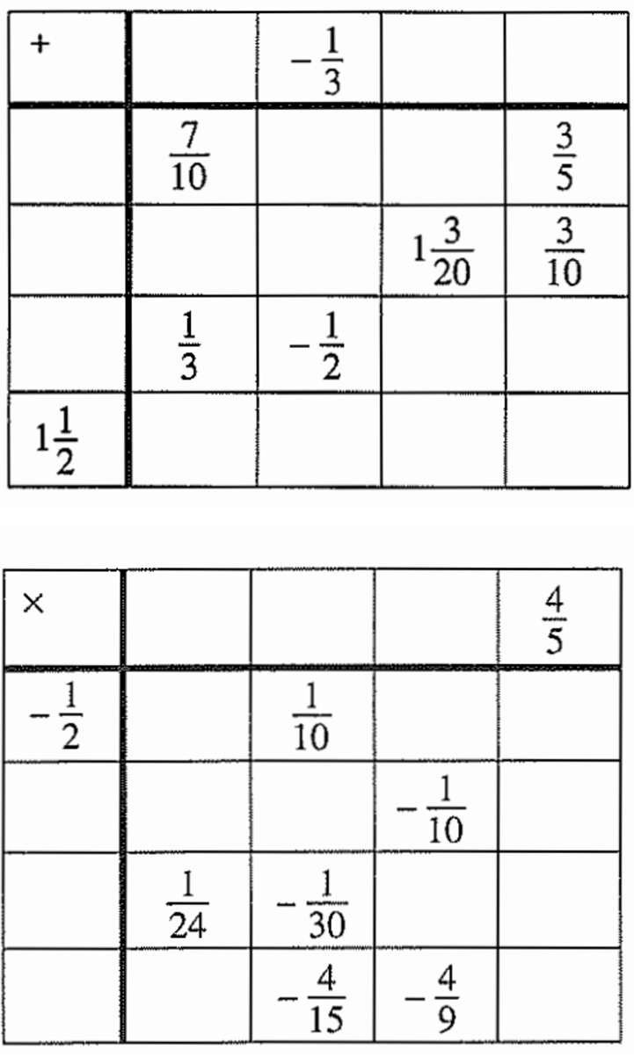

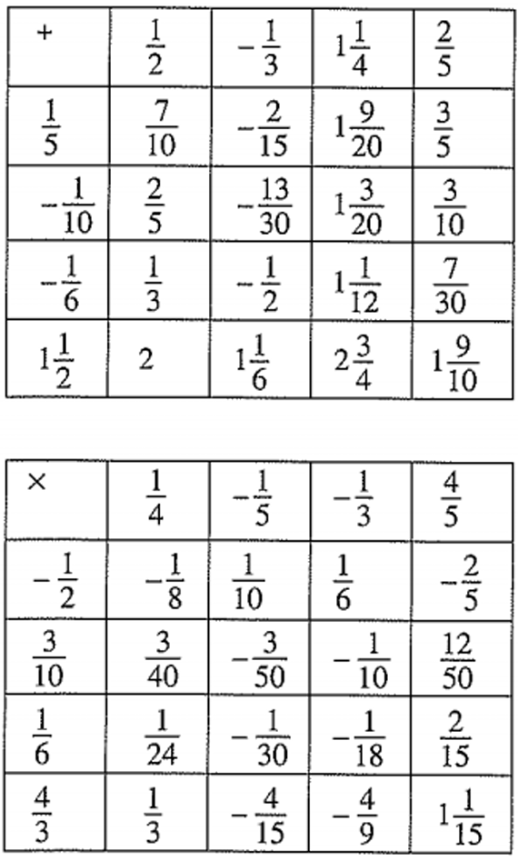

- Complete the following magic squares, in which each row, column and diagonal must add up to the same sum.
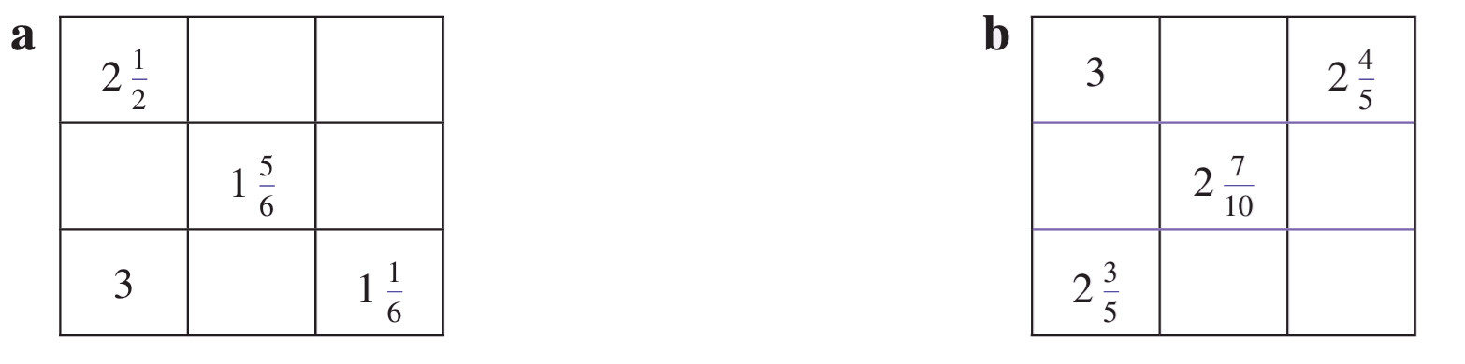  $$Row 1: 2\frac{1}{2}, 2\frac{1}{3},\frac{2}{3}$$  $$Row 2: 0, 1\frac{5}{6}, 3\frac{2}{3}$$  $$Row 3: 3, 1\frac{1}{3}, 1\frac{1}{6}$$ | $$Row 1: 2\frac{3}{10}, 2\frac{4}{5}$$  $$Row 2: 2\frac{1}{2}, 2\frac{7}{10}, 2\frac{9}{10}$$  $$Row 3: 2\frac{3}{5}, 3\frac{1}{10}, 2\frac{2}{5}$$

- Use three of these fractions:
$$\left(\frac{1}{2},\frac{1}{3},\frac{1}{4},\frac{1}{5}\right)$$
to make true:
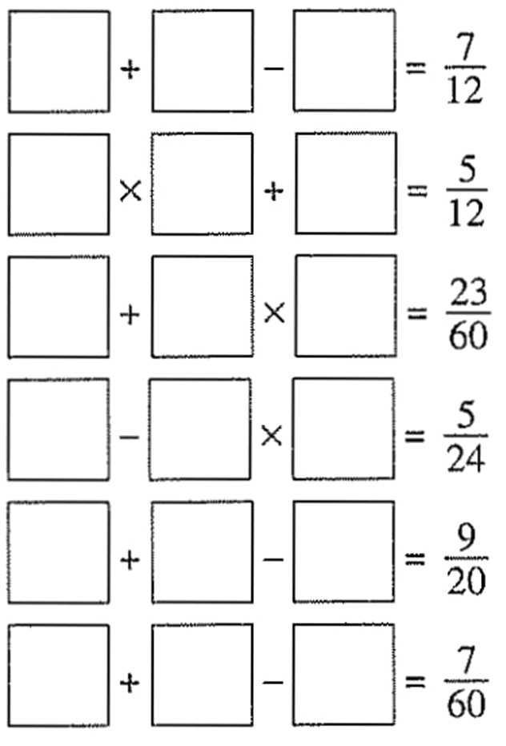  $$\frac{1}{2}+\frac{1}{3}-\frac{1}{4}=\frac{7}{12}$$ | $$\frac{1}{3}×\frac{1}{2}+\frac{1}{4}=\frac{5}{12}$$
$$\frac{1}{3}+\frac{1}{5}×\frac{1}{4}=\frac{23}{60}$$ | $$\frac{1}{3}-\frac{1}{2}×\frac{1}{4}=\frac{5}{24}$$
$$\frac{1}{2}+\frac{1}{5}-\frac{1}{4}=\frac{9}{20}$$ | $$\frac{1}{5}+\frac{1}{4}-\frac{1}{3}=\frac{7}{60}$$

- Evaluate:
$$\frac{1}{4}+\frac{2}{4}+\frac{3}{4}$$  $$\frac{6}{4}= 1\frac{1}{2}$$ | $$\frac{1}{5}+\frac{2}{5}+\frac{3}{5}+\frac{4}{5}$$  $$\frac{10}{5}= 2$$
$$\frac{1}{6}+\frac{2}{6}+\frac{3}{6}+\frac{4}{6}+\frac{5}{6}$$  $$\frac{15}{6}= 2\frac{1}{2}$$ | $$\frac{1}{2}+\frac{1}{3}+\frac{2}{3}+\frac{1}{4}+\frac{2}{4}+\frac{3}{4}+ ... +\frac{9}{10}$$  Notice that the sums increase by 1 and a half. So:  $$\frac{1}{2}+ 1 + 1\frac{1}{2}+ 2 + 2\frac{1}{2}+ 3 + 3\frac{1}{2}+ 4 + 4\frac{1}{2}= 22\frac{1}{2}$$
- Joanne and Kevin put all their marbles in a bag. $\frac{3}{5}$ of the marbles belong to Joanne.
In a competition Kevin doubled the number of marbles that he owned, and Joanne won 6 more, so that now they had an equal number of marbles.
How many marbles did they each have originally?
Originally, Joanne has $\frac{3}{5}$ and Kevin $\frac{2}{5}:$ $J=$ $\frac{3}{2}$ $K$
Afterwards: $J+6=2K$
$$\frac{3}{2}K+6=2K$$
$$3K+12=4K$$
$$12=K$$
$$∴J=\frac{3}{2}K=\frac{3}{2}\left(12\right)=18$$
Kevin had 12 marbles and Joanne had 18 marbles
- In the elections for year 7 representatives, two-fifths of the votes went to Julian,
one-quarter to Georgina, one-sixth to Ruffy and the remaining 11 votes were cast for Deborah.
How many students are there in year 7?
$$Let x be students in year 7$$
$$\frac{2}{5}x +\frac{1}{4}x +\frac{1}{6}x + 11= x$$
$$49x + 660 = 60x$$
$$11x = 660$$
$x = 60$
- Evie spent $\frac{1}{2}$ of her earnings on a pair of shorts and $\frac{1}{2}$ of what remained on a present.
If she spent $90, how much does she earn?
$$Let earnings be \$y$$
$$total spent =\frac{1}{2}y +\frac{1}{4}y = \$90$$
$$\frac{3}{4}y = 90$$
$$y = 120, earns \$120$$

  - $1 -$ $\left(\frac{1}{2}+\frac{1}{4}\right)$
$$1 -\frac{3}{4}=\frac{1}{4}$$
  - $1 -$ $\left(\frac{1}{2}+\frac{1}{4}+\frac{1}{8}\right)$
$$1 -\frac{7}{8}=\frac{1}{8}$$
  - $1 -$ $\left(\frac{1}{2}+\frac{1}{4}+\frac{1}{8}+\frac{1}{16}\right)$
$$1 -\frac{15}{16}=\frac{1}{16}$$
  - $1 -$ $\left(\frac{1}{2}+\frac{1}{4}+\frac{1}{8}+\frac{1}{16}+\frac{1}{32}+\frac{1}{64}+\frac{1}{128}\right)$
$$1 -\frac{127}{128}=\frac{1}{128}$$
  - What do you notice?

The answer is always the smallest fraction in the brackets. This means that the sum of the fractions is getting closer and closer to 1.

- Johan found a 4-litre tub of ice cream. He stopped when he had eaten half of it.
The next night he again stopped when he had eaten half of what was there.
This went on for five nights in a row.
How much ice cream was left at the end of each of the five nights?
Would he ever have finished all the ice cream?

Left after night $n = 4 × {\left(\frac{1}{2}\right)}^{n}$
$$Night 1: 2L, Night 2: 1L, Night 3: \frac{1}{2}L, Night 4: \frac{1}{4}L, Night 5: \frac{1}{8}L$$No, there would always have been a bit left (half of what was there at the start of each night).
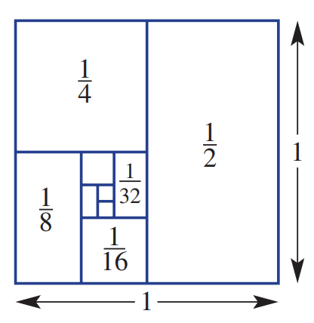
- The square given below, which has an area of 1 unit, is divided to show the areas of $\frac{1}{2},\frac{1}{4},\frac{1}{8}…$

  - Write the next 5 numbers in this number pattern.
$\frac{1}{2},\frac{1}{4},\frac{1}{8},$ ……, ……, ……, ……, ……
$$\frac{1}{16},\frac{1}{32},\frac{1}{64},\frac{1}{128},\frac{1}{256}…$$
  - What is the total area of the starting square?
The total area is 1 unit, as given in the question
  - What does that tell you about the total of
$$\frac{1}{2}+\frac{1}{4}+\frac{1}{8}+…(forever)$$
It is equal to 1!
- Evaluate:

$$\left(1 -\frac{1}{2}\right)\left(1 -\frac{1}{3}\right)\left(1 -\frac{1}{4}\right)\left(1 -\frac{1}{5}\right)\left(1 -\frac{1}{6}\right)\left(1 -\frac{1}{7}\right)\left(1 -\frac{1}{8}\right)$$

$$\left(\frac{1}{2}\right)×\left(\frac{2}{3}\right)×\left(\frac{3}{4}\right)×\left(\frac{4}{5}\right)×\left(\frac{5}{6}\right)×\left(\frac{6}{7}\right)×\left(\frac{7}{8}\right)=\frac{1}{8}$$

$$\left(1 +\frac{1}{2}\right)\left(1 +\frac{1}{3}\right)\left(1 +\frac{1}{4}\right)\left(1 +\frac{1}{5}\right)\left(1 +\frac{1}{6}\right)\left(1 +\frac{1}{7}\right)\left(1 +\frac{1}{8}\right)$$

$$\left(\frac{3}{2}\right)×\left(\frac{4}{3}\right)×\left(\frac{5}{4}\right)×\left(\frac{6}{5}\right)×\left(\frac{7}{6}\right)×\left(\frac{8}{7}\right)×\left(\frac{9}{8}\right)=\frac{9}{2}$$

$$\frac{1 -\frac{1}{2}}{1 -\frac{1}{5}}$$  $$\frac{\frac{1}{2}}{\frac{4}{5}}= \left(\frac{1}{2}\right)×\left(\frac{5}{4}\right)=\frac{5}{8}$$ | $$\frac{1}{1 -\frac{1}{1 -\frac{1}{2}}}$$  $$\frac{1}{1 - 2}= -1$$ | $$\frac{\frac{2}{3}+\frac{1}{5}}{1 - \left(\frac{2}{3}\right)\left(\frac{1}{5}\right)}$$  $$multiply numerator and denominator by the HCF 15$$  $$\frac{10 + 3}{15 - 2}=\frac{13}{13}= 1$$

- What is the value of $\frac{\frac{1}{2}-\frac{1}{5}}{\frac{1}{2}+\frac{1}{5}}$
Multiply numerator and denominator by HCF 10
$$\frac{\frac{1}{2}-\frac{1}{5}}{\frac{1}{2}+\frac{1}{5}}$$
$$=\frac{5 - 2}{5 + 2}=\frac{3}{7}$$

- Find the value of $m$:
$$\frac{m}{m}+\frac{m}{m}= m$$  $$1 + 1 = m$$  $m = 2$ | $$m +\frac{1}{m}= 2\frac{1}{2}$$  $$m +\frac{1}{m}=\frac{5}{2}$$  $m = 2 or\frac{1}{2}$
$${\left(m - 3\right)}^{2}=\frac{1}{4}$$  $$m - 3 = ±\frac{1}{2}$$  $$m = 3\frac{1}{2}or 2\frac{1}{2}$$ | $${\left(m - 1\right)}^{2}=\frac{4}{9}$$  $$m - 1 = ±\frac{2}{3}$$  $$m = 1\frac{2}{3}or\frac{1}{3}$$

- $\sqrt{\frac{4}{3}×\frac{5}{4}×\frac{6}{5}× ... ×\frac{a}{b}}$ $= 2$, find the value of $\frac{a}{b}$

The 4s, 5,s 6s… cancel out
$$\sqrt{\frac{a}{3}}= 2 →\frac{a}{3}= 4$$
$$a = 12$$
$$b = 11$$
$$\frac{a}{b}=\frac{12}{11}$$

- We can write $\frac{1}{6}$ as the sum of two fractions, each with 1 as the numerator, as $\frac{1}{7}$ $+$ $\frac{1}{42}$.
This can be done in four other ways. Find these.
$$Let\frac{1}{6}=\frac{1}{x}+\frac{1}{y}.$$
$$\frac{1}{y}=\frac{1}{6}-\frac{1}{x}=\frac{x-6}{6x}$$
$$y =\frac{6x}{x-6}= 6 +\frac{36}{x-6}$$
$$For y to be an integer, \left(x-6\right) must be a factor of 36.$$
$$Factors of 36 yielding unique pairs: x-6 = 2, 3, 4, 6$$
$$Sub x = 8, 9, 10, 12 to find pairs:$$
$$\frac{1}{8}+\frac{1}{24},\frac{1}{9}+\frac{1}{18},\frac{1}{10}+\frac{1}{15},\frac{1}{12}+\frac{1}{12}$$
- Express $\frac{1}{8}$ as the sum of two fractions, each with 1 as the numerator, in four ways.

$$Let\frac{1}{8}=\frac{1}{x}+\frac{1}{y}$$
$$y = 8 +\frac{64}{x-8}$$
$$Factors of 64 yielding unique pairs: x-8 = 1, 2, 4, 8.$$
$$Sub x = 9, 10, 12, 16 to find pairs:$$
$$\frac{1}{9}+\frac{1}{72},\frac{1}{10}+\frac{1}{40},\frac{1}{12}+\frac{1}{24},\frac{1}{16}+\frac{1}{16}$$
- Evaluate by following the order of operations. Remember that fractions have invisible brackets.
$$1+\frac{1}{1+\frac{1}{2}}$$  $$=1 +\frac{1}{\left(\frac{3}{2}\right)}$$  $$= 1 +\frac{2}{3}$$  $$= 1\frac{2}{3}$$ | $$1 +\frac{1}{1 +\frac{1}{1 +\frac{1}{2}}}$$  $$=1 +\frac{1}{1 +\frac{1}{\left(\frac{3}{2}\right)} }$$  $$=1 +\frac{1}{1 +\frac{2}{3}}$$  $$= 1 +\frac{1}{\frac{5}{3}}$$  $$= 1 +\frac{3}{5}$$  $$= 1\frac{3}{5}$$

- Using the numbers 1, 2 and 3, fill in the boxes to make these statements true.
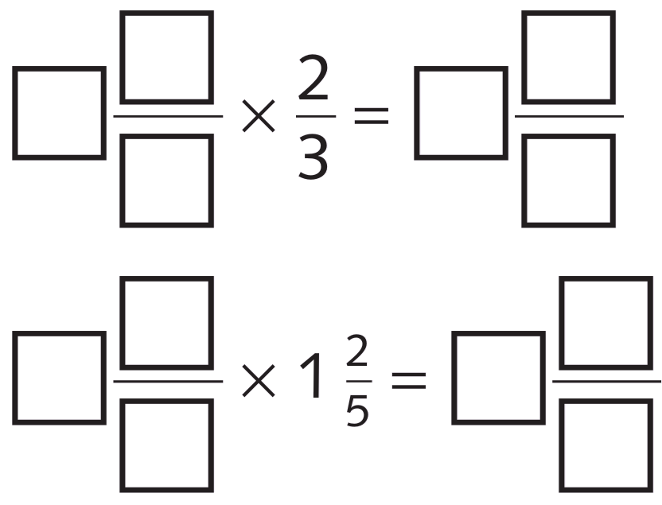  $$3\frac{1}{2}×\frac{2}{3}= 2\frac{1}{3}$$ | $$1\frac{2}{3}× 1\frac{2}{5}= 2\frac{1}{3}$$

- One quick method of calculation is called ‘the difference of two squares:’
$$\left(11+7\right)\left(11-7\right)={11}^{2}-7^{2} \\ \left(9+4\right)\left(9-4\right)=9^{2}-4^{2} \\ \left(a+b\right)\left(a-b\right)=a^{2}-b^{2}$$
Use this method to solve the following:
$$\frac{1}{96}+\frac{97 × 95}{96}- 95$$

$$\frac{1 + \left(96+1\right)\left(96-1\right)}{96}- 95$$
$$=\frac{1 + {96}^{2}- 1}{96}- 95$$
$$=\frac{{96}^{2}}{96}- 95$$
$$= 96 - 95$$
$$= 1$$
- At the first station, $\frac{1}{2}$ of the train's passengers leave and 135 new passengers board.
At the second station, $\frac{1}{3}$ of the passengers who arrived on the train at the first station leave,
and 110 new passengers board.
The train arrives at Brampton with 350 passengers.
How many passengers were on the train when it left Alston?

$$Let x = initial passengers.$$
$$After Station 1:\frac{x}{2}+ 135$$
$$After Station 2: \left(\frac{x}{2}+ 135\right)-\frac{x}{3}+ 110 = 350$$
$$\frac{x}{6}+ 245 = 350$$
$$\frac{x}{6}= 105$$
$$x = 630 passengers$$

$$\frac{1}{5}+\frac{6×4}{5}- 6$$  $$\frac{1 + 24}{5}- 6 = -1$$ | $$\frac{1}{68}+\frac{69×67}{68}- 69$$  $$\frac{1}{68}+\frac{\left(68+1\right)\left(68-1\right)}{68}-69$$  $$=\frac{1+{68}^{2}-1^{2}}{68}-69$$  $$=68-69$$  $$= -1$$ | $$\frac{1}{n}+\frac{\left(n+1\right)\left(n-1\right)}{n}- \left(n+1\right)$$  $$\frac{1 + n^{2}- 1}{n}- n - 1$$  $$=n - n - 1$$  $$= -1$$

- Find $x$ and $y$ if:
$$2 +\frac{1}{\frac{x}{y}}=\frac{25}{11}$$  $$\frac{25}{11}= 2\frac{3}{11}= 2 +\frac{1}{\frac{11}{3}}= 2 +\frac{1}{\frac{x}{y}}$$  $$x = 11, y = 3$$ | $$2 +\frac{1}{3 +\frac{x}{y}}=\frac{25}{11}$$  $$\frac{25}{11}=2 +\frac{1}{\frac{11}{3}}= 2 +\frac{1}{3 +\frac{2}{3}}= 2 +\frac{1}{3 +\frac{x}{y}}$$  $$x = 2, y = 3$$
$$2 +\frac{1}{3 +\frac{1}{\frac{x}{y}}}=\frac{25}{11}$$  $$\frac{25}{11}=2 +\frac{1}{3 +\frac{2}{3}}= 2 +\frac{1}{3 +\frac{1}{\frac{3}{2}}}= 2 +\frac{1}{3 +\frac{1}{x}}$$  $$x = 3, y = 2$$ | $$2 +\frac{1}{3 +\frac{1}{1 +\frac{x}{y}}}=\frac{25}{11}$$  $$\frac{25}{11}=2 +\frac{1}{3 +\frac{1}{\frac{3}{2}}}= 2 +\frac{1}{3 +\frac{1}{1 +\frac{1}{2}}}$$  $$∴x = 1, y = 2$$

- Evaluate:
$$\sqrt{a^{2}+ b^{2}} if a =\frac{1}{4}and b =\frac{1}{3}$$  $$\sqrt{{\left(\frac{1}{4}\right)}^{2}+ {\left(\frac{1}{3}\right)}^{2}}$$  $$=\sqrt{\frac{9 + 16}{16×9}}$$  $$=\sqrt{\frac{5^{2}}{4^{2}3^{2}}}$$  $$=\frac{5}{12}$$ | $$\sqrt{a^{2}+ b^{2}} if a =\frac{1}{5}and b =\frac{1}{12}$$  $$\sqrt{{\left(\frac{1}{5}\right)}^{2}+ {\left(\frac{1}{12}\right)}^{2}}$$  $$=\sqrt{\frac{144 + 25}{25×144}}$$  $$=\sqrt{\frac{{13}^{2}}{5^{2}{12}^{2}}}$$  $$=\frac{13}{60}$$

- A certain fraction has 1 added to both numerator and denominator.
If the new fraction is (or is equivalent to) $\frac{2}{3}$, write down four possible fractions that we could have started with.
Work backwards from the possible equivalent fractions:
$$\frac{2}{3},\frac{4}{6},\frac{6}{8},\frac{8}{12}$$
Subtract 1 from each numerator and denominator:
$$\frac{1}{2},\frac{3}{5},\frac{5}{7},\frac{7}{11}$$

  - Find the fraction that is equivalent to $\frac{3}{4}$ and:
the difference between the denominator and the numerator is 7.
$$Equivalent to\frac{3a}{4a}$$
$$4a - 3a = 7$$
$$a = 7$$
$$fraction is\frac{21}{28}$$
  - Find the fraction that is equivalent to $\frac{3}{4}$ and:
the product of the denominator and the numerator is 300.
$$12a² = 300$$
$$a² = 25$$
$$a = ±5$$
$$fraction is ±\frac{15}{20}$$
- How many times do you need to write the fraction $\frac{1}{3}$ to make this statement true?
$$\frac{1}{3}÷\frac{1}{3}÷\frac{1}{3}÷ ... ÷\frac{1}{3}= 81$$
This is the same as
$$\frac{1}{3}×3×3×3…=81$$
Two of which cancel out, because $\frac{1}{3}×3=1$, so this simplifies to
$$\left(1\right)×3×3×3…=81$$
Since $81=3^{4}$
We need 4 + 2 = 6 terms
$$\left(\frac{1}{3}\right)× 3^{n-1}= 3^{4}$$
$$3^{n-2}= 3^{4}$$
$n - 2 = 4, so n = 6$
- Find the whole numbers $a, b$ and $c$ if
$$\frac{37}{13}= 2 +\frac{1}{a +\frac{1}{b +\frac{1}{c}}}$$
$$\frac{37}{13}= 2 +\frac{11}{13}$$
$$so a+\frac{1}{b+\frac{1}{c}}=\frac{1}{\left(\frac{11}{13}\right)}$$
$$=\frac{13}{11}$$
$$\frac{13}{11}= 1 +\frac{2}{11}=a+\frac{1}{\left(b+\frac{1}{c}\right)} \left(so a = 1\right)$$
$$\frac{1}{b+\frac{1}{c}}=\frac{2}{11}$$
$$\frac{11}{2}= 5 +\frac{1}{2}=b+\frac{1}{c} (so b = 5, c = 2)$$

